9. Assessment of the Pacific Ocean Perch Stock in the Gulf of Alaska

Maia S. Kapur, Peter-John F. Hulson, Benjamin C. Williams, and Bridget Ferriss

November 2023

This report may be cited as: Kapur, M.S., Hulson, P-J., Williams, B.C., 2023. Assessment of the Pacific Ocean Perch Stock in the Gulf of Alaska. North Pacific Fishery Management Council, Anchorage, AK. Available from <https://www.npfmc.org/library/safe-reports/>

# Executive Summary

## Summary of Changes in Assessment Inputs

*Changes in the input data*: This assessment includes updated catch for 2022, assumed catches of 30,381 t for 2023, 31,454 t for 2024 and 29,890 t for 2025 (see How Future Catch is Specified for details). Additional changes to input data include 2023 bottom trawl survey biomass, 2022 fishery age composition data, and 2021 survey age composition.

*Changes in the assessment methodology*: The assessment methodology is the same as the most recent assessment (Hulson *et al.* 2021).

## Summary of Results

For the 2024 fishery, we recommend the maximum allowable ABC of 39,719 t. This ABC is a 9.7% increase from the ABC recommended by last year’s model for 2024 of 36,196 t. The increase is attributed to the fact that the model has observed six consecutive survey biomass estimates larger than 1 million tons as well as an increase in survey biomass in 2023 compared to 2021. (This same dynamic resulted in increases in ABC from 2019 to 2021). The corresponding reference values for Pacific ocean perch are summarized in the following table. The stock is not subject to overfishing, is not currently overfished, nor is it approaching a condition of being overfished.

|  | As estimated or specified *last* year for: | | As estimated or recommended *this* year for: | |
| --- | --- | --- | --- | --- |
| **Quantity/Status** | 2023 | 2024 | 2024* | 2025* |
| M (natural mortality) | 0.075 | 0.075 | 0.074 | 0.074 |
| Tier | 3a | 3a | 3a | 3a |
| Projected total (age 2+) biomass (t) | 636,129 | 621,249 | 650,027 | 628,753 |
| Projected female spawning biomass (t) | 210,795 | 205,713 | 228,030 | 221,384 |
| B*100%* | 331,917 | 331,917 | 343,618 | 343,618 |
| B*40*% | 132,767 | 132,767 | 137,447 | 137,447 |
| B*35*% | 116,171 | 116,171 | 120,266 | 120,266 |
| F*OFL* | 0.12 | 0.12 | 0.12 | 0.12 |
| *max*FABC | 0.10 | 0.10 | 0.10 | 0.10 |
| FABC | 0.10 | 0.10 | 0.10 | 0.10 |
| OFL (t) | 44,302 | 43,117 | **47,466** | 45,835 |
| *max*ABC (t) | 37,193 | 36,196 | 39,719 | 38,354 |
| ABC (t) | 37,193 | 39,196 | **39,719** | 38,354 |
|  | As determined *last* year for: | | As determined *this* year for: | |
| **Status** | 2022 | 2023 | 2023 | 2024 |
| Overfishing | No | n/a | No | n/a |
| Overfished | n/a | No | n/a | No |
| Approaching overfished | n/a | No | n/a | No |
| *Projections are based on an estimated catch of 30,381 t for 2023 and estimates of 31,454 t and 29,890 t used in place of maximum permissible ABC for 2024 and 2025. | | | | |

## Area Allocation of Catches

The apportionment of catches for 2024 and 2025 was conducted using the REMA model using the same assumptions as in 2021. Details on the workflow to calculate apportionment are provided in Area Allocation of Catches.

Because Amendment 41 prohibits trawling in the Eastern area east of 140° W longitude, the ABC allocation derived from REMA for the Eastern Gulf is split between W. Yakutat and E. Yakutat/Southeast Outside (‘Southeast’ or ‘SEO’) using a weighted average of area-specific biomass ratios obtained from the trawl survey. The OFL for the SEO region remains separate because of concerns regarding stock structure differences in the SEO vs other areas. Per the 2012 Groundfish Plan team recommendation, OFLs are combined for the Western, Central, and West Yakutat areas (W/C/WYK).

| REMA-derived apportionment (%) | | 4.5 | 72.4 | 23.1 | | 100 |
| --- | --- | --- | --- | --- | --- | --- |
| Year | Quantity | Western | Central | W. Yakutat | E. Yakutat/SEO | Total |
| 2024 | ABC (t) | 1,787 | 28,757 | 2,110 | 7,065 | 39,719 |
| 2025 | ABC (t) | 1,726 | 27,768 | 2,038 | 6,822 | 38,354 |
| 2024 | OFL (t) | 39,023 | | | 8,443 | 47,466 |
| 2025 | OFL (t) | 37,682 | | | 8,153 | 45,835 |

## Responses to SSC and Plan Team Comments on Assessments in General

“The SSC requests that all authors fill out the risk table in 2019…” (SSC December 2018)

We provide a risk table in the Harvest Recommendations section. After completing this exercise, we do not recommend ABC be reduced below maximum permissible ABC.

## Responses to SSC and Plan Team Comments Specific to this Assessment

Several topics have emerged as recommended areas of exploration across multiple cycles of POP. For concision, the following section states each topic once, the date(s) the topic or recommendation was mentioned, and the author response.

Many of these topics were endorsed for consideration in the 2021 CIE review, which is summarized in the Appendix. That appendix includes detailed responses to high-priority requests and comments; where applicable, results are briefly summarized below.

1. Re-evaluation of the age-plus group, as changes to the model and input data have occurred since this was previously evaluated (Plan Team, November 2018; CIE, 2021)

This was investigated as part of the CIE review and authors did not find large differences in derived quantities when the plus group was reduced from 29 to 25; this is sensible given that growth is stable after age twenty and there is a paucity of data for older individuals.

2. Continued evaluation of methods for weighting for the compositional data as new models are developed and/or changes are made to input data. (Plan Team, November 2018)

Recent work has been completed that provides age and length composition input sample size using bootstrap methodologies for all AFSC trawl surveys (Hulson *et al.* 2023) and work is currently being initiated that will develop methods to determine age and length composition input sample size for fishery-dependent data. We will investigate the inclusion of these input sample sizes to weight compositional data in future assessments.

3. Investigation of natural mortality, as the current estimate of 0.066 is higher than the expected value from the prior distribution (0.05) and the prior may be constraining the model. (Plan Team, November 2018; SSC, December 2020; CIE, 2021)

Natural mortality $M$ was investigated during this cycle in response to CIE comments (see the Appendix for details). The prior on $M$ does appear to be constraining in the present ADMB model, but additional explorations suggest the range of $M$ from 0.04-0.07 is a) indeed consistent with the data and model uncertainty and b) recoverable in an alternative modeling framework, even in the presence of a broader prior on $M$. The new author plans to transition the POP assessment to a Stock Synthesis model in future cycles and eliminate the need for this restrictive prior. For the present Operational Update, we have not changed how $M$ is specified.

4. Incorporation of hydroacoustic information into the assessment as the species are regularly found throughout the water column. Exploration of using the raw acoustic survey lengths, the acoustic abundance weighted length compositions, or using the bottom trawl survey selectivity as a proxy. (SSC, December 2018; September 2019; Plan Team, November 2020; SSC, December 2020)

POP biomass estimates from the hydroacoustic survey are available from 2013 onwards. The authors have elected to continue reporting these values in the SAFE for **full** operational assessments; similar to 2021 these data are not included as an index in the base model. This data source will be continue to be evaluated as POP is transitioned to a new modeling framework by the new author in subsequent cycles.

5. Re-examination of fishery-dependent information, e.g., how age samples are being collected. (SSC, December 2018; SSC, December 2020)

This topic has not been revisited this cycle, as the authors suspect that deeper investigations into data weighting will be illustrative of the value of revisiting data collection methods. This comment will be considered as POP is transitioned to a new modeling framework by the new author in subsequent cycles.

6. Examination of catchability, which has been an ongoing issue for POP and other rockfish species, coupled with selectivity (SSC, December 2018; Plan Team, November 2019; SSC, December 2019; SSC, December 2020)

The authorship team plans to transition to a framework where $q$ is calculated analytically and selectivity is estimated with greater flexibility in future cycles. The current cycle has not changed the configuration of $q$ from 2021.

7. Evaluate the impacts of using a VAST model for POP abundance and/or apportionment. (SSC, December 2018; Plan Team, November 2019; SSC, December 2019)

Previous investigations have shown the model to be sensitive to the biomass index used (VAST vs. design-based). While the trajectory of both indices is similar (Figure 1), the uncertainty for the VAST index is lower, and means are generally higher; these discrepancies appear to have some spatial patterns that are not yet fully understood. Following the CIE panel’s recommendation, the base model used for POP assessment will continue fitting to the design-based estimates. The AFSC’s Groundfish Assessment Program (GAP) has formed a technical working group to resolve model based estimates of trawl surveys. The assessment authors will consider their advice in developing future versions of this model. Please consult the Appendices of the last full assessment for more discussion of this topic.

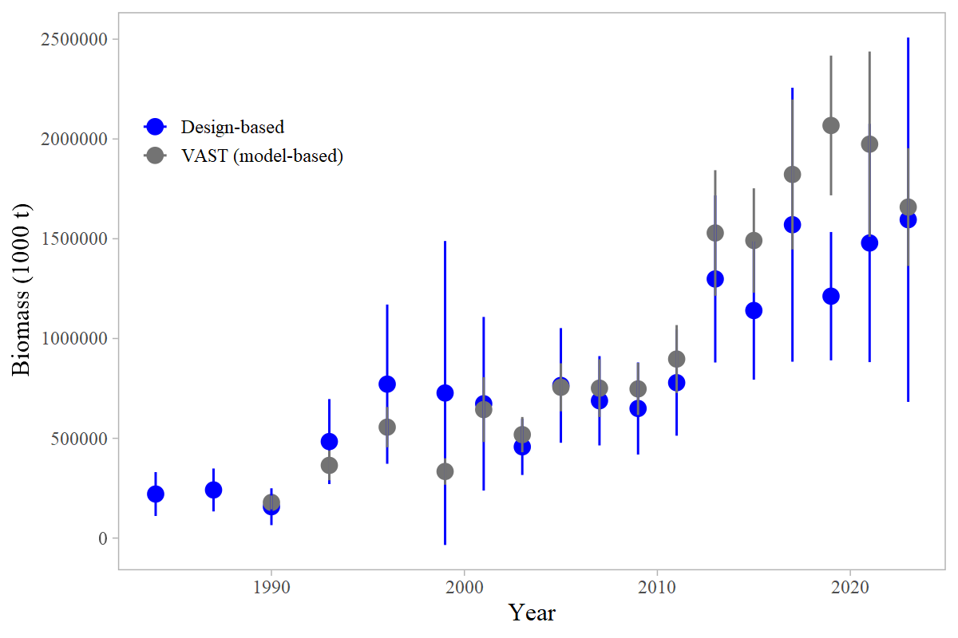

Figure 9.1. Comparison of indices of relative abundance derived from a model (VAST, grey points) or using the survey design (blue points). Vertical bars are 95% confidence intervals.

# Introduction

Operational Update: The reader is referred to the full operational stock assessment (Hulson et al. 2021) for the description of POP biology and life history.

# Fishery

Operational Update: The reader is referred to the last full operational stock assessment assessment (Hulson et al. 2021) for the full description of the POP fishery history, fishery effort and CPUE, and information regarding discarding.

Table 1 shows a time series of total catch, total ABC, total OFL and TAC. Relevant management measures are shown in Table 2.

# Data

Operational Update: The data description for POP has been truncated to highlight relevant updates or changes made for this cycle. The reader is referred to the last full assessment (Hulson et al. 2021) for the entirety of this section. There was a typographical error in the previous assessment where the Data table indicated that age compositions taken on NMFSC groundfish survey in 1984 and 1987 were included in the model; this was not the case and the table below has been corrected.

The following table summarizes the data used for this assessment.

| **Source** | **Data** | **Years** |
| --- | --- | --- |
| NMFS Groundfish survey | Survey biomass | 1990-1999 (triennial), 2001-2023 (biennial) |
| Age composition | 1990, 1993, 1996, 1999, 2003, 2005, 2007, 2009, 2011, 2013, 2015, 2017, 2019, 2021 |
| U.S. trawl fishery | Catch | 1961-2023 |
| Age composition | 1990, 1998-2002, 2004, 2005, 2006, 2008, 2010, 2012, 2014, 2016, 2018, 2020, 2022 |
| Length composition | 1963-1977, 1991-1997 |

## Fishery

Catches as used in the model are shown in Table 1; discards are not used in the model. Fishery-dependent compositional data (catch-at-length and catch-at-age, and associated input sample sizes) are shown in Tables 3 and 4, respectively.

## Survey

Survey biomass estimates and associated sampling variability (annual CVs) are shown in Table 5. Suvey compositional data (survey catch-at-age and associated input sample sizes) are shown in Table 6. This assessment includes a new survey observation for 2023, which was higher and more uncertain than the previous ten years of survey data. The increased uncertainty is attributed to a small number of unusually large trawls in the eastern Gulf.

## Other time series data used in the assessment

The input size-at-age matrices are time-varying in this assessment. The matrices corresponding to the recent time period are updated with the availability of new survey data. The parameters used to inform these matrices, and a comparison between previous and current values, are provided in the Modeling Section.

# Analytical approach

Operational Update: The data description for POP has been truncated to highlight relevant details and changes made for this cycle. The reader is referred to the last full assessment (Hulson et al. 2021) for the entirety of this section.

## General Model Structure

The model structure used for this Operational Update is unchanged from 2021. The POP assessment is a single-sex, age-structured statistical catch-at-age model written in AD Model Builder (see Fournier *et al.* (2012) for recent reference) as described in Courtney *et al.* (2007). Formulae for the population dynamics, observation, and likelihood components of the assessment model are presented in the Appendix.

## Description of Base Model

Given the change in lead authorship and results of the CIE review, this model is an Operational Update. The configuration matches the accepted model from 2021, with updated data. A full revision to the modeling framework is anticipated in the next cycle. There are no alternative models presented here.

## Parameters Estimated Outside the Assessment Model

Values estimated outside the assessment include the parameters of the von Bertalanffy growth curve ($L_{∞}$, $κ$, and $t_{0}$), intercept and slope parameters for a regression of length uncertainty versus age, and weight-at-age parameters ($w_{∞}$). Values used to specify the size-at-age probability matrices for the 1960s-1970s are unchanged. The values used to specify size-at-age probability matrices for the 1980s to present are updated using new age and length data from the trawl survey.

A comparison of these values is as follows:

| **Symbol, Description** | **2021 Value** | **Updated Value** |
| --- | --- | --- |
| $L_{∞}$, asymptotic length | 41.1 cm | unchanged |
| $κ$, growth rate | 0.18 $cmyr^{-1}$ | unchanged |
| $t_{0}$, age at length zero | -0.49 | -0.51 |
| $w_{∞}$, asymptotic weight | 901 g | 899 g |
| $k$, weight-at-age growth rate | 0.2 $kgyr^{-1}$ | unchanged |
| $t_{0}$, age at weight zero | -0.37 | -0.38 |
| $a$, $b$, slope and intercept of linear relationship between sd(length at age) and age, post 1980s | -0.02, 2.18 | -0.02, 2.17 |

An exploratory model was run wherein the 2021 size-at-age probability matrix for 1980-present was used instead of the updated matrix; estimated female spawning biomass and total (2+ biomass) for 2024 varied by less than 0.16%. Therefore, updating the length and age data from the 2023 trawl survey had minimal impact on model estimates of biomass.

## Parameters Estimated Inside the Assessment Model

The parameters estimated conditionally inside the assessment model are listed in the table below.

Parameters estimated within the assessment model.

| **Parameter** | **Symbol** | **Number** |
| --- | --- | --- |
| Natural mortality | $$M$$ | 1 |
| Survey catchability | $$q$$ | 1 |
| log(mean recruitment) | $$μ_{r}$$ | 1 |
| Recruitment variability | $$σ_{r}$$ | 1 |
| Spawner-per-recruit reference points | $F_{35\%}$, $F_{40\%}$, $F_{100\%}$ | 3 |
| Recruitment deviations | $$ϵ_{y}^{r}$$ | 89 |
| Average fishing mortality | $$μ_{f}$$ | 1 |
| Fishing mortality deviations | $$ϵ_{y}^{f}$$ | 63 |
| Fishery selectivity coefficients | $$s_{a}^{f}$$ | 6 |
| Survey selectivity coefficients | $$s_{a}^{t}$$ | 2 |
| Maturity-at-age coefficients | $${\hat{m}}_{a}$$ | 2 |
| Total |  | 170 |

Three parameters are estimated with priors: natural mortality ($M∼N\left(0.0661,0.00661\right)$), catchability ($q∼N\left(1,0.45\right)$), and the uncertainty in recruitment deviations ($σ_{r}∼N\left(1.7,0.11\right)$).

Fishery and survey selectivity are age-based. Fishery selectivity is time-blocked into four periods, corresponding with large-scale changes in the fishery and management structure (Table 2). The period from 1961-1976 is asymptotic (via a two-parameter logistic curve), and the three periods from 1977 onwards are each dome-shaped (via an averaged logistic gamma for the second block, and a gamma function for the third and fourth blocks, with two estimated parameters for each block). Bottom trawl survey selectivity is estimated to be asymptotic with a two-parameter logistic curve.

Maturity-at-age is conditionally estimated within the assessment following the method presented in Hulson et al. (2011). Parameter estimates for maturity-at-age are obtained by fitting two datasets collected on female POP maturity from Lunsford (1999) and Conrath and Knoth (2013). Parameters for the logistic function describing maturity-at-age are estimated conditionally within the model so that uncertainty in model results (e.g., ABC) can be linked to uncertainty in maturity parameter estimates.

# Model Uncertainty

Evaluation of model uncertainty is obtained through a Markov Chain Monte Carlo (MCMC) algorithm (Gelman and Rubin 1996). The chain length of the MCMC was 10,000,000 and was thinned to one iteration out of every 2,000. We omit the first 2,000,000 iterations to allow for a burn-in period. We use these MCMC methods to provide further evaluation of uncertainty in the results below including 95% credible intervals for some parameters (computed as the 5th and 95th percentiles of the MCMC samples).

# Selected Model Results

Operational Update: This section has been condensed to follow the newest guidelines for “Operational Update Assessments” to the best of the Authors’ ability. A minimal set of figures and tables are provided here; links to electronic files for supplementary data (e.g., numbers-at-age from the base model) are included in-text.

The model used in this assessment is the same as the model accepted in 2021 (Model 20.1) with updated data and parameter priors. Model 20.1 with data updated through 2023 generally results in reasonable fits to the data, estimates biologically plausible parameters, and produces consistent patterns in abundance compared to previous assessments. The assessment model continues to underestimate the trawl biomass since the 2013 survey, though the retrospective pattern indicates that the model trajectory continues to stabilize with additional assessments, despite the increasing survey observations.

## Model Evaluation

### Residual Analysis and Convergence Criteria

The model achieved convergence as defined by an invertible Hessian matrix and a low maximum gradient component (1e-4). Time-series plots of observed and predicted values, and the time-series of recruitment deviations, did not suggest unusual residual patterns, or different behavior than in previous assessments. The uncertainty around parameter estimates (obtained via MCMC, see below) and related derived quantities were in line with previous models.

### Parameter Estimates and Parameter Uncertainty

Table 7 lists all estimated parameters in the base model. It includes the associated asymptotic standard error estimates or other statistical measures of uncertainty. Time series of deviation parameters (fishing mortality rates $F$ for 1961-2023 and recruitment deviations from 1935-2023) are shown in Figures 9 and 10, respectively.

From the MCMC chains described in Model Uncertainty, we summarize the posterior densities of key parameters for the recommended model using histograms (Figure 8) and credible intervals (Table 7). We also use these posterior distributions to show uncertainty around time series estimates of survey biomass (Figure 4), total and spawning biomass, fully selected fishing mortality and recruitment (Figure 9).

Table 7 shows the maximum likelihood estimate (MLE) of key parameters with corresponding 95% credible intervals from the MCMC analysis. In 2021, a comparison between standard deviations derived from the Hessian matrix and MCMC indicated that uncertainty estimates were similar for $q$, $M$, and $F_{40\%}$, but the MCMC standard deviations were larger for the estimates of female spawning biomass and ABC. These larger standard deviations indicate that these parameters are more uncertain than indicated by the Hessian approximation. The distributions of these parameters with the exception of natural mortality are slightly skewed with higher means than medians for current spawning biomass and ABC, indicating possibilities of higher biomass estimates (Figure 9).

Likelihood profiles for $M$ are provided for the 2021 model in the Appendix.

### Time Series Results

*Definitions:* Spawning biomass is the estimated weight of mature females. Total biomass is the estimated weight of all POP age two and greater. Recruitment is measured as the number of age-2 POP. Fishing mortality is the mortality at the age the fishery has fully selected the fish.

Key results have been summarized in Table 8. Model predictions generally fit the data well (Figures .3 through 10.4). A comma-separated electronic file containing the estimated numbers-at-age is available at <https://github.com/pete-hulson/goa_pop/blob/main/2023/mgmt/2020.1-2023/processed/naa.csv>.

#### Biomass

Estimated total biomass gradually increased from a low near 85,000 t in 1980 to over 596,000 t at its peak in 2015 (Figure 9).The recent estimates of spawning biomass are nearly at historical levels prior to the 1970s. Both trajectories show a rapid increase since 1992, which coincides with an increase in uncertainty. MCMC credible intervals indicate that the historic low is reasonably certain while recent increases are less certain. Spawning biomass shows a similar trend (Figure 9). This is consistent with uncertainty in catchability $q$ (Figure 8), which informs the population scale after the onset of survey data in the later period. The high catchability for POP is supported by several empirical studies using line transect densities counted from a submersible compared to trawl survey densities (Krieger (1993), [$q$ =2.1], Krieger and Sigler (1996, $q$ =1.3), Jones *et al.* (2021, $q$ =1.15)). Spawning biomass and age-2+ total biomass have increased in response to fitting the large trawl survey biomass estimates since 2013 (Table 5, Figure 4).

Age of 50% selection is 5 for the survey and between 7 and 9 years for the fishery (Figure 11). Fish are fully selected by both the fishery and survey between ages 10 and 15. Current fishery selectivity is dome-shaped and with the addition of the recent time block after 2007 matches well with the ages caught by the fishery. Catchability is slightly lower (1.73) than the 2021 estimate (1.82).

#### Fishing Mortality

Figure 12, the ‘phase-plane’ plot, compares fishing mortality relative to the target reference point $F_{OFL}$ ($F_{35}$%) and spawning biomass relative to the corresponding biomass reference point $B_{OFL}$ ($B_{35}$%). It includes two years of projected $F$ and $B$. Fully-selected fishing mortality shows that fishing mortality has decreased dramatically from historic rates and has leveled out in the last decade (Figure 9). The fishing mortality rate for POP has been below the $F_{40}$% and biomass has been above $B_{40}$% since the mid 1980s.

#### Selectivity

The estimated selectivity curves are shown in Figure 11. The descending limb of the second-to-last time block (ending in 2006) is somewhat more domed (lower values) than the previous model, but the curves are otherwise similar.

#### Recruitment

Recruitment (as measured by age-2 fish) for POP is highly variable and large recruitment events comprise much of the biomass for future years (Figure 9). The model estimates that recruitment was below average from 1975-1985 (Figure 10), after which it was above average for many years. The survey age data and the large survey biomass observations from 2013 onwards suggest that there were strong year classes in 2008, 2010, 2012, 2014 and 2018 (Figure 10). However, these recent recruitment events are still uncertain as indicated by the MCMC credible intervals in Figure 10, some of which cross the zero (average) line. The high recruitment estimate of 2018 has been revised downwards from the 2021 assessment with the addition of survey and fishery ages through 2021 and 2022, respectively, and is now of a similar scale to earlier estimates.

POP do not seem to exhibit a stock-recruitment relationship because large recruitment has occurred during periods of high and low biomass (Figure 9 and Table 8). The POP model does not specify an explicit stock-recruitment relationship. The average annual recruitment (in numbers) spawned after 1976 is estimated to be 85 million.

### Retrospective and Historical Analysis

A within-model retrospective analysis of the recommended model was conducted for the last 10 years of the time series by dropping data one year at a time. The revised Mohn’s “rho” statistic in female spawning biomass was -0.153 (slightly smaller than the 2021 value of -0.16), and the trajectories and uncertainty intervals from MCMC for 2021 and 2023 are nearly identical (Figure 13). Across retrospective peels, SSB estimates have usually increased with the addition of new survey observations and the increases have been large (up to 30%), which is sensible given the large and uncertain survey biomass observations from the trawl survey since 2013. The 2023 SSB trajectory does not exhibit as dramatic of an increase from the 2021 nor 2022 retrospective peels, despite the addition of a new survey observation, likely due to the high uncertainty in that terminal estimate (Figure 4).

A historical comparison of key derived quantities from the base model and the most recent full assessment is shown in Figure 9. Parameter estimates and likelihood functions have remained similar to the 2021 model, and the MCMC-derived 95% credible intervals of the 2023 parameter estimates encompass the 2021 medians (Figure 9 and Tables 7, 9).

## Harvest recommendations

Operational Update: The description of Amendment 56 specifications for POP and details regarding the development of the Risk Table have been truncated to provide minimal background and highlight relevant updates or changes made for this cycle. The reader is referred to the last full assessment (Hulson et al. 2021) for the entirety of this section, including details on the projection approach.

### Amendment 56 Reference Points

POP in the GOA are managed under Tier 3 of Amendment 56. It is assumed that the equilibrium level of recruitment is equal to the average of age-2 recruitments between 1979 and 2021 (i.e., the 1977-2019 year classes). The most recent two years of recruitment are not included in the projection due to lack of data that would support these recruitment estimates. This definition of equilibrium recruitment is used to estimate the $B_{40}$ reference point. Other useful biomass reference points which can be calculated using this assumption are $B_{100}$ and $B_{35}$, defined analogously to $B_{40}$.

Female spawning biomass for 2024 is estimated at 228,030 t. This is above $B_{40}$ =137,447 t. Under Amendment 56, Tier 3, the maximum permissible fishing mortality for ABC is $F_{40}$ and fishing mortality for OFL is $F_{35}$. The 2024 estimates of biomass-based reference points, and the resultant ABC and OFL based on the fishing mortality rates are:

| **Reference Point** | **Description** | **Value** |
| --- | --- | --- |
| $$B_{100\%}$$ | The equilibrium spawning biomass that would be obtained in the absence of fishing | 343,618 t |
| $$B_{40\%}$$ | 40% of the equilibrium spawning biomass that would be obtained in the absence of fishing | 137,447 t |
| $$B_{35\%}$$ | 35% of the equilibrium spawning biomass that would be obtained in the absence of fishing | 120,266 t |
| $$F_{40\%}$$ | The fishing mortality rate that reduces the equilibrium level of spawning per recruit to 40% of the level that would be obtained in the absence of fishing | 0.1 |
| ABC | Yield at $F_{40\%}$ in 2024 | 39,719 t |
| $$F_{35\%}$$ | The fishing mortality rate that reduces the equilibrium level of spawning per recruit to 35% of the level that would be obtained in the absence of fishing | 0.12 |
| OFL | Yield at $F_{35\%}$ in 2024 | 47,466 t |

### Specification of OFL and Maximum Permissible ABC

#### Standard Harvest Scenarios (Harvest Projections)

A standard set of projections is required for each stock managed under Tier 3 of Amendment 56. This set of projections encompasses seven harvest scenarios designed to satisfy the requirements of Amendment 56, the National Environmental Policy Act, and the Magnuson-Stevens Fishery Conservation and Management Act (MSFCMA). They are as follows; the modifications made for the present assessment are indicated where appropriate.

The first five scenarios are designed to provide a range of harvest alternatives that are likely to bracket the final TAC for 2023, are as follow (“max $F_{ABC}$” refers to the maximum permissible value of $F_{ABC}$ under Amendment 56):

* *Scenario 1*: In all future years, $F$ is set equal to max $F_{ABC}$ (Rationale: Historically, TAC has been constrained by ABC, so this scenario provides a likely upper limit on future TACs.)
* *Scenario 2*: In 2024 and 2025, $F$ is set equal to a constant fraction of max $F_{ABC}$, where this fraction is equal to the ratio of the realized catches in 2020-2022 to the ABC (which is generally the same as the TAC) recommended in the assessment for each of those years. For the remainder of the future years, maximum permissible ABC is used. (Rationale: Using recent catch to ABC ratios will yield more realistic projections for the POP fishery, which rarely realizes its full TAC or ABC). The exact calculation of these values is shown below.
* *Scenario 3*: In all future years, $F$ is set equal to 50% of max $F_{ABC}$. (Rationale: This scenario provides a lower bound on $F_{ABC}$ that still allows future harvest rates to be adjusted downward when stocks fall below reference levels.)
* *Scenario 4*: In all future years, $F$ is set equal to the 2017-2021 average F. (Rationale: For some stocks, TAC can be well below ABC, and recent average $F$ may provide a better indicator of FTAC than $F_{ABC}$.)
* *Scenario 5*: In all future years, $F$ is set equal to zero. (Rationale: In extreme cases, TAC may be set at a level close to zero.)

Two other scenarios are needed to satisfy the MSFCMA’s requirement to determine whether a stock is currently in an overfished condition or is approaching an overfished condition. These two scenarios are as follows (for Tier 3 stocks, the MSY level is defined as $B_{35\%}$):

* *Scenario 6*: In all future years, $F$ is set equal to $F_{OFL}$. (Rationale: This scenario determines whether a stock is overfished. If the stock is expected to be above 1) above its MSY level in 2023 or 2) above ½ of its MSY level in 2023 and above its MSY level in 2033 under this scenario, then the stock is not overfished.) While Scenario 6 gives the best estimate of OFL for 2023, it does not provide the best estimate of OFL for 2024, because the mean 2023 catch under Scenario 6 is predicated on the 2023 catch being equal to the 2023 OFL, whereas the actual 2023 catch will likely be less than the 2023 OFL. The executive summary contains the appropriate one- and two-year ahead projections for both ABC and OFL.
* *Scenario 7*: In 2024 and 2025, $F$ is set equal to max $F_{ABC}$, and in all subsequent years $F$ is set equal to $F_{OFL}$. (Rationale: This scenario determines whether a stock is approaching an overfished condition. If the stock is 1) above its MSY level in 2025 or 2) above 1/2 of its *MSY* level in 2025 and expected to be above its MSY level in 2035 under this scenario, then the stock is not approaching an overfished condition.)

#### How Future Catches are Specified for Scenario 2 (Author’s F)

The method for specifying catches in years 2023 to 2025 has not changed from the 2021 assessment.

For Scenario 2 (*Author’s F*); we use pre-specified catches to increase accuracy of short-term projections in fisheries where the catch is usually less than the ABC. This was suggested to help management with setting preliminary ABCs and OFLs for two-year ahead specifications.

The method to calculate catches for this scenario is as follows:

1. In-year catches are defined as the catch through the beginning or middle of October (the specific date depends on when the data is pulled for the assessment model) expanded by the expected amount of catch to be taken for the remainder of the year. This expected catch is determined by taking the average of the total catch divided by the catch taken through the beginning or middle of October of the previous three complete years (2020 to 2022). The expansion factor for the observed catch through 2023 is 1.11; the estimated in-year catch for 2023 is 30,381 t.
2. For 2024 and 2025, predicted catch is given by the ratio of the last three catches to their respective TACs, multiplied by the TACs in future year $y^{*}$ given above (which are generally the same as the ABCs): $⟨\sum_{y-3}^{y-1}{\frac{C_{y}}{TAC_{y}}}⟩TAC_{y^{*}}$. The resultant average ratio from catch to TAC in the previous three years is 0.79; predicted catches for 2024 and 2025 are 31,454 t and 29,890 t, respectively.

Projected catches, spawning biomass, and fishing mortality rates corresponding to the alternative harvest scenarios over a 13-year period are shown in Tables 10 through 12.

## Risk Table and ABC recommendation

The SSC in its December 2018 minutes recommended that all assessment authors use the risk table when determining whether to recommend an ABC lower than the maximum permissible.

The risk table scoring for POP has not changed since 2021, with the exception that the 2021 SSC requested that the number of Risk Table categories (i.e., levels of concern) be reduced from four to three. Per leadership instruction in 2023, we have consolidated what were previously categories 2 and 3 (“substantially increased” and “major concern” into a single category, “increased/major concern”). This impacts the first two considerations, which were rated a level 2 in the 2021 Assessment.

| *Assessment-related considerations* | *Population dynamics considerations* | *Environmental/ecosystem considerations* | *Fishery Performance* |
| --- | --- | --- | --- |
| Level 2: Major concern | Level 2: Major concern | Level 1: No concern | Level 1: No concern |

An abridged summary of the considerations that led to this determination for each category follows.

### Assessment considerations

The GOA POP assessment model exhibits a strong negative retrospective pattern (spawning biomass continues to increase with new data), though this effect was less pronounced in the 2023, likely due to high uncertainty in the observed survey biomass. This is driven by ongoing increases in the trawl survey biomass, which have been consistently under-estimated since 2013, and may be suggestive of model misspecification.

*This results in a Level 2 assessment considerations rating, a major concern.*

### Population dynamics considerations

The model estimates above-average recruitment events in the last three decades to account for the increasing survey biomass observations (Figures 10.4, 10.9 and 10.10). The estimated recruitment events are still insufficient to satisfactorily fit the recent survey data; these increases are not observed in the early time series nor are they typical for an ecosystem that is warming (with the exception of sablefish).

The unusual trend of rapid increases in stock size and recruitment estimates *results in a Level 2 population dynamics rating, a major concern.*

### Environmental/Ecosystem considerations

This year, the GOA ecosystem was characterized by moderate thermal conditions, mixed trends for zooplankton abundance, moderate predation, and increased competition for zooplankton prey resources. The warmer surface waters predicted for 2024 may be favorable for POP larval survival. Ecosystem: While optimal temperatures for POP life stages are not known, it is reasonable to expect that the 2023 average ocean temperatures at depth on the shelf edge (for adults) and surface temperatures (for larvae) were adequate for POP. POP are semi-demersal/pelagic, outer shelf and continental slope (150-420 m depths) dwellers as adults, with a pelagic then inshore benthic juvenile stage (age 1 to 3) in the Gulf of Alaska (GOA) (Carlson and Haight 1976, Love et al. 2002, Rooper and Bolt 2005, Rooper et al. 2007, NPFMC 2010). There is evidence that POP are being observed higher in the water column, potentially a result of an expanding population. As warm spring temperatures are favorable for larval survival (Doyle 2009), cooler spring to above average summer temperatures varying from 5.8°C (WGOA Bottom Trawl Survey, O’Leary 2023) to 10.5°C (Icy Strait, SEAK, Fergusson 2023) were cooler than optimal, but not considered detrimental. While optimal temperatures are not known for adults, there is no indication of concern given bottom temperatures along the shelf edge in the GOA cooled to average in 2023 (AFSC longline survey: Siwicke 2023). Surface temperatures are predicted to warm in late winter/early spring of 2024, in alignment with El Niño conditions (Bond 2023). These warmer surface temperatures in April/May (larval release) may be favorable for larval survival. As it takes time for warm surface waters to extend to depth, shelf bottom temperatures are not expected to warm in the spring.

Prey: Planktivorous foraging conditions were average to below average across the GOA in 2023. The primary prey of the adult POP include calanoid copepods, euphausiids, myctophids, and miscellaneous prey in the GOA (Byerly 2001, Yang 2000, Yang 2003). POP body condition increased to average in 2023 after below average condition (i.e. lower weights at length) since 2015 (Bottom Trawl Survey, O’Leary, 2023b). The timing of this declining trend matches the time frame of increasing POP population since the 2014-2016 marine heatwave and could be explained by prey availability and competition within an expanding population. Zooplankton biomass in the WGOA progressed from below average in the spring (lower calanoid copepod biomass and higher euphausiid biomass) to improved conditions in the summer (above average biomass of large calanoid copepods and euphausiids, but continued lower small copepod biomass; Shelikof St., Kimmel 2023, and Seward Line, Hopcroft 2023). Summer planktivorous foraging conditions were somewhat improved with above average large calanoid copepod and euphausiid biomass, but continued lower small copepod biomass (Shelikof, Kimmel 2023). Eastern GOA inside waters had below average total zooplankton biomass, although euphuasiids were above average here as in the western GOA. Planktivorous seabird reproductive success, an indicator of zooplankton availability and nutritional quality, was approximately average south of Kodiak (Chowiet Isl.), and in the central GOA (Middleton Island on shelf edge off Seward) (Drummond 2023, Whelan 2023), and above average in the EGOA (St. Lazaria Isl.).

Predators & Competitors: Predation pressure is considered moderate and competition may have increased in 2023. Predators of juvenile POP include Pacific halibut, arrowtooth flounder, seabirds, rockfish, salmon, and lingcod (Moss 2016). Predators of adults include Pacific halibut, sablefish, and sperm whales (Moss 2016). Halibut and arrowtooth flounder populations remain low relative to previous levels, and, in general, there is no cause to suspect increased predation pressure on larval or adult demersal shelf rockfish. Potential competitors include large returns of pink salmon (Whitehouse, 2023, Vulstek, 2023), a relatively large and increasing population of walleye pollock, other POP as the population continues to increase, and continued large year classes of juvenile sablefish. POP are being found shallower in the water column, increasing their habitat overlap and potential competition for zooplankton prey with walleye pollock.

The most recent data available *result in a Level 1 ecosystem rating, no apparent concerns.*

#### References for Environmental & Ecosystem Considerations

Bond, N. 2023. Seasonal Projections from the National Multi-Model Ensemble (NMME). In Ferriss, B., 2023. Ecosystem Status Report 2023: Gulf of Alaska, Stock Assessment and Fishery Evaluation Report, North Pacific Fishery Management Council, 1007 West Third, Suite 400, Anchorage, Alaska 99501.

Byerly, M.M. 2001. Ecology of age-1 copper rockfish (*Sebastes caurinus*) in vegetated habitats of Sitka Sound, Alaska. M.S. Thesis. University of Alaska Fairbanks, Juneau, Alaska.

Carlson, H.R., and R.E. Haight. 1976. Juvenile life of Pacific ocean perch, *Sebastes alutus*, in coastal fiords of southeastern Alaska: their environment, growth, food habits, and schooling behavior. Trans. Am. Fish. Soc. 105:191-201.

Danielson, S., and R. Hopcroft. 2023. Ocean temperature synthesis: Seward line may survey. In Ferriss, B., 2023. Ecosystem Status Report 2023: Gulf of Alaska, Stock Assessment and Fishery Evaluation Report, North Pacific Fishery Management Council, 1007 West Third, Suite 400, Anchorage, Alaska 99501.

Doyle, M. J., Picquelle, S. J., Mier, K. L., Spillane, M. C., Bond, N. A. 2009. Larval fish abundance and physical forcing in the Gulf of Alaska, 1981-2003. Prog. Ocean. 80(3-4): 163-187.

Drummond, B., Kettle, A. and Renner, H. 2023. Seabird synthesis: Alaska Maritime National Wildlife Refuge data. In Ferriss, B., 2023. Ecosystem Status Report 2023: Gulf of Alaska, Stock Assessment and Fishery Evaluation Report, North Pacific Fishery Management Council, 1007 West Third, Suite 400, Anchorage, Alaska 99501.

Fergusson, E. and Strasburger, W. 2023. Long-term trends in zooplankton densities in Icy Strait, Southeast Alaska. In Ferriss, B., 2023. Ecosystem Status Report 2023: Gulf of Alaska, Stock Assessment and Fishery Evaluation Report, North Pacific Fishery Management Council, 1007 West Third, Suite 400, Anchorage, Alaska 99501.

Fergusson, E. and Strasburger, W. 2023. Ocean temperature synthesis: Southeast Coastal Monitoring Survey. In Ferriss, B., 2023. Ecosystem Status Report 2023: Gulf of Alaska, Stock Assessment and Fishery Evaluation Report, North Pacific Fishery Management Council, 1007 West Third, Suite 400, Anchorage, Alaska 99501.

Hinckley, S., et al. 2019. Connectivity between spawning and nursery areas for Pacific cod (*Gadus macrocephalus*) in the Gulf of Alaska. Deep Sea Research Part II: Topical Studies in Oceanography 165 (2019): 113-126.

Hopcroft, R. 2023. Seward Line: Large Copepod & Euphausiid Biomass. In Ferriss, B., 2023. Ecosystem Status Report 2023: Gulf of Alaska, Stock Assessment and Fishery Evaluation Report, North Pacific Fishery Management Council, 1007 West Third, Suite 400, Anchorage, Alaska 99501.

Kimmel, D., Axler, K., Cormack, B., Crouser, D., Fennie, W., Keister, J., Lamb, J., Pinger, C., Rogers, L., and Suryan, R. 2023. Current and Historical Trends for Zooplankton in the Western Gulf of Alaska. In Ferriss, B., 2023. Ecosystem Status Report 2023: Gulf of Alaska, Stock Assessment and Fishery Evaluation Report, North Pacific Fishery Management Council, 1007 West Third, Suite 400, Anchorage, Alaska 99501.

Love, M.S., M. Yoklavich, and L. Thorsteinson. 2002. The rockfishes of the northeast Pacific. U. of California Press. 405 pp.

Major, Richard L., and Herbert H. Shippen. 1970. Synopsis of biological data on Pacific ocean perch, Sebastodes alutus. FAO Fisheries Synopsis no.79

Monnahan, C.C., Dorn, M.W., Correa, G.M., Deary, A.L., Ferriss, B.E., Levine, M., McGowan, D.W., Rogers, L., Shotwell, S.K., Tyrell, A. and Zador, S. 2023. Assessment of the walleye pollock stock in the Gulf of Alaska. In Stock assessment and fishery evaluation report for the groundfish resources of the Gulf of Alaska, North Pacific Fishery Management Council, 1007 West Third, Suite 400, Anchorage, Alaska 99501.

Morgan, C.A., B.R., Beckman, L.A. Weitkamp, and K.L. Fresh. 2019. Recent ecosystem disturbance in the Northern California Current. Fisheries, 44(10), pp.465-474.

Moss, J. H., et al. 2016. Surviving the Gauntlet: A comparative study of the pelagic, demersal, and spatial linkages that determine groundfish recruitment and diversity in the Gulf of Alaska ecosystem. NPRB GOA Project G81 Upper Trophic Level Final Report). Anchorage, AK: North Pacific Research Board. NWAFC Processed Rep (2016): 88-21.

NPFMC (North Pacific Fishery Management Council). 2010. Essential Fish Habitat (EFH): 5-year review for 2010, Summary Report. North Pacific Fishery Management Council, 605 W. 4th Ave, suite 306. Anchorage, AK 99501.

O’Leary, C. 2023a. Ocean temperature synthesis: Bottom trawl survey. In Ferriss, B., 2023. Ecosystem Status Report 2023: Gulf of Alaska, Stock Assessment and Fishery Evaluation Report, North Pacific Fishery Management Council, 1007 West Third, Suite 400, Anchorage, Alaska 99501.

O’Leary, C. and Rohan, S. 2023b. Gulf of Alaska Groundfish Condition. In Ferriss, B., 2023. Ecosystem Status Report 2023: Gulf of Alaska, Stock Assessment and Fishery Evaluation Report, North Pacific Fishery Management Council, 1007 West Third, Suite 400, Anchorage, Alaska 99501.

Rooper, C.N. , J.L. Boldt, and M. Zimmermann. 2007. An assessment of juvenile Pacific Ocean perch (*Sebastes alutus*) habitat use in a deepwater nursery. Estuarine, Coastal and Shelf Science 75:371-380

Rooper, C.N. and J.L. Boldt. 2005. Distribution of juvenile Pacific ocean perch *Sebastes alutus* in the Aleutian Islands in relation to benthic habitat. Alaska Fisheries Research Bulletin 11(2):102-112.

Siwicke, K. 2023. Ocean temperature synthesis: Longline survey. In Ferriss, B., 2023. Ecosystem Status Report 2023: Gulf of Alaska, Stock Assessment and Fishery Evaluation Report, North Pacific Fishery Management Council, 1007 West Third, Suite 400, Anchorage, Alaska 99501.

Vulstek, S., Russell, J. R. 2023. Trends in survival of coho, sockeye, and pink salmon from Auke Creek, Southeast Alaska. In Ferriss, B., 2023. Ecosystem Status Report 2023: Gulf of Alaska, Stock Assessment and Fishery Evaluation Report, North Pacific Fishery Management Council, 1007 West Third, Suite 400, Anchorage, Alaska 99501.

Whelan, S., Hatch, S.A., Arimitsu, M., and Piatt, J.F. 2023. Seabird breeding performance on Middleton Island. In Ferriss, B., 2023. Ecosystem Status Report 2023: Gulf of Alaska, Stock Assessment and Fishery Evaluation Report, North Pacific Fishery Management Council, 1007 West Third, Suite 400, Anchorage, Alaska 99501.

Yang, M., and M.W. Nelson. 2000. Food habits of the commercially important groundfishes in the Gulf of Alaska in 1990, 1993, and 1996. U. S. Dep. Commer. NOAA Tech. Memo. NMFS-AFSC- 112, 174 p.

Yang, M-S. 2003. Food habits of important groundfishes in the Aleutian Islands in 1994 and 1997. U.S. Dep. Commer., AFSC Processed Report 203-07., 233 p.

### Fishery performance

There have been no recent changes to spatial distribution of catch, percent of TAC taken, or fishing duration. There are no indications of adverse signals or concerns about the fishery in terms of resource-use, performance, or behavior.

*Fishery Performance for POP is scored as Level 1 (normal concern)*.

### Risk Table Summary and ABC recommendation

*We do not recommend a reduction in ABC because the retrospective pattern in this assessment indicates an increasing population abundance and the population is well above* B*40%.* We acknowledge that the current assessment model does not appropriately explain these dynamics at present.

### Area Allocation of Harvests

#### Overview

Apportionment of ABC and OFL among regulatory areas uses the random effects model (“REMA” version 0.1.0) developed by Sullivan et. al. (2022); these estimates are then subdivided further to account for closed areas in the Eastern Gulf. The Eastern Gulf is comprised of two sub-areas for apportionment purposes: the area west of ${140}^{∘}W$ longitude (“West Yakutat”) and the area east and southeast of ${140}^{∘}W$ longitude (“East Yakutat and Southeast Outside”, or “SEO”). Amendment 41 prohibited trawling in the latter area, so we re-calculate apportionment for the Eastern Gulf to consider the ratio of biomass both within and outside of the closed area. The Groundfish Plan Team recommended use of a weighted average so apportionment values do not change too dramatically with each new survey observation.

The workflow to calculate allocation is as follows:

1. Apply the REMA model to estimate random effects parameters that control the variation of estimated biomass across years and areas, and is fit to the trawl survey biomass estimates (with associated variance) for the Western, Central, and Eastern GOA. The REMA model fits the survey data in each area well, except for the terminal value in the Eastern GOA, which is under-fit (see figure below). That observation is far outside the previous time series for that region, and the uncertainty is higher than previously observed. Both the observations and predictions indicate that most biomass is in the Central Gulf; biomass has decreased in the Central and Western Gulf, and increased in the Eastern Gulf. The estimated apportionment among areas have changed accordingly: 4.5% for the Western area (down from 6.8% in 2021), 72.4% for the Central area (down from 80.5% in 2021), and 23.1% for the Eastern area (up from 12.7% in 2021).

These apportionment percentages correspond to recommended 2024 ABCs of 1,787 t for the Western area, 28,757 t for the Central area, and 9,175 t for the Eastern area.

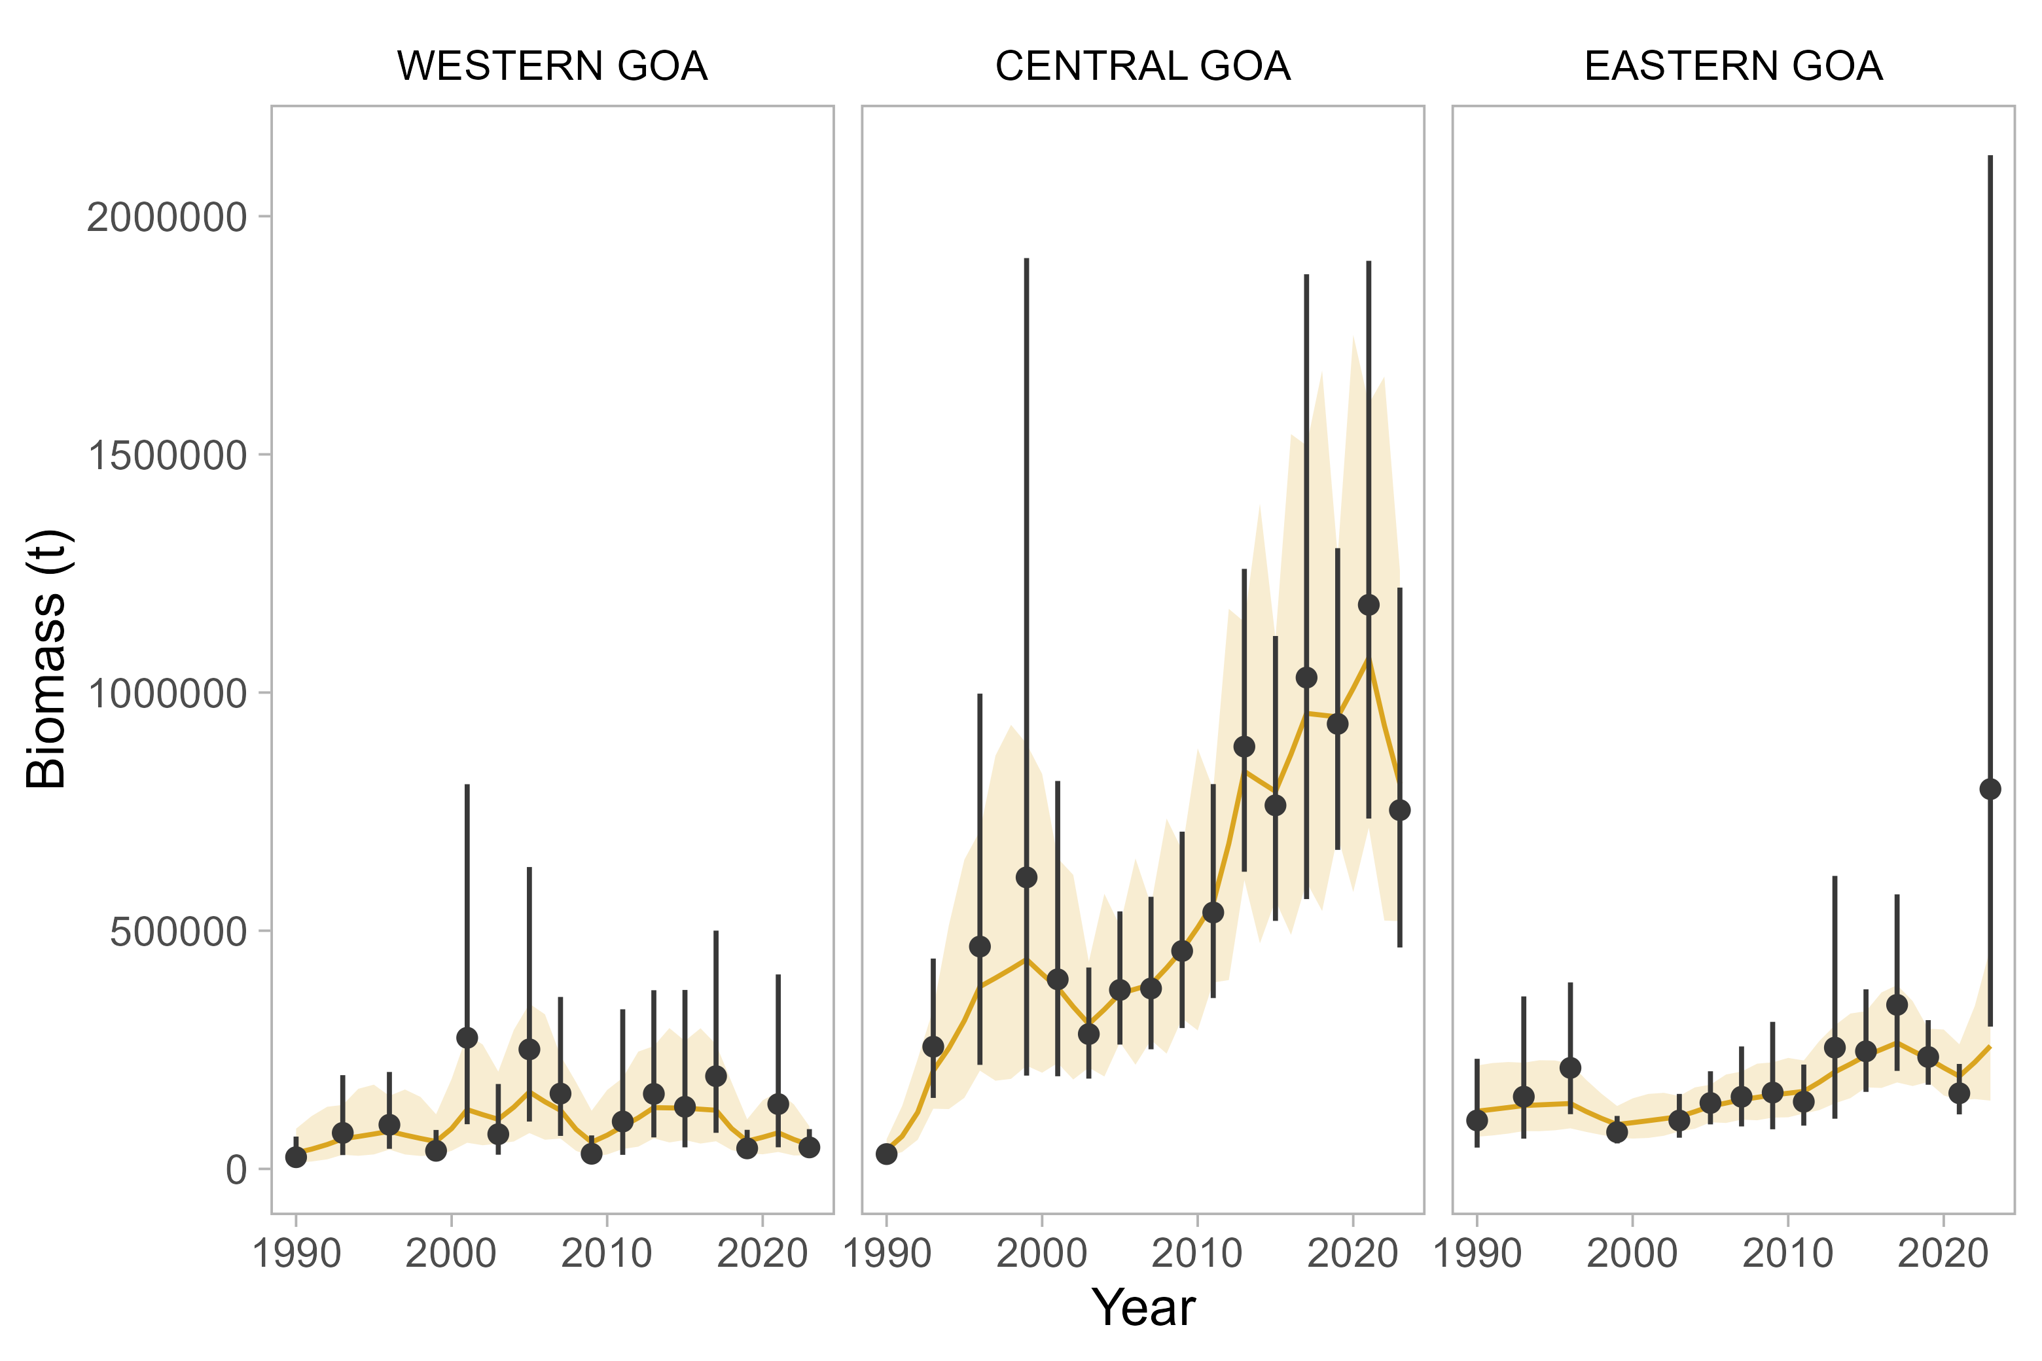

Figure 9.2. Observed survey biomass with 95% confidence intervals (black points and error bars), and estimated fits from the REMA model with 95% confidence intervals (gold lines and ribbon) for three areas of the Gulf of Alaska.

1. Obtain the biomass ratios in the Eastern GOA between the open and closed areas (W. Yakutat versus E. Yakutat/SEO) from the last three calendar years (These ratios are provided by the survey program and are accessed via AKFIN). Using these values, first calculate a 4:6:9 weighted average of the mean ($μ_{w}$) and upper limit of the 95% confidence interval ($σ_{w}$) for the W. Yakutat biomass ratio (assigning greater weight to more recent surveys). Then calculate a total ratio for use in apportionment via $μ_{w}=2\sqrt{σ_{w}}$. The ratio for 2024 using survey observations from 2019, 2021, 2023 is 0.22, down from the ratio of 0.29 used in 2021.

Applying the biomass ratio to the 2024 ABC for the Eastern Gulf results in an ABC apportionment of 2,110 t to the W. Yakutat area, with 7,065 t unharvested in the E. Yakutat/SEO. The 2024 OFL for POP, where $F_{OFL}$ = $F_{35\%}$ =0.12), is 47,466. Using the same approach as for ABCs, the 2024 OFL for the Western Gulf, Central Gulf, and W. Yakutat[1] is 39,023 t and 8,443 t in the Southeast/Outside area.

### Status Determination

The status definitions under the MSFCMA have been truncated from this report.

#### Overfishing

The official catch estimate for the most recent complete year (2022) is 29,484 t. This is less than the 2022 OFL of 45,580 t. *The stock is not subject to overfishing.*

#### Overfished (Harvest Scenario 6)

The minimum stock size threshold (MSST) for POP is given by the $B_{35\%}$ which is 120,266 in 2023. The estimated stock spawning biomass in 2023 is nearly double the MSST at 228,030. *The stock is not overfished*.

#### Approaching Overfished (Harvest Scenario 7)

The mean estimated stock spawning biomass in 2025 is above the MSST. *The stock is not approaching an overfished state*.

# Ecosystem Considerations

Operational Update: The Ecosystem Considerations for POP are unchanged. The reader is referred to the last full assessment (Hulson et al., 2021) for the entirety of this section, which has been summarized below. The Fishery Impacts on the Ecosystem and GOA Rockfish Economic Performance Report for 2020 have been removed from this document.

In general, a determination of ecosystem considerations for POP is hampered by the lack of biological and habitat information.

## Ecosystem Effects on the Stock

**Prey availability/abundance trends**: Similar to many other rockfish species, stock condition of POP appears to be influenced by periodic abundant year classes. Availability of suitable zooplankton prey items in sufficient quantity for larval or post-larval POP may be an important determining factor of year class strength.

**Predator population trends**: POP are preyed upon by a variety of other fish at all life stages, and to some extent marine mammals during late juvenile and adult stages. Whether the impact of any particular predator is significant or dominant is unknown.

**Changes in physical environment**: Stronger year classes corresponding to the period around 1977 have been reported for many species of groundfish in the GOA, including POP, northern rockfish, sablefish, and Pacific cod. Therefore, it appears that environmental conditions may have changed during this period in such a way that survival of young-of-the-year fish increased for many groundfish species, including slope rockfish. POP appeared to have strong 1986-88 year classes, and there may be other years when environmental conditions were especially favorable for rockfish species. The environmental mechanism for this increased survival remains unknown.

# Data Gaps and Research Priorities

Operational Update: The reader is referred to the last full stock assessment (Hulson et al., 2021) for the entirety of the POP Data Gaps and Research Priorities section.

# Acknowledgements

The authors would like to acknowledge fruitful discussions with P. Spencer and the input of the 2023 September Groundfish Plan Team, as well as a review by C. Lunsford.

# References

Courtney, D.L., Ianelli, J., Hanselman, D. and Heifetz, J. (2007) [Extending statistical age-structured assessment approaches to gulf of alaska rockfish (sebastes spp.)](https://doi.org/10.4027/bamnpr.2007.24).pp 429–449.

Fournier, D.A., Skaug, H.J., Ancheta, J., et al. (2012) [AD model builder: Using automatic differentiation for statistical inference of highly parameterized complex nonlinear models](https://doi.org/10.1080/10556788.2011.597854). *Optimization Methods and Software* 27, 233–249.

Gelman, A. and Rubin, D.B. (1996) [Markov chain monte carlo methods in biostatistics](https://doi.org/10.1177/096228029600500402). *Statistical Methods in Medical Research* 5, 339–355.

Hulson, P.-J.F., Williams, B., Fissel, B.E., Ferriss, Bridget E., Hall, Madison, Yasumiishi, Ellen M. and Jones, D.T. (2021) Assessment of the Pacific ocean perch stock in the Gulf of Alaska. In: *Stock assessment and fishery evaluation report for the groundfish resources of the Gulf of Alaska*. North Pacific Fishery Management Council, Anchorage, AK.

Hulson, P.-J.F., Williams, B., Siskey, M., Bryan, M. and Conner, J. (2023) Bottom trawl survey age and length composition input sample sizes for stocks assessed with statistical catch-at-age assessment models at the Alaska Fisheries Science Center. *U.S. Department of Commerce. NOAA Technical Memorandum NMFS-AFSC-470*, 38 p.

Jones, D.T., Rooper, C.N., Wilson, C.D., Spencer, P.D., Hanselman, D.H. and Wilborn, R.E. (2021) [Estimates of availability and catchability for select rockfish species based on acoustic-optic surveys in the gulf of alaska](https://doi.org/10.1016/j.fishres.2020.105848). *Fisheries Research* 236, 105848.

Krieger, K. (1993) Distribution and abundance of rockfish determined from a submersible and by bottom trawling. *Fish. Bull.* 91, 87–96.

Krieger, K. and Sigler, M. (1996) Catchability coefficient for rockfish estimated from trawl and submersible surveys. 94.

Methot, R.D. and Wetzel, C.R. (2013) [Stock synthesis: A biological and statistical framework for fish stock assessment and fishery management](https://doi.org/10.1016/j.fishres.2012.10.012). *Fisheries Research* 142, 86–99.

Sullivan, J., C. Monnahan, P. Hulson, J. Ianelli, J. Thorson, and A. Havron. 2022a. REMA: a consensus version of the random effects model for ABC apportionment and Tier 4/5 assessments. Plan Team Report, Joint Groundfish Plan Teams, North Pacific Fishery Management Council. 605 W 4th Ave, Suite 306 Anchorage, AK 99501. [Available through the Oct 2022 Joint GPT e-Agenda](https://meetings.npfmc.org/CommentReview/DownloadFile?p=eaa760cf-8a4e-4c05-aa98-82615da1982a.pdf&fileName=Tier%204_5%20Random%20Effects.pdf).

Wetzel, C., Cronin-Fine, L. and Johnson, K. (2017) Status of Pacific ocean perch( Sebastes alutus) along the US west coast in 2017. Pacific Fishery Management Council, Anchorage, AK.

# Auxiliary Files

The associated ADMB model files to conduct the base assessment model are available at <https://github.com/pete-hulson/goa_pop/tree/main/2023/mgmt/2020.1-2023>. A script to reproduce this assessment (including profiles, MCMC analyses, retrospectives, projections, and apportionment) is available at <https://github.com/pete-hulson/goa_pop/blob/main/2023/R/2023_analysis.R>.

# Tables

Table 9.1. Commercial catch (t) of POP in the GOA, with Gulf-wide values of acceptable biological catch (ABC) and fishing quotas (t), 1977-2023 (2023 catch as of 9/25/2023). Note: There were no foreign or joint venture catches after 1988. Catches prior to 1989 are landed catches only. Catches in 1989 and 1990 also include fish reported in weekly production reports as discarded by processors. Catches in 1991-2019 also include discarded fish, as determined through a blend of weekly production reports and information from the domestic observer program. Definitions of terms: Catch defined as follows: 1977, all Sebastes rockfish for Japanese catch, and POP for catches of other nations; 1978, POP only; 1979-87, the 5 species comprising the POP complex; 1988-2019, POP. Quota defined as follows: 1977-86, optimum yield; 1987, target quota; 1988-2019 total allowable catch. Sources: Catch: 1977-84, Carlson et al. (1986); 1985-88, Pacific Fishery Information Network (PacFIN); 1989-2019, National Marine Fisheries Service, Alaska Region. ABC and Quota: 1977-1986 Karinen and Wing (1987); 1987-1990, Heifetz et al. (2000); 1991-2019, NMFS AKRO BLEND/Catch Accounting System via AKFIN database.

|  |  |  |  |  |  |  |  |  |  |  |  |
| --- | --- | --- | --- | --- | --- | --- | --- | --- | --- | --- | --- |
| **Year** | **Total** | **ABC** | **Quota** | **Year** | **Total** | **ABC** | **Quota** | **Year** | **Total** | **ABC** | **Quota** |
| 1977 | 23,453 | 50,000 | 30,000 | 1996 | 8,379 | 8,060 | 6,959 | 2015 | 18,733 | 21,012 | 21,012 |
| 1978 | 8,176 | 50,000 | 25,000 | 1997 | 9,519 | 12,990 | 9,190 | 2016 | 23,035 | 24,437 | 24,437 |
| 1979 | 9,921 | 50,000 | 25,000 | 1998 | 8,908 | 12,820 | 10,776 | 2017 | 23,861 | 23,918 | 23,918 |
| 1980 | 12,471 | 50,000 | 25,000 | 1999 | 10,473 | 13,120 | 12,590 | 2018 | 24,736 | 29,236 | 29,236 |
| 1981 | 12,184 | 50,000 | 25,000 | 2000 | 10,145 | 13,020 | 13,020 | 2019 | 25,470 | 28,555 | 28,555 |
| 1982 | 7,991 | 50,000 | 11,475 | 2001 | 10,817 | 13,510 | 13,510 | 2020 | 25,191 | 31,238 | 31,238 |
| 1983 | 4,705 | 50,000 | 11,475 | 2002 | 11,734 | 13,190 | 13,190 | 2021 | 25,149 | 36,177 | 36,177 |
| 1984 | 4,452 | 50,000 | 11,475 | 2003 | 10,846 | 13,663 | 13,660 | 2022 | 29,484 | 38,268 | 38,268 |
| 1985 | 1,087 | 11,474 | 6,083 | 2004 | 11,640 | 13,336 | 13,340 | 2023 | 28,812 | 37,193 | 37,193 |
| 1986 | 2,981 | 10,500 | 3,702 | 2005 | 11,248 | 13,575 | 13,580 |  |  |  |  |
| 1987 | 1,981 | 10,500 | 5,000 | 2006 | 13,595 | 14,261 | 14,261 |  |  |  |  |
| 1988 | 13,779 | 16,800 | 16,800 | 2007 | 12,955 | 14,636 | 14,635 |  |  |  |  |
| 1989 | 19,003 | 20,000 | 20,000 | 2008 | 12,461 | 14,999 | 14,999 |  |  |  |  |
| 1990 | 21,140 | 17,700 | 17,700 | 2009 | 12,986 | 15,111 | 15,111 |  |  |  |  |
| 1991 | 6,548 | 5,800 | 5,800 | 2010 | 15,616 | 17,584 | 17,584 |  |  |  |  |
| 1992 | 6,538 | 5,730 | 5,200 | 2011 | 14,224 | 16,997 | 16,997 |  |  |  |  |
| 1993 | 2,060 | 3,378 | 2,560 | 2012 | 14,916 | 16,918 | 16,918 |  |  |  |  |
| 1994 | 1,842 | 3,030 | 2,550 | 2013 | 13,182 | 16,412 | 16,412 |  |  |  |  |
| 1995 | 5,740 | 6,530 | 5,630 | 2014 | 17,712 | 19,309 | 19,309 |  |  |  |  |

Table 9.2. Management measures since the break out of POP from slope rockfish.

| Year | Catch (t) | ABC (t) | TAC (t) | OFL (t) | Management Measures |
| --- | --- | --- | --- | --- | --- |
| 1988 | 1,621 | 16,800 | 16,800 |  | The slope rockfish assemblage, including POP, was one of three management groups for Sebastes implemented by the North Pacific Management Council. Previously, Sebastes in Alaska were managed as POP complex or other rockfish. |
| 1989 | 19,003 | 20,000 | 20,000 |  |  |
| 1990 | 21,140 | 17,700 | 17,700 |  |  |
| 1991 | 6,548 | 5,800 |  |  | Slope assemblage split into three management subgroups with separate ABCs and TACs: POP, shortraker/rougheye rockfish, and all other slope species |
| 1992 | 6,538 | 5,730 | 5,200 |  |  |
| 1993 | 2,060 | 3,378 | 2,560 |  |  |
| 1994 | 1,842 | 3,030 | 2,550 | 3,940 | Amendment 32 establishes rebuilding plan |
|  |  |  |  |  | Assessment done with an age structured model using stock synthesis |
| 1995 | 5,740 | 6,530 | 5,630 | 8,232 |  |
| 1996 | 8,379 | 8,060 | 6,959 | 10,165 |  |
| 1997 | 9,519 | 12,990 | 9,190 | 19,760 |  |
| 1998 | 8,908 | 12,820 | 10,776 | 18,090 |  |
| 1999 | 10,473 | 13,120 | 12,590 | 18,490 | Eastern Gulf divided into West Yakutat and East Yakutat/Southeast Outside and separate ABCs and TACs assigned |
| 2000 | 10,145 | 13,020 | 13,020 | 15,390 | Amendment 41 became effective which prohibited trawling in the Eastern Gulf east of 140 degrees W. |
| 2001 | 10,817 | 13,510 | 13,510 | 15,960 | Assessment is now done using an age structured model constructed with AD Model Builder software |
| 2002 | 11,734 | 13,190 | 13,190 | 15,670 |  |
| 2003 | 10,846 | 13,663 | 13,660 | 16,240 |  |
| 2004 | 11,640 | 13,336 | 13,340 | 15,840 |  |
| 2005 | 11,248 | 13,575 | 13,575 | 16,266 |  |
| 2006 | 13,595 | 14,261 | 14,261 | 16,927 |  |
| 2007 | 12,955 | 14,636 | 14,636 | 17,158 | Amendment 68 created the Central Gulf Rockfish Pilot Project |
| 2008 | 12,461 | 14,999 | 14,999 | 17,807 |  |
| 2009 | 12,986 | 15,111 | 15,111 | 17,940 |  |
| 2010 | 15,616 | 17,584 | 17,584 | 20,243 |  |
| 2011 | 14,224 | 16,997 | 16,997 | 19,566 |  |
| 2012 | 14,916 | 16,918 | 16,918 | 19,498 |  |
| 2013 | 13,182 | 16,412 | 16,412 | 18,919 | Area OFL for W/C/WYK combined, SEO separate |
| 2014 | 17,712 | 19,309 | 19,309 | 22,319 |  |
| 2015 | 18,733 | 21,012 | 21,012 | 24,360 |  |
| 2016 | 23,035 | 24,437 | 24,437 | 28,431 |  |
| 2017 | 23,861 | 23,918 | 23,918 | 27,826 |  |
| 2018 | 24,736 | 29,236 | 29,236 | 34,762 |  |
| 2019 | 25,470 | 28,555 | 28,555 | 33,951 |  |
| 2020 | 25,191 | 31,238 | 31,238 | 37,092 |  |
| 2021 | 25,149 | 36,177 | 36,177 | 42,977 |  |
| 2022 | 29,484 | 38,268 | 38,268 | 45,580 |  |
| 2023* | 28,812 | 37,193 | 37,193 | 48,161 |  |

Table 9.3. Fishery length frequency data for POP in the GOA for the most recent 10 complete years used in the model. Input sample sizes (square root of nominal sample size scaled with a maximum of 100) are in parentheses.

| Length (cm) | 1973 (24) | 1974 (43) | 1975 (42) | 1976 (41) | 1977 (35) | 1991 (29) | 1992 (28) | 1995 (20) | 1996 (26) | 1997 (30) |
| --- | --- | --- | --- | --- | --- | --- | --- | --- | --- | --- |
| 16 | 0.000 | 0.000 | 0.000 | 0.000 | 0.000 | 0.002 | 0.004 | 0.000 | 0.000 | 0.002 |
| 17 | 0.000 | 0.000 | 0.000 | 0.000 | 0.000 | 0.002 | 0.002 | 0.000 | 0.000 | 0.002 |
| 18 | 0.000 | 0.000 | 0.000 | 0.000 | 0.000 | 0.001 | 0.002 | 0.000 | 0.000 | 0.005 |
| 19 | 0.000 | 0.000 | 0.000 | 0.000 | 0.000 | 0.004 | 0.003 | 0.000 | 0.000 | 0.002 |
| 20 | 0.001 | 0.000 | 0.000 | 0.000 | 0.000 | 0.009 | 0.002 | 0.000 | 0.000 | 0.002 |
| 21 | 0.001 | 0.000 | 0.000 | 0.001 | 0.001 | 0.011 | 0.004 | 0.000 | 0.000 | 0.002 |
| 22 | 0.002 | 0.000 | 0.000 | 0.002 | 0.001 | 0.011 | 0.005 | 0.000 | 0.000 | 0.002 |
| 23 | 0.003 | 0.001 | 0.001 | 0.005 | 0.003 | 0.017 | 0.005 | 0.001 | 0.000 | 0.003 |
| 24 | 0.008 | 0.002 | 0.002 | 0.010 | 0.005 | 0.019 | 0.007 | 0.003 | 0.001 | 0.002 |
| 25 | 0.019 | 0.002 | 0.003 | 0.015 | 0.007 | 0.019 | 0.009 | 0.005 | 0.002 | 0.004 |
| 26 | 0.033 | 0.004 | 0.006 | 0.021 | 0.010 | 0.025 | 0.009 | 0.010 | 0.002 | 0.005 |
| 27 | 0.054 | 0.010 | 0.011 | 0.030 | 0.016 | 0.020 | 0.011 | 0.008 | 0.003 | 0.008 |
| 28 | 0.073 | 0.018 | 0.019 | 0.042 | 0.025 | 0.015 | 0.011 | 0.007 | 0.004 | 0.009 |
| 29 | 0.078 | 0.025 | 0.029 | 0.056 | 0.032 | 0.016 | 0.016 | 0.010 | 0.006 | 0.011 |
| 30 | 0.086 | 0.032 | 0.045 | 0.078 | 0.046 | 0.014 | 0.023 | 0.010 | 0.009 | 0.016 |
| 31 | 0.099 | 0.039 | 0.064 | 0.095 | 0.067 | 0.021 | 0.036 | 0.020 | 0.018 | 0.018 |
| 32 | 0.103 | 0.048 | 0.079 | 0.100 | 0.088 | 0.033 | 0.057 | 0.039 | 0.029 | 0.024 |
| 33 | 0.098 | 0.069 | 0.096 | 0.103 | 0.104 | 0.048 | 0.103 | 0.081 | 0.066 | 0.044 |
| 34 | 0.084 | 0.094 | 0.108 | 0.099 | 0.110 | 0.077 | 0.144 | 0.128 | 0.125 | 0.074 |
| 35 | 0.068 | 0.123 | 0.115 | 0.091 | 0.112 | 0.096 | 0.152 | 0.149 | 0.171 | 0.120 |
| 36 | 0.055 | 0.142 | 0.117 | 0.083 | 0.109 | 0.110 | 0.129 | 0.150 | 0.178 | 0.149 |
| 37 | 0.046 | 0.140 | 0.107 | 0.068 | 0.094 | 0.100 | 0.097 | 0.124 | 0.152 | 0.151 |
| 38 | 0.037 | 0.115 | 0.085 | 0.047 | 0.072 | 0.091 | 0.066 | 0.092 | 0.099 | 0.119 |
| 39 | 0.024 | 0.073 | 0.056 | 0.028 | 0.047 | 0.084 | 0.040 | 0.056 | 0.056 | 0.081 |
| 40 | 0.013 | 0.036 | 0.030 | 0.015 | 0.027 | 0.061 | 0.026 | 0.035 | 0.033 | 0.057 |
| 41 | 0.007 | 0.015 | 0.014 | 0.007 | 0.013 | 0.042 | 0.015 | 0.021 | 0.019 | 0.037 |
| 42 | 0.004 | 0.005 | 0.005 | 0.003 | 0.005 | 0.028 | 0.010 | 0.016 | 0.013 | 0.023 |
| 43 | 0.003 | 0.002 | 0.002 | 0.001 | 0.003 | 0.012 | 0.005 | 0.009 | 0.007 | 0.015 |
| 44 | 0.001 | 0.001 | 0.002 | 0.000 | 0.001 | 0.006 | 0.003 | 0.006 | 0.003 | 0.008 |
| 45+ | 0.000 | 0.004 | 0.004 | 0.000 | 0.001 | 0.007 | 0.003 | 0.019 | 0.004 | 0.008 |

Table 9.4. Fishery age frequency data for POP in the GOA for the most recent 10 complete years used in the model. Input sample sizes (square root of nominal sample size) are in parentheses.

| Age (yr) | 2005 (26) | 2006 (28) | 2008 (25) | 2010 (25) | 2012 (32) | 2014 (29) | 2016 (34) | 2018 (32) | 2020 (32) | 2022 (34) |
| --- | --- | --- | --- | --- | --- | --- | --- | --- | --- | --- |
| 2 | 0.000 | 0.000 | 0.000 | 0.000 | 0.000 | 0.000 | 0.000 | 0.000 | 0.000 | 0.000 |
| 3 | 0.002 | 0.000 | 0.000 | 0.000 | 0.000 | 0.000 | 0.000 | 0.000 | 0.002 | 0.000 |
| 4 | 0.002 | 0.002 | 0.002 | 0.013 | 0.022 | 0.014 | 0.005 | 0.007 | 0.003 | 0.001 |
| 5 | 0.011 | 0.001 | 0.003 | 0.008 | 0.030 | 0.004 | 0.004 | 0.010 | 0.006 | 0.006 |
| 6 | 0.020 | 0.049 | 0.031 | 0.022 | 0.021 | 0.039 | 0.021 | 0.042 | 0.026 | 0.016 |
| 7 | 0.085 | 0.091 | 0.033 | 0.019 | 0.025 | 0.053 | 0.023 | 0.006 | 0.051 | 0.015 |
| 8 | 0.083 | 0.118 | 0.098 | 0.068 | 0.031 | 0.038 | 0.068 | 0.058 | 0.054 | 0.040 |
| 9 | 0.103 | 0.107 | 0.100 | 0.070 | 0.046 | 0.035 | 0.089 | 0.063 | 0.054 | 0.070 |
| 10 | 0.144 | 0.083 | 0.161 | 0.117 | 0.088 | 0.060 | 0.072 | 0.122 | 0.071 | 0.088 |
| 11 | 0.116 | 0.106 | 0.109 | 0.146 | 0.102 | 0.078 | 0.050 | 0.105 | 0.081 | 0.057 |
| 12 | 0.077 | 0.092 | 0.048 | 0.119 | 0.112 | 0.093 | 0.059 | 0.047 | 0.064 | 0.058 |
| 13 | 0.048 | 0.059 | 0.093 | 0.073 | 0.089 | 0.077 | 0.059 | 0.047 | 0.057 | 0.049 |
| 14 | 0.045 | 0.034 | 0.053 | 0.057 | 0.091 | 0.064 | 0.052 | 0.036 | 0.041 | 0.044 |
| 15 | 0.020 | 0.035 | 0.043 | 0.051 | 0.051 | 0.074 | 0.066 | 0.035 | 0.041 | 0.041 |
| 16 | 0.030 | 0.033 | 0.023 | 0.040 | 0.044 | 0.063 | 0.079 | 0.036 | 0.043 | 0.023 |
| 17 | 0.051 | 0.022 | 0.025 | 0.038 | 0.050 | 0.047 | 0.066 | 0.052 | 0.045 | 0.032 |
| 18 | 0.041 | 0.041 | 0.012 | 0.021 | 0.035 | 0.036 | 0.049 | 0.065 | 0.042 | 0.032 |
| 19 | 0.032 | 0.029 | 0.027 | 0.014 | 0.025 | 0.041 | 0.034 | 0.046 | 0.048 | 0.035 |
| 20 | 0.025 | 0.027 | 0.027 | 0.014 | 0.023 | 0.032 | 0.027 | 0.036 | 0.060 | 0.037 |
| 21 | 0.025 | 0.031 | 0.028 | 0.017 | 0.015 | 0.014 | 0.033 | 0.027 | 0.032 | 0.044 |
| 22 | 0.012 | 0.009 | 0.026 | 0.035 | 0.016 | 0.021 | 0.032 | 0.022 | 0.035 | 0.051 |
| 23 | 0.008 | 0.014 | 0.019 | 0.011 | 0.011 | 0.014 | 0.020 | 0.031 | 0.023 | 0.035 |
| 24 | 0.006 | 0.007 | 0.013 | 0.006 | 0.006 | 0.019 | 0.013 | 0.023 | 0.021 | 0.039 |
| 25+ | 0.012 | 0.011 | 0.027 | 0.042 | 0.068 | 0.084 | 0.081 | 0.084 | 0.100 | 0.188 |

Table 9.5. Biomass estimates (t) with coefficient of variation (CV) for gulf-wide total biomass for POP in the GOA from trawl surveys after 1990. The 2001 survey did not sample the eastern GOA (the Yakutat and Southeastern areas). Substitute estimates of biomass for the Yakutat and Southeastern areas were obtained by averaging the biomass estimates for POP in these areas in the 1993, 1996, and 1999 surveys, that portion of the variance was obtained by using a weighted average of the three prior surveys’ variance.

| Year | Biomass (t) | CV |
| --- | --- | --- |
| 1990 | 157,295 | 0.30 |
| 1993 | 483,622 | 0.22 |
| 1996 | 771,413 | 0.26 |
| 1999 | 727,064 | 0.53 |
| 2001 | 673,155 | 0.33 |
| 2003 | 457,422 | 0.16 |
| 2005 | 764,901 | 0.19 |
| 2007 | 688,180 | 0.17 |
| 2009 | 649,449 | 0.18 |
| 2011 | 778,670 | 0.17 |
| 2013 | 1,298,443 | 0.16 |
| 2015 | 1,140,407 | 0.16 |
| 2017 | 1,570,359 | 0.22 |
| 2019 | 1,212,145 | 0.14 |
| 2021 | 1,478,940 | 0.21 |
| 2023 | 1,595,547 | 0.29 |

Table 9.6. Survey age frequency data for POP in the GOA for the most recent 10 complete years used in the model. Input sample sizes (square root of nominal sample size) are in parentheses.

| Age (yr) | 2003 (31) | 2005 (31) | 2007 (34) | 2009 (20) | 2011 (28) | 2013 (29) | 2015 (27) | 2017 (32) | 2019 (34) | 2021 (33) |
| --- | --- | --- | --- | --- | --- | --- | --- | --- | --- | --- |
| 2 | 0.016 | 0.002 | 0.003 | 0.005 | 0.001 | 0.000 | 0.006 | 0.001 | 0.033 | 0.001 |
| 3 | 0.056 | 0.037 | 0.020 | 0.087 | 0.030 | 0.022 | 0.027 | 0.012 | 0.087 | 0.010 |
| 4 | 0.054 | 0.051 | 0.018 | 0.045 | 0.046 | 0.012 | 0.008 | 0.016 | 0.017 | 0.037 |
| 5 | 0.070 | 0.078 | 0.044 | 0.049 | 0.124 | 0.067 | 0.061 | 0.028 | 0.049 | 0.041 |
| 6 | 0.041 | 0.069 | 0.041 | 0.025 | 0.042 | 0.058 | 0.024 | 0.006 | 0.035 | 0.013 |
| 7 | 0.055 | 0.119 | 0.056 | 0.096 | 0.036 | 0.065 | 0.079 | 0.033 | 0.045 | 0.033 |
| 8 | 0.107 | 0.070 | 0.089 | 0.065 | 0.024 | 0.057 | 0.054 | 0.030 | 0.030 | 0.059 |
| 9 | 0.117 | 0.087 | 0.125 | 0.106 | 0.071 | 0.059 | 0.108 | 0.076 | 0.066 | 0.060 |
| 10 | 0.056 | 0.093 | 0.094 | 0.047 | 0.073 | 0.042 | 0.049 | 0.070 | 0.062 | 0.076 |
| 11 | 0.054 | 0.063 | 0.063 | 0.053 | 0.105 | 0.067 | 0.037 | 0.052 | 0.064 | 0.069 |
| 12 | 0.040 | 0.035 | 0.064 | 0.079 | 0.073 | 0.065 | 0.027 | 0.053 | 0.056 | 0.067 |
| 13 | 0.037 | 0.026 | 0.050 | 0.035 | 0.065 | 0.069 | 0.052 | 0.043 | 0.041 | 0.054 |
| 14 | 0.059 | 0.029 | 0.030 | 0.039 | 0.047 | 0.059 | 0.033 | 0.039 | 0.026 | 0.044 |
| 15 | 0.049 | 0.039 | 0.026 | 0.047 | 0.037 | 0.053 | 0.057 | 0.039 | 0.018 | 0.028 |
| 16 | 0.043 | 0.022 | 0.013 | 0.013 | 0.024 | 0.030 | 0.045 | 0.051 | 0.031 | 0.025 |
| 17 | 0.033 | 0.027 | 0.018 | 0.006 | 0.015 | 0.031 | 0.045 | 0.059 | 0.032 | 0.032 |
| 18 | 0.027 | 0.036 | 0.039 | 0.015 | 0.024 | 0.039 | 0.035 | 0.055 | 0.030 | 0.026 |
| 19 | 0.015 | 0.024 | 0.028 | 0.005 | 0.024 | 0.029 | 0.015 | 0.037 | 0.032 | 0.042 |
| 20 | 0.015 | 0.021 | 0.043 | 0.012 | 0.023 | 0.025 | 0.037 | 0.033 | 0.025 | 0.030 |
| 21 | 0.010 | 0.013 | 0.024 | 0.032 | 0.018 | 0.019 | 0.037 | 0.045 | 0.033 | 0.040 |
| 22 | 0.005 | 0.018 | 0.022 | 0.062 | 0.009 | 0.009 | 0.022 | 0.029 | 0.029 | 0.032 |
| 23 | 0.004 | 0.004 | 0.016 | 0.013 | 0.018 | 0.015 | 0.013 | 0.014 | 0.017 | 0.023 |
| 24 | 0.007 | 0.008 | 0.018 | 0.022 | 0.019 | 0.016 | 0.013 | 0.025 | 0.024 | 0.019 |
| 25+ | 0.031 | 0.030 | 0.055 | 0.043 | 0.053 | 0.091 | 0.114 | 0.154 | 0.120 | 0.141 |

Table 9.7. Estimated parameters from the base model, with 95% credible intervals derived via MCMC. The MLE for sigma R is 0.764 and is fixed for MCMC analyses.

| Estimated parameter | 2.5% Interval | Median | 97.5% Interval |
| --- | --- | --- | --- |
| Avg. log Annual Recruitment | 4.288 | 4.415 | 4.549 |
| Age at 50% Selectivity, Timeblock 2 | 2.511 | 2.536 | 2.565 |
| Delta Selectivity, Timeblock 2 | 4.821 | 5.146 | 5.483 |
| Age at 50% Selectivity, Timeblock 3 | 6.191 | 6.352 | 6.527 |
| Delta Selectivity, Timeblock 3 | 1.803 | 2.051 | 2.293 |
| Age at 50% Selectivity, Timeblock 4 | 2.799 | 2.862 | 2.936 |
| Delta Selectivity, Timeblock 4 | 9.566 | 10.666 | 12.223 |
| Age at 50% Selectivity, Survey | 5.324 | 5.806 | 6.331 |
| Delta Selectivity, Survey | 5.585 | 6.325 | 7.197 |
| Avg. log fishing mortality | -2.838 | -2.624 | -2.407 |
| Age at 50% maturity | 9.415 | 9.491 | 9.564 |
| Delta Maturity | 0.642 | 0.670 | 0.697 |
| log catchability (survey) | 0.429 | 0.564 | 0.706 |
| log natural mortality | -2.620 | -2.563 | -2.505 |
| F50% | 0.065 | 0.078 | 0.095 |
| F40% | 0.095 | 0.116 | 0.142 |
| F35% | 0.115 | 0.142 | 0.181 |

Table 9.8. Estimated time series of fully-selected fishing mortality rate, age 2+ Recruitment, female spawning biomass, and total biomass (2+) for POP in the GOA. Values shown are the median and 95% credible intervals (parentheses) from the MCMC estimated posterior distribution.

| Year | Fully Selected F | Age 2+ Recruits (millions) | SSB (kt) | Total 2+ Biomass (kt) |
| --- | --- | --- | --- | --- |
| 1961 | 0.032 (0.024, 0.043) | 171 (14, 882) | 232 (189, 279) | 1,075 (970, 1,201) |
| 1962 | 0.12 (0.088, 0.15) | 125 (23, 435) | 245 (204, 290) | 1,203 (1,093, 1,333) |
| 1963 | 0.22 (0.17, 0.3) | 154 (26, 396) | 253 (214, 297) | 1,265 (1,153, 1,396) |
| 1964 | 0.41 (0.32, 0.54) | 134 (27, 363) | 251 (212, 292) | 1,231 (1,121, 1,359) |
| 1965 | 0.69 (0.53, 0.9) | 152 (27, 427) | 220 (186, 257) | 1,056 (958, 1,176) |
| 1966 | 0.47 (0.36, 0.61) | 258 (41, 512) | 158 (133, 186) | 762 (687, 849) |
| 1967 | 0.32 (0.25, 0.42) | 157 (30, 391) | 136 (115, 160) | 616 (554, 692) |
| 1968 | 0.32 (0.25, 0.41) | 86 (19, 233) | 127 (108, 151) | 542 (485, 614) |
| 1969 | 0.26 (0.2, 0.34) | 63 (17, 173) | 116 (98, 138) | 481 (431, 551) |
| 1970 | 0.17 (0.13, 0.22) | 64 (17, 154) | 108 (90, 130) | 443 (394, 512) |
| 1971 | 0.31 (0.23, 0.4) | 53 (16, 134) | 108 (91, 131) | 426 (378, 497) |
| 1972 | 0.34 (0.25, 0.45) | 41 (12, 102) | 96 (79, 117) | 370 (323, 442) |
| 1973 | 0.28 (0.21, 0.37) | 35 (11, 91) | 83 (67, 104) | 309 (265, 380) |
| 1974 | 0.29 (0.21, 0.38) | 33 (10, 86) | 75 (60, 96) | 266 (224, 335) |
| 1975 | 0.35 (0.24, 0.48) | 30 (10, 78) | 66 (52, 88) | 225 (184, 296) |
| 1976 | 0.4 (0.26, 0.59) | 29 (9, 76) | 54 (40, 77) | 182 (142, 253) |
| 1977 | 0.26 (0.16, 0.42) | 35 (10, 93) | 41 (28, 66) | 144 (105, 214) |
| 1978 | 0.1 (0.059, 0.17) | 55 (17, 129) | 37 (23, 63) | 131 (92, 203) |
| 1979 | 0.11 (0.062, 0.18) | 43 (13, 109) | 38 (24, 64) | 133 (93, 206) |
| 1980 | 0.14 (0.081, 0.24) | 38 (12, 93) | 38 (24, 65) | 135 (93, 210) |
| 1981 | 0.14 (0.08, 0.24) | 39 (13, 99) | 38 (23, 64) | 134 (91, 210) |
| 1982 | 0.072 (0.041, 0.13) | 50 (16, 119) | 37 (22, 64) | 134 (90, 212) |
| 1983 | 0.036 (0.021, 0.061) | 52 (16, 122) | 38 (23, 65) | 140 (95, 222) |
| 1984 | 0.032 (0.019, 0.053) | 56 (19, 130) | 41 (25, 68) | 150 (102, 234) |
| 1985 | 0.0087 (0.0052, 0.014) | 82 (28, 181) | 44 (28, 72) | 162 (112, 249) |
| 1986 | 0.022 (0.014, 0.035) | 126 (50, 254) | 48 (31, 77) | 179 (125, 272) |
| 1987 | 0.042 (0.027, 0.065) | 113 (41, 233) | 52 (35, 82) | 197 (140, 297) |
| 1988 | 0.077 (0.049, 0.12) | 181 (85, 332) | 56 (38, 86) | 219 (155, 328) |
| 1989 | 0.1 (0.065, 0.16) | 139 (55, 277) | 58 (39, 90) | 241 (170, 362) |
| 1990 | 0.11 (0.068, 0.17) | 109 (41, 224) | 59 (39, 93) | 262 (183, 397) |
| 1991 | 0.051 (0.032, 0.081) | 57 (18, 132) | 61 (40, 97) | 281 (195, 431) |
| 1992 | 0.045 (0.027, 0.071) | 67 (25, 141) | 68 (44, 106) | 305 (212, 466) |
| 1993 | 0.012 (0.0075, 0.019) | 68 (24, 142) | 76 (51, 119) | 326 (227, 495) |
| 1994 | 0.0091 (0.0057, 0.014) | 80 (31, 163) | 88 (60, 136) | 349 (245, 523) |
| 1995 | 0.025 (0.016, 0.037) | 62 (21, 143) | 102 (70, 155) | 369 (260, 547) |
| 1996 | 0.04 (0.025, 0.061) | 153 (68, 287) | 115 (80, 173) | 385 (273, 569) |
| 1997 | 0.042 (0.027, 0.064) | 162 (69, 318) | 125 (87, 188) | 401 (285, 589) |
| 1998 | 0.038 (0.024, 0.057) | 95 (30, 221) | 133 (92, 198) | 416 (294, 609) |
| 1999 | 0.044 (0.028, 0.066) | 120 (40, 261) | 138 (96, 207) | 432 (307, 631) |
| 2000 | 0.042 (0.027, 0.064) | 256 (124, 454) | 142 (99, 211) | 452 (323, 659) |
| 2001 | 0.045 (0.029, 0.068) | 147 (45, 323) | 145 (101, 214) | 476 (341, 695) |
| 2002 | 0.049 (0.032, 0.075) | 248 (116, 457) | 148 (103, 219) | 506 (363, 737) |
| 2003 | 0.045 (0.029, 0.068) | 123 (39, 290) | 153 (106, 226) | 535 (384, 779) |
| 2004 | 0.046 (0.03, 0.07) | 194 (83, 373) | 160 (111, 235) | 566 (408, 824) |
| 2005 | 0.043 (0.027, 0.065) | 73 (19, 186) | 168 (117, 247) | 594 (427, 863) |
| 2006 | 0.049 (0.031, 0.074) | 128 (48, 267) | 178 (125, 261) | 619 (446, 898) |
| 2007 | 0.039 (0.024, 0.06) | 90 (26, 215) | 188 (133, 277) | 638 (459, 927) |
| 2008 | 0.035 (0.022, 0.054) | 208 (95, 406) | 201 (142, 294) | 657 (473, 953) |
| 2009 | 0.034 (0.022, 0.053) | 141 (46, 323) | 214 (152, 313) | 674 (485, 980) |
| 2010 | 0.04 (0.026, 0.061) | 238 (105, 461) | 226 (161, 330) | 693 (499, 1,008) |
| 2011 | 0.035 (0.022, 0.054) | 81 (22, 220) | 235 (167, 342) | 707 (510, 1,025) |
| 2012 | 0.036 (0.023, 0.054) | 193 (81, 387) | 242 (172, 353) | 725 (521, 1,047) |
| 2013 | 0.031 (0.02, 0.047) | 68 (18, 205) | 247 (177, 359) | 737 (529, 1,064) |
| 2014 | 0.04 (0.026, 0.061) | 189 (72, 403) | 253 (180, 366) | 750 (539, 1,082) |
| 2015 | 0.042 (0.027, 0.063) | 124 (35, 318) | 256 (182, 373) | 759 (543, 1,095) |
| 2016 | 0.051 (0.033, 0.076) | 116 (34, 295) | 260 (184, 378) | 763 (544, 1,103) |
| 2017 | 0.052 (0.033, 0.08) | 62 (16, 188) | 262 (184, 383) | 759 (539, 1,102) |
| 2018 | 0.054 (0.035, 0.082) | 192 (63, 492) | 263 (184, 387) | 755 (534, 1,102) |
| 2019 | 0.056 (0.036, 0.086) | 121 (31, 363) | 264 (183, 389) | 750 (525, 1,094) |
| 2020 | 0.056 (0.036, 0.087) | 72 (17, 282) | 262 (179, 389) | 741 (512, 1,085) |
| 2021 | 0.066 (0.041, 0.1) | 69 (16, 274) | 260 (177, 388) | 731 (499, 1,076) |
| 2022 | 0.068 (0.043, 0.11) | 86 (17, 400) | 256 (171, 384) | 713 (479, 1,062) |
| 2023 | 0.072 (0.044, 0.12) | 83 (17, 370) | 240 (157, 365) | 697 (461, 1,046) |
| 2024 |  |  | 232 (150, 355) | 676 (441, 1,034) |

Table 9.9. Comparison of median parameter estimates (from MCMC) and likelihood component scores from the base model and the 2021 model (shown in parentheses). The MLE for sigma R is 0.764 in the base model and 0.771 in the 2021 model; that parameter is fixed for MCMC analyses.

| Likelihood Component/Parameter | 2023 Value (2021 Value) |
| --- | --- |
| Age at 50% Selectivity, Timeblock 2 | 2.54 (2.54) |
| Age at 50% Selectivity, Survey | 5.81 (5.52) |
| Age at 50% Selectivity, Timeblock 3 | 6.35 (6.34) |
| Age at 50% Selectivity, Timeblock 4 | 2.86 (2.79) |
| Delta Selectivity, Timeblock 2 | 5.15 (5.26) |
| Delta Selectivity, Survey | 6.32 (5.92) |
| Delta Selectivity, Timeblock 3 | 2.05 (2) |
| Delta Selectivity, Timeblock 4 | 10.67 (9.47) |
| Avg. log fishing mortality | -2.62 (-2.53) |
| Avg. log Annual Recruitment | 4.41 (3.92) |
| log catchability (survey) | 0.56 (0.68) |
| log natural mortality | -2.56 (-2.67) |
| Age at 50% maturity | 9.49 (9.49) |
| Delta Maturity | 0.67 (0.67) |
| F35% | 0.14 (0.12) |
| F40% | 0.12 (0.11) |
| F50% | 0.08 (0.07) |
| Bottom Trawl Survey Age Composition Likelihood | 29.28 (26.37) |
| Bottom Trawl Survey Likelihood | 16.44 (16.28) |
| Data Likelihood | 137.17 (129.1) |
| Fishery Age Composition Likelihood | 25 (20.9) |
| Fishery Size Composition Likelihood | 66.23 (65.36) |
| Fishing Mortality Deviations Penalty | 6.14 (5.94) |
| Maturity Likelihood | 103.52 (103.52) |
| Objective Function | 267.67 (260.06) |
| Priors M | 1.83 (2.1) |
| Priors q Bottom Trawl Survey | 0.42 (0.53) |
| Priors SigmaR | 7.98 (7.8) |
| Recruitment Deviations Likelihood | 10.6 (11.07) |
| SSQ Catch Likelihood | 0.22 (0.19) |

Table 9.10. Table of 13-year projected catches corresponding to the alternative harvest scenarios, using stochastic methods if possible (mean values or other statistics may be shown in the case of stochastic recruitment scenarios). This set of projections encompasses six harvest scenarios designed to satisfy the requirements of Amendment 56, the National Environmental Protection Act, and the Magnuson-Stevens Fishery Conservation and Management Act (MSFCMA). For a description of scenarios see Projections and Harvest Alternatives. All units in t.

| Year | Maximum permissible F | Author’s F* (pre-specified catch) | Half maximum F | 5-year average F | No fishing | Overfished | Approaching overfished |
| --- | --- | --- | --- | --- | --- | --- | --- |
| 2023 | 30,381 | 30,381 | 30,381 | 30,381 | 30,381 | 30,381 | 30,381 |
| 2024 | 39,719 | 31,454 | 20,242 | 25,975 | 0 | 47,466 | 39,719 |
| 2025 | 37,742 | 29,890 | 19,968 | 25,346 | 0 | 44,423 | 37,742 |
| 2026 | 35,825 | 36,997 | 19,641 | 24,673 | 0 | 41,564 | 42,814 |
| 2027 | 33,990 | 35,038 | 19,271 | 23,970 | 0 | 38,908 | 40,007 |
| 2028 | 32,296 | 33,223 | 18,890 | 23,282 | 0 | 36,516 | 37,473 |
| 2029 | 30,769 | 31,580 | 18,513 | 22,625 | 0 | 34,411 | 35,234 |
| 2030 | 29,434 | 30,136 | 18,159 | 22,025 | 0 | 32,608 | 33,311 |
| 2031 | 28,310 | 28,913 | 17,842 | 21,499 | 0 | 31,131 | 31,725 |
| 2032 | 27,493 | 28,007 | 17,635 | 21,135 | 0 | 30,035 | 30,533 |
| 2033 | 26,892 | 27,326 | 17,486 | 20,862 | 0 | 29,258 | 29,684 |
| 2034 | 26,397 | 26,763 | 17,352 | 20,629 | 0 | 28,266 | 28,882 |
| 2035 | 26,019 | 26,326 | 17,273 | 20,485 | 0 | 27,354 | 27,899 |
| 2036 | 25,750 | 26,006 | 17,201 | 20,347 | 0 | 26,775 | 27,182 |

Table 9.11. Table of 13-year projected spawning biomass corresponding to the alternative harvest scenarios, using stochastic methods if possible (mean values or other statistics may be shown in the case of stochastic recruitment scenarios). This set of projections encompasses six harvest scenarios designed to satisfy the requirements of Amendment 56, the National Environmental Protection Act, and the Magnuson-Stevens Fishery Conservation and Management Act (MSFCMA). For a description of scenarios see Projections and Harvest Alternatives. All units in t.

| Year | Maximum permissible F | Author’s F* (pre-specified catch) | Half maximum F | 5-year average F | No fishing | Overfished | Approaching overfished |
| --- | --- | --- | --- | --- | --- | --- | --- |
| 2023 | 234,352 | 234,352 | 234,352 | 234,352 | 234,352 | 234,352 | 234,352 |
| 2024 | 226,765 | 228,030 | 229,725 | 228,861 | 232,726 | 225,567 | 226,765 |
| 2025 | 216,578 | 221,384 | 227,781 | 224,465 | 239,611 | 212,171 | 216,578 |
| 2026 | 206,974 | 213,773 | 225,595 | 220,007 | 246,048 | 199,850 | 205,891 |
| 2027 | 197,586 | 203,755 | 222,795 | 215,129 | 251,570 | 188,200 | 193,593 |
| 2028 | 188,193 | 193,734 | 219,131 | 209,602 | 255,796 | 176,975 | 181,742 |
| 2029 | 179,136 | 184,065 | 214,932 | 203,770 | 258,934 | 166,485 | 170,659 |
| 2030 | 170,996 | 175,345 | 210,820 | 198,255 | 261,545 | 157,267 | 160,892 |
| 2031 | 164,278 | 168,090 | 207,417 | 193,652 | 264,271 | 149,755 | 152,883 |
| 2032 | 159,101 | 162,428 | 204,981 | 190,187 | 267,433 | 144,003 | 146,684 |
| 2033 | 155,297 | 158,192 | 203,487 | 187,798 | 271,096 | 139,836 | 142,097 |
| 2034 | 152,525 | 155,040 | 202,696 | 186,218 | 275,082 | 136,951 | 138,811 |
| 2035 | 150,497 | 152,676 | 202,390 | 185,206 | 279,233 | 134,990 | 136,506 |
| 2036 | 148,985 | 150,862 | 202,368 | 184,549 | 283,371 | 133,641 | 134,869 |

Table 9.12. Table of 13-year projected fishing mortality rates corresponding to the alternative harvest scenarios, using stochastic methods if possible (mean values or other statistics may be shown in the case of stochastic recruitment scenarios). This set of projections encompasses six harvest scenarios designed to satisfy the requirements of Amendment 56, the National Environmental Protection Act, and the Magnuson-Stevens Fishery Conservation and Management Act (MSFCMA). For a description of scenarios see Projections and Harvest Alternatives. All units in t.

| Year | Maximum permissible F | Author’s F* (pre-specified catch) | Half maximum F | 5-year average F | No fishing | Overfished | Approaching overfished |
| --- | --- | --- | --- | --- | --- | --- | --- |
| 2023 | 0.070 | 0.070 | 0.070 | 0.070 | 0.070 | 0.070 | 0.070 |
| 2024 | 0.100 | 0.080 | 0.050 | 0.060 | 0.000 | 0.120 | 0.100 |
| 2025 | 0.100 | 0.080 | 0.050 | 0.060 | 0.000 | 0.120 | 0.100 |
| 2026 | 0.100 | 0.100 | 0.050 | 0.060 | 0.000 | 0.120 | 0.120 |
| 2027 | 0.100 | 0.100 | 0.050 | 0.060 | 0.000 | 0.120 | 0.120 |
| 2028 | 0.100 | 0.100 | 0.050 | 0.060 | 0.000 | 0.120 | 0.120 |
| 2029 | 0.100 | 0.100 | 0.050 | 0.060 | 0.000 | 0.120 | 0.120 |
| 2030 | 0.100 | 0.100 | 0.050 | 0.060 | 0.000 | 0.120 | 0.120 |
| 2031 | 0.100 | 0.100 | 0.050 | 0.060 | 0.000 | 0.120 | 0.120 |
| 2032 | 0.100 | 0.100 | 0.050 | 0.060 | 0.000 | 0.120 | 0.120 |
| 2033 | 0.100 | 0.100 | 0.050 | 0.060 | 0.000 | 0.120 | 0.120 |
| 2034 | 0.100 | 0.100 | 0.050 | 0.060 | 0.000 | 0.120 | 0.120 |
| 2035 | 0.100 | 0.100 | 0.050 | 0.060 | 0.000 | 0.120 | 0.120 |
| 2036 | 0.100 | 0.100 | 0.050 | 0.060 | 0.000 | 0.110 | 0.120 |

# Figures

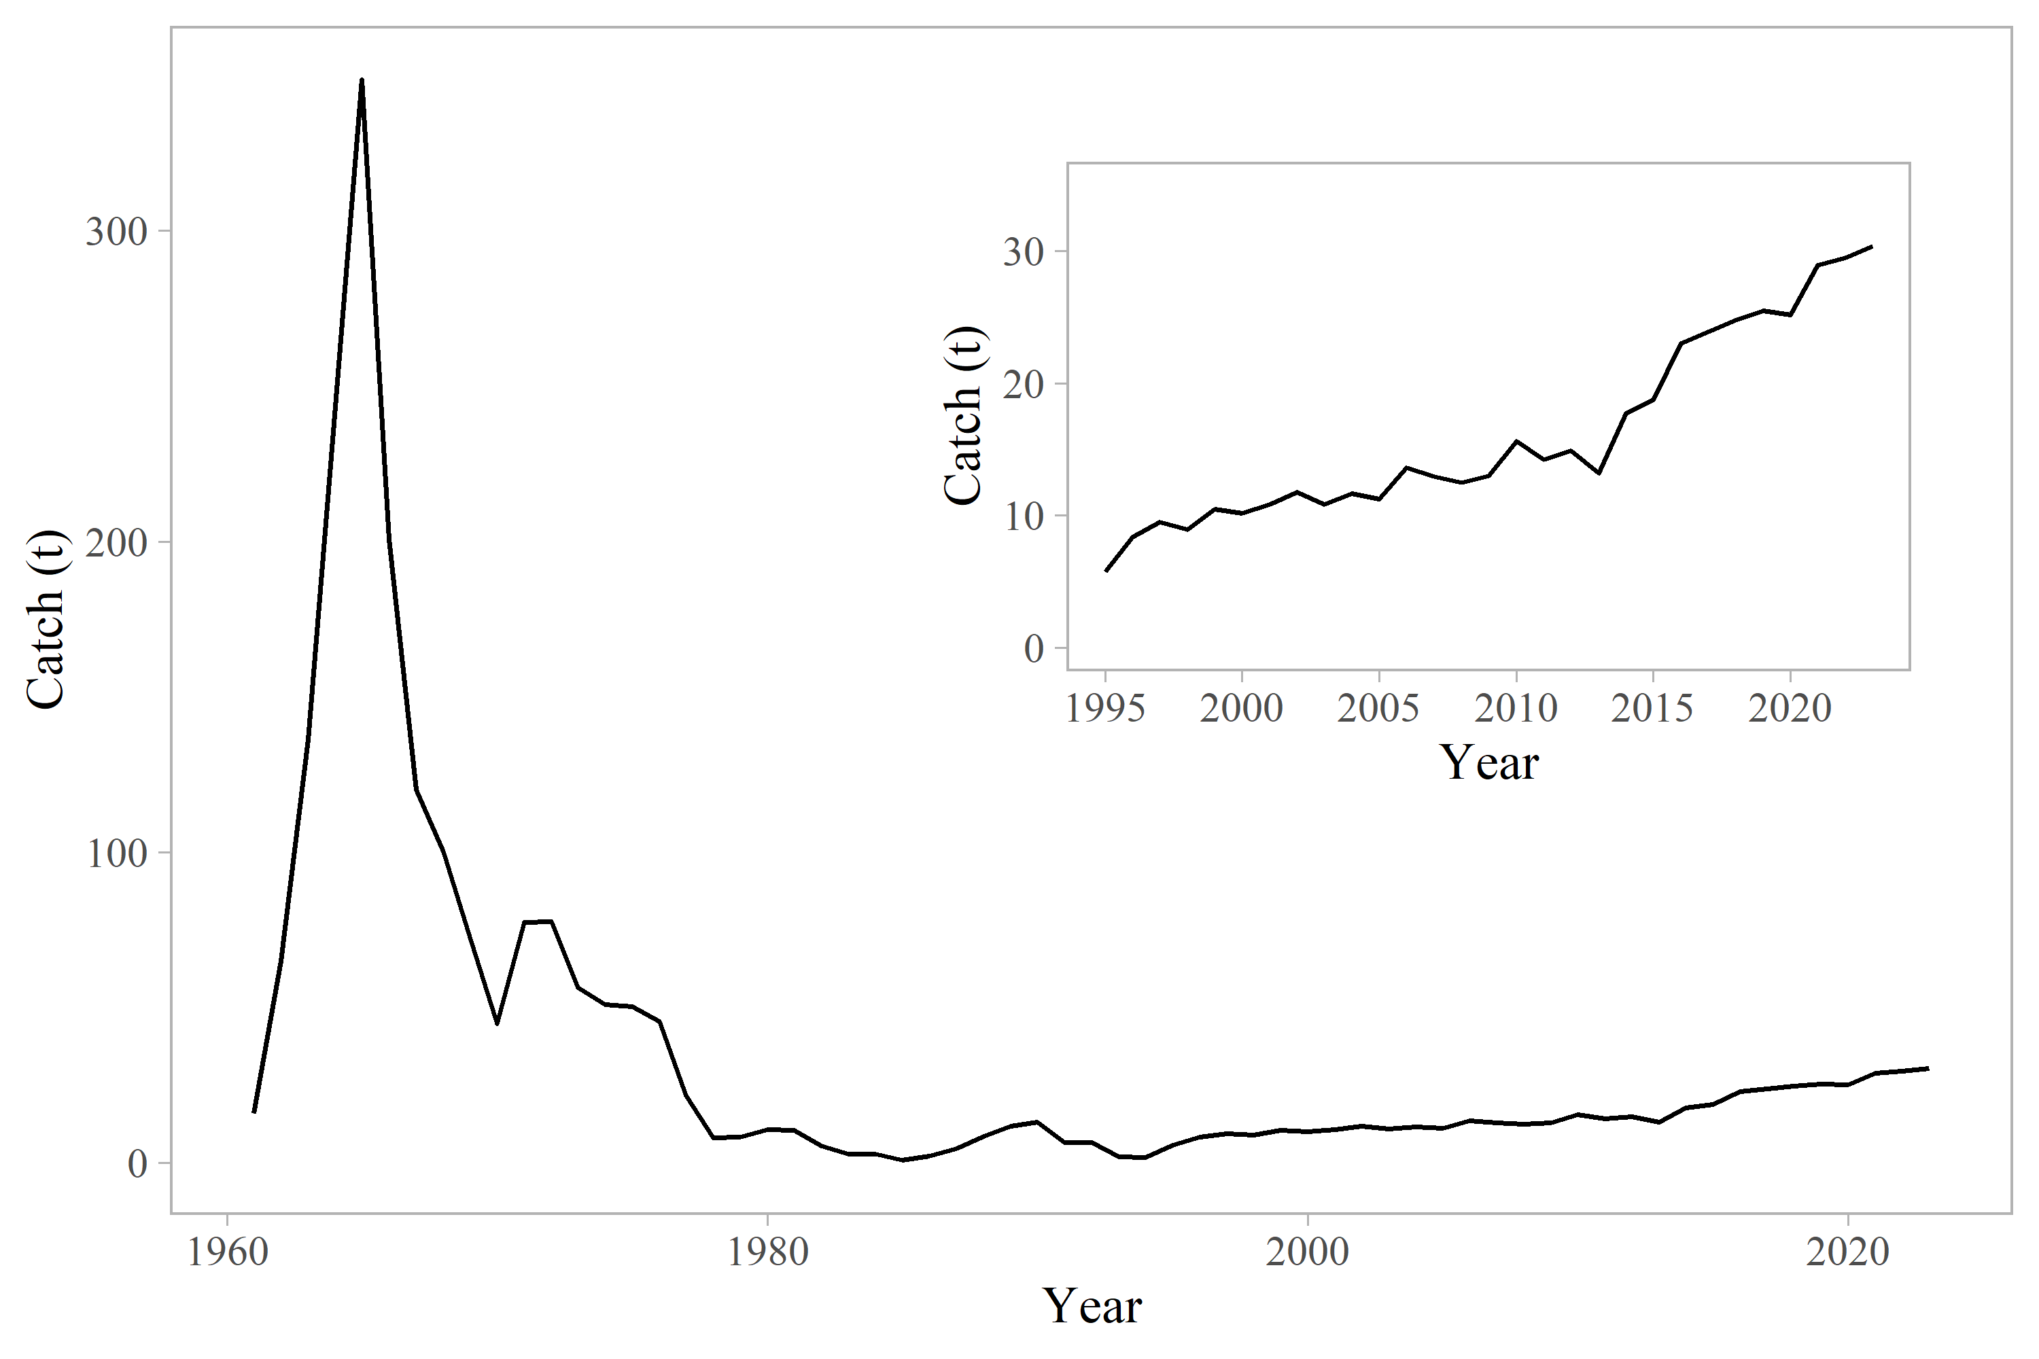

Figure 9.3. Observed catches for POP for the entire time series (main figure) and since 1995 (inset).

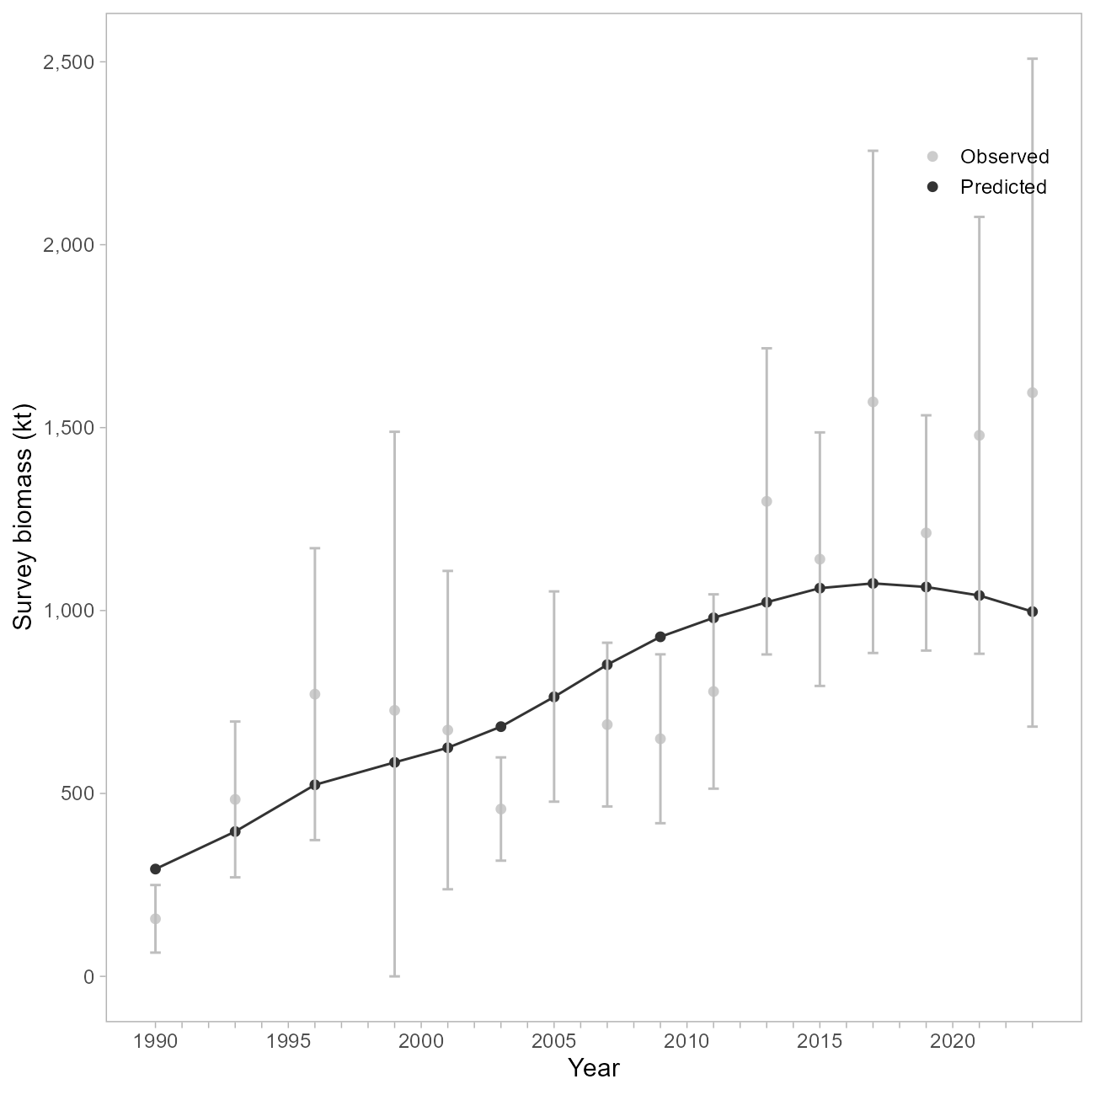

Figure 9.4. NMFS Groundfish Survey observed biomass estimates with 95% sampling error confidence intervals for GOA POP (grey points and vertical bars). Model estimates are shown in black.

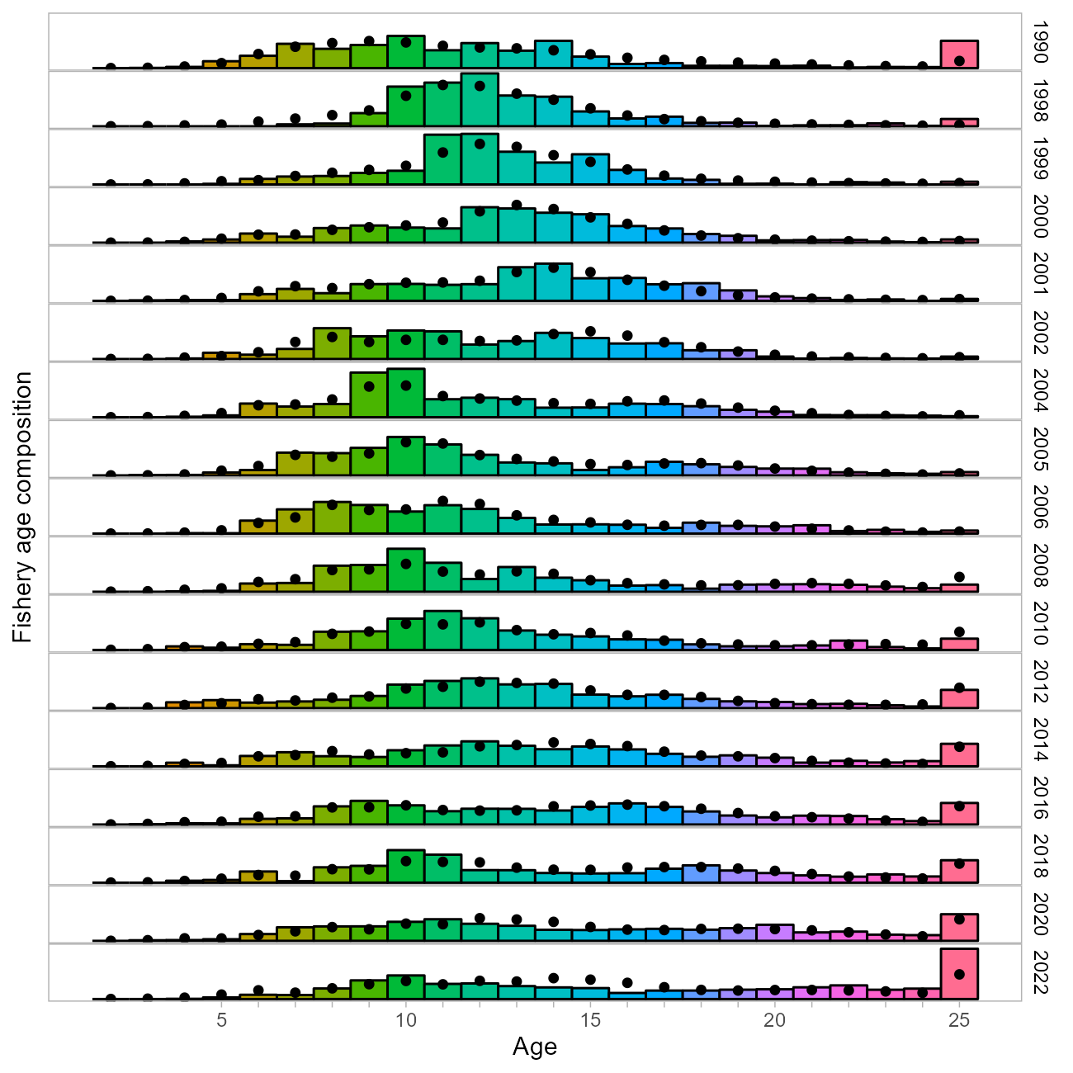

Figure 9.5. Observed (colored bars) and predicted (black points) fishery age compositions for GOA POP.

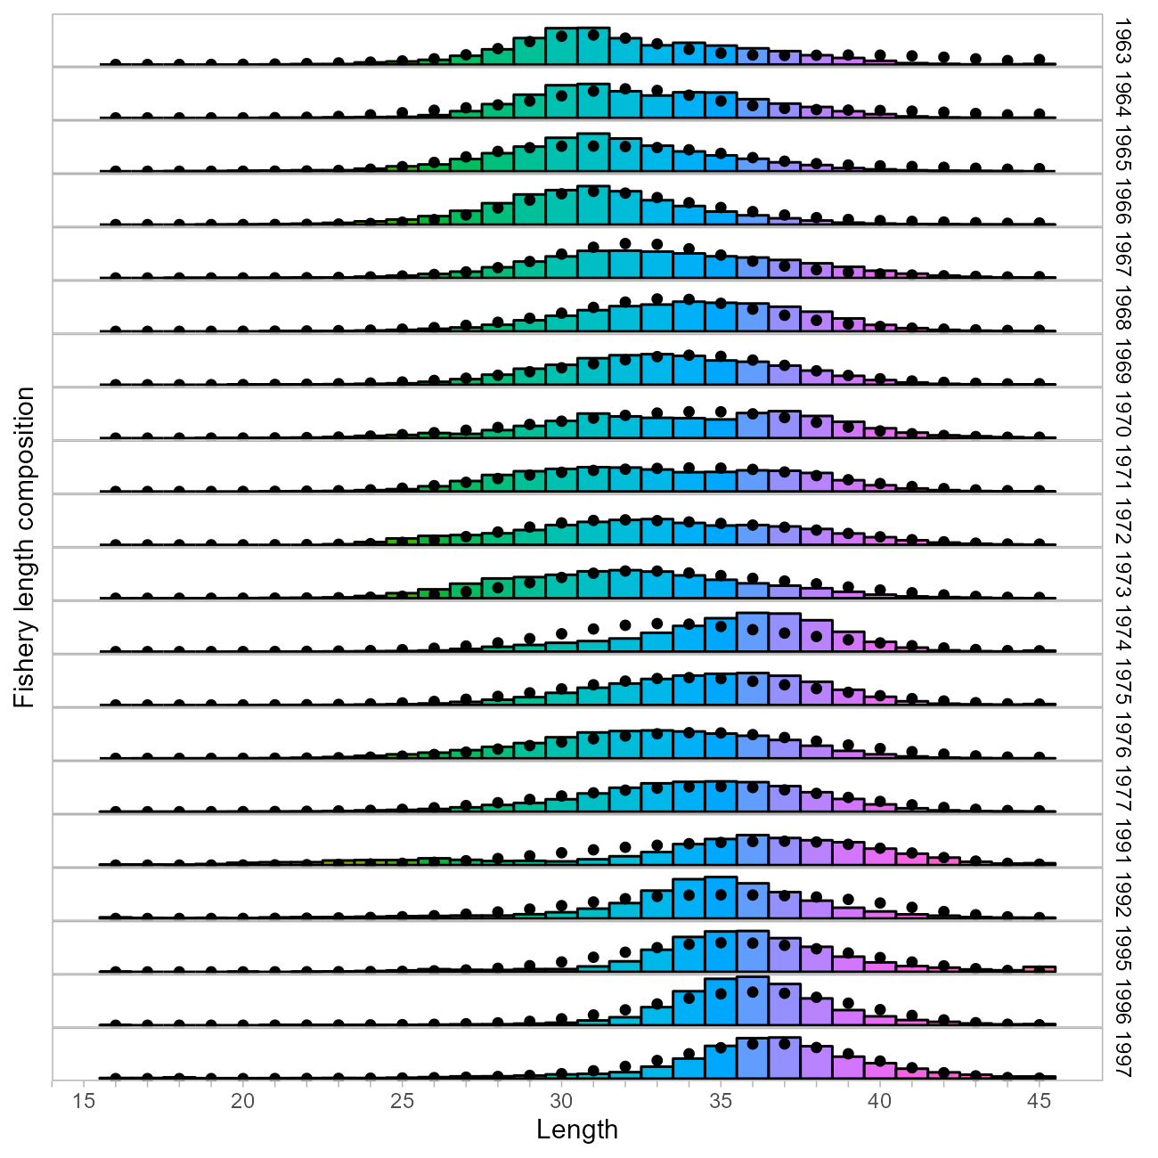

Figure 9.6. Observed (colored bars) and predicted (black points) fishery length (cm) compositions for GOA POP.

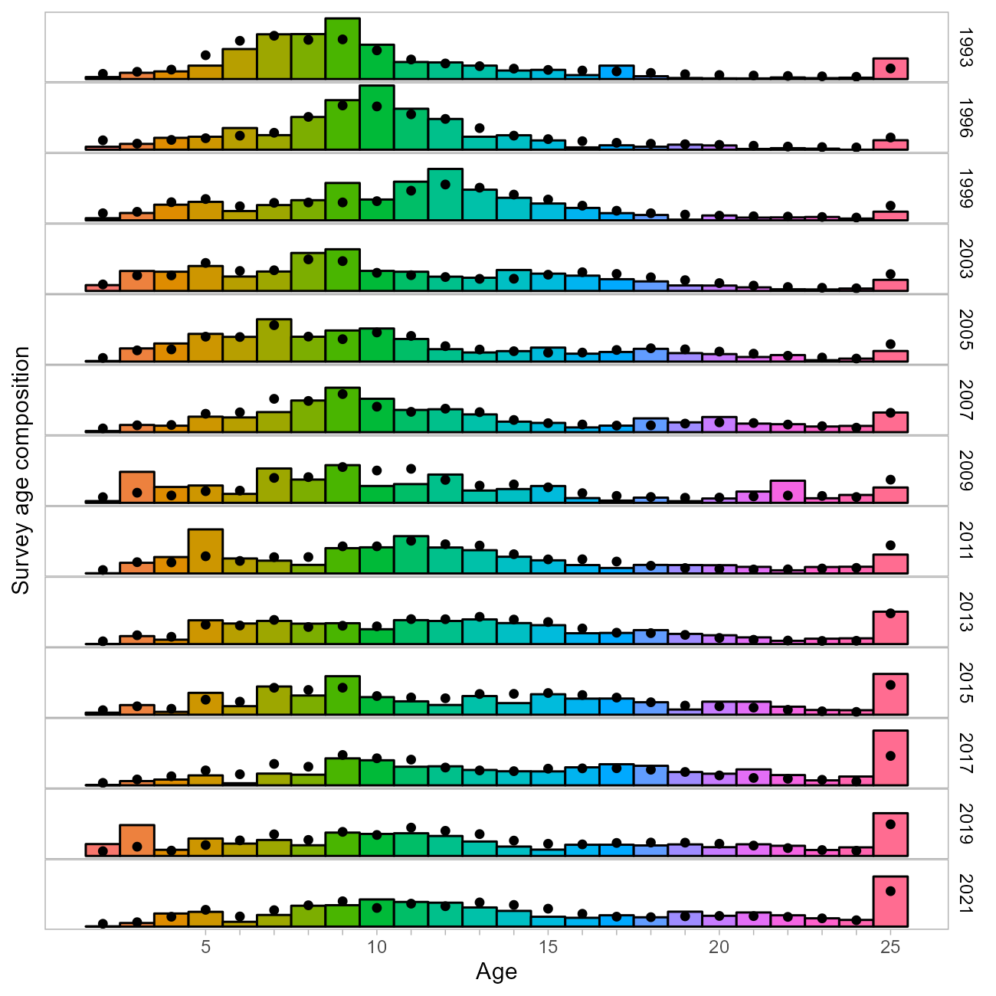

Figure 9.7. Observed (colored bars) and predicted (black points) groundfish bottom trawl survey age compositions for GOA POP.

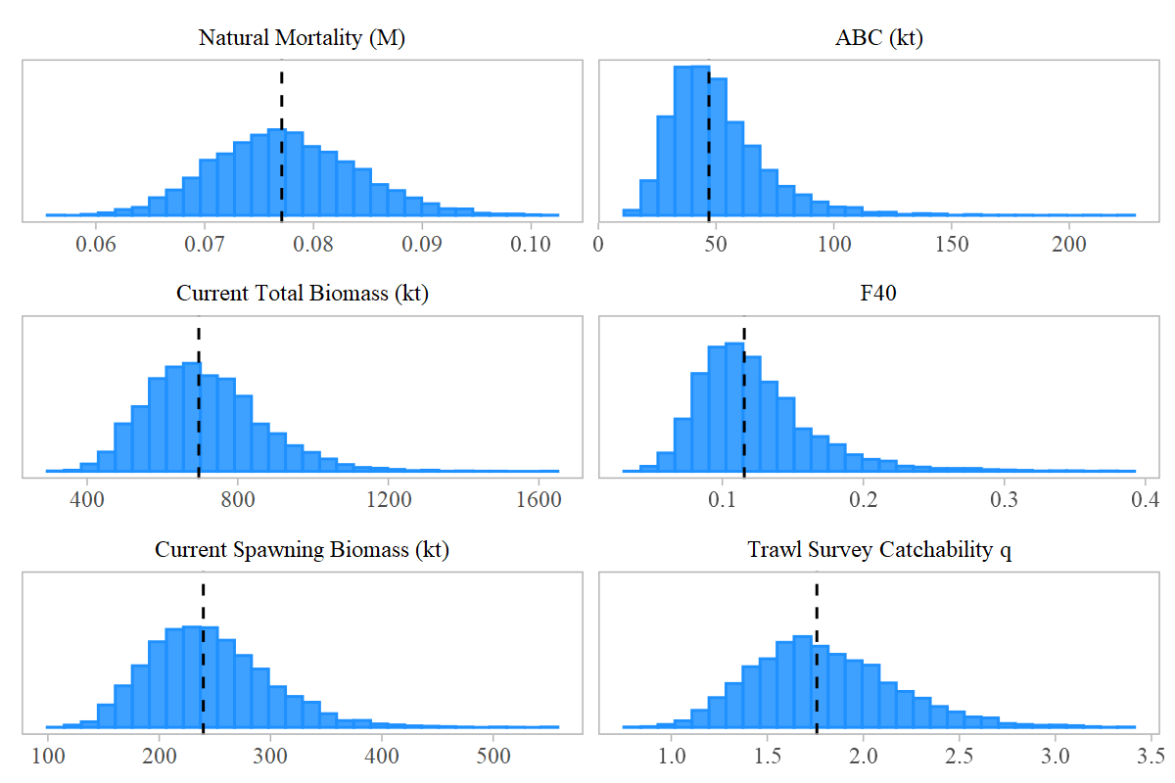

Figure 9.8. Histograms (blue) of estimated posterior distributions and medians (vertical dashed lines) of key parameters derived from MCMC for GOA POP.

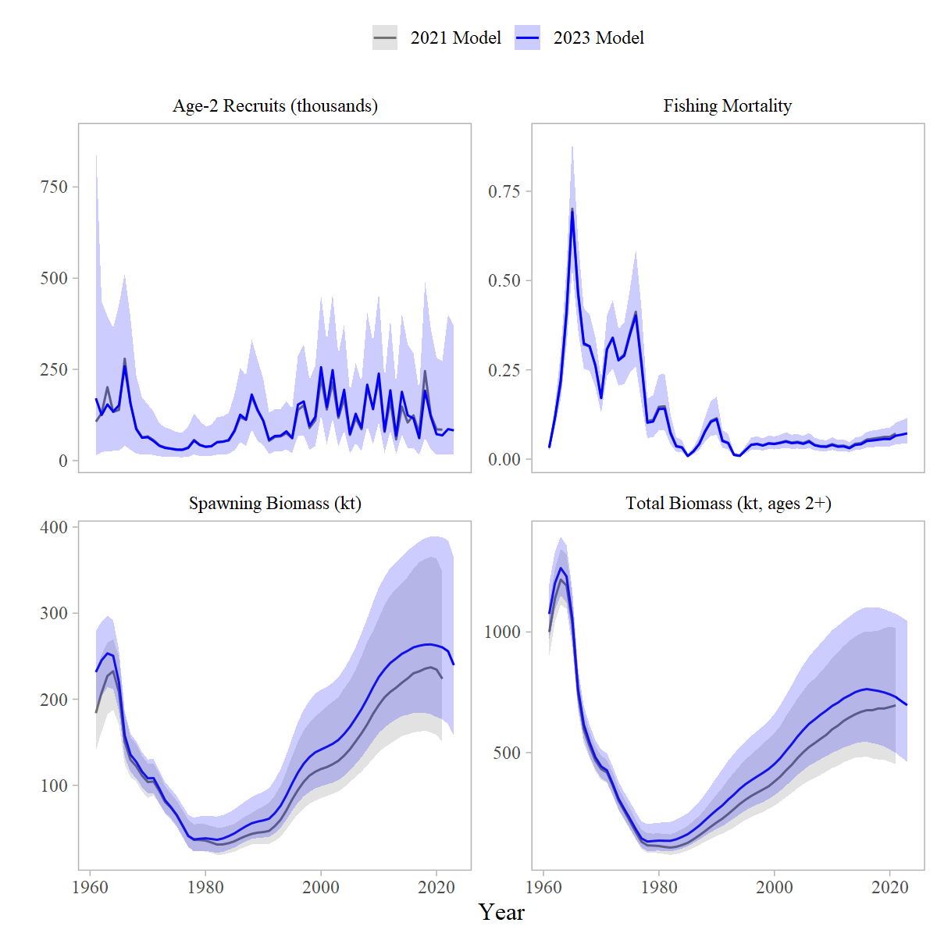

Figure 9.9. Comparison of recruitment, fishing mortality rates, spawning and total biomass for the 2023 Update model (blue) and 2021 Full model (grey). The shaded ribbon represents the 95% quantile obtained via MCMC; Age-2 recruits and F rates were not included in the MCMC analysis in 2021, so those figures show the mean estimates only.

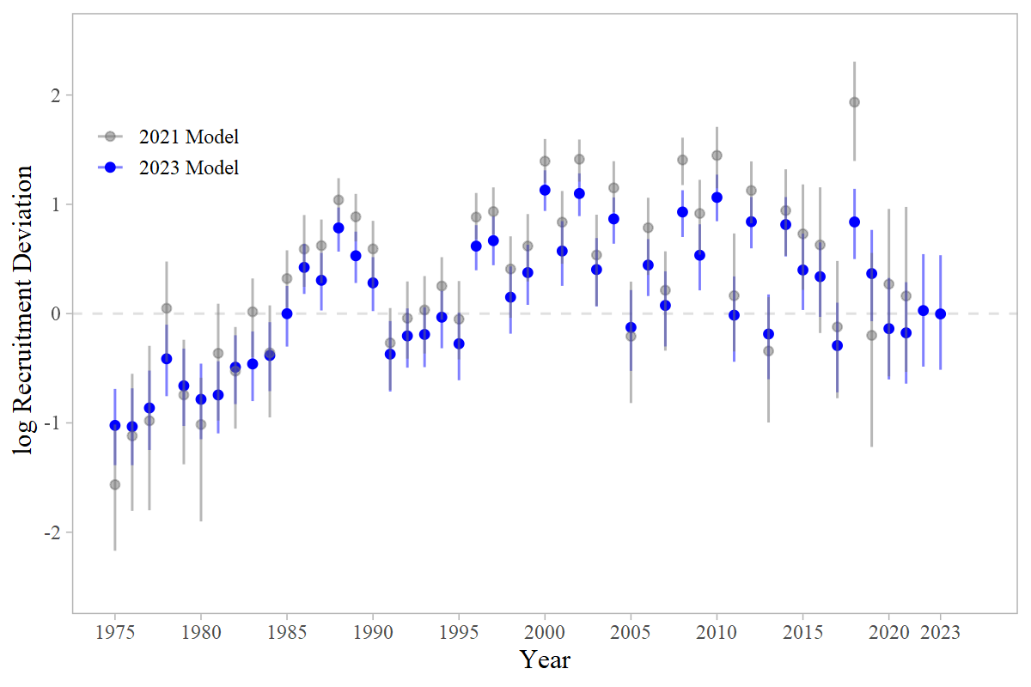

Figure 9.10. Time series of recruitment deviations, 1975-2023, from the 2023 base model (blue) and 2021 base model (grey), with 95% intervals obtained via MCMC.

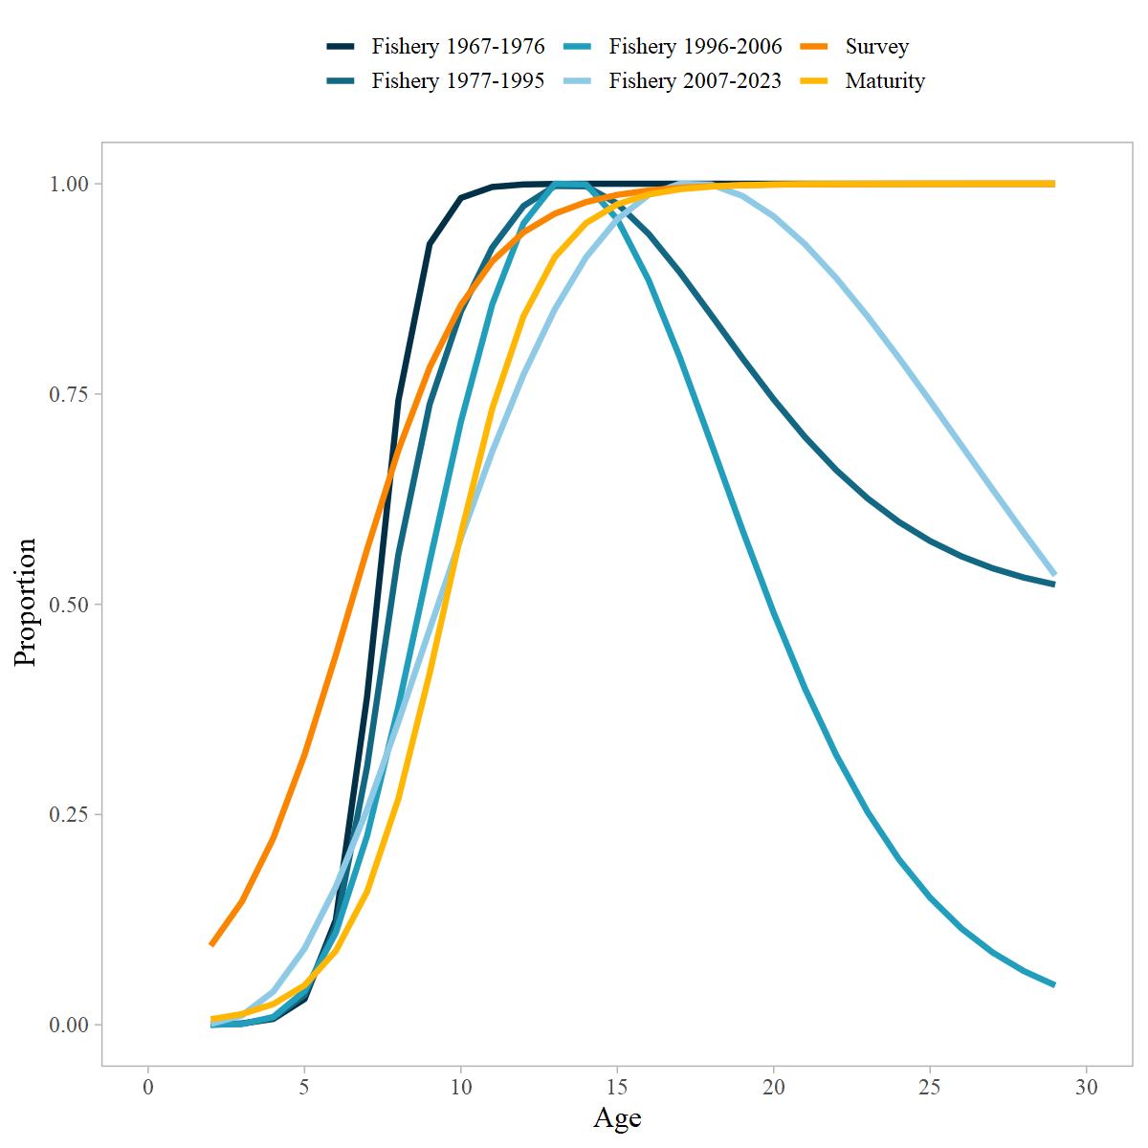

Figure 9.11. Estimated selectivity curves, maturity-at-age and weight-at-age for GOA POP.

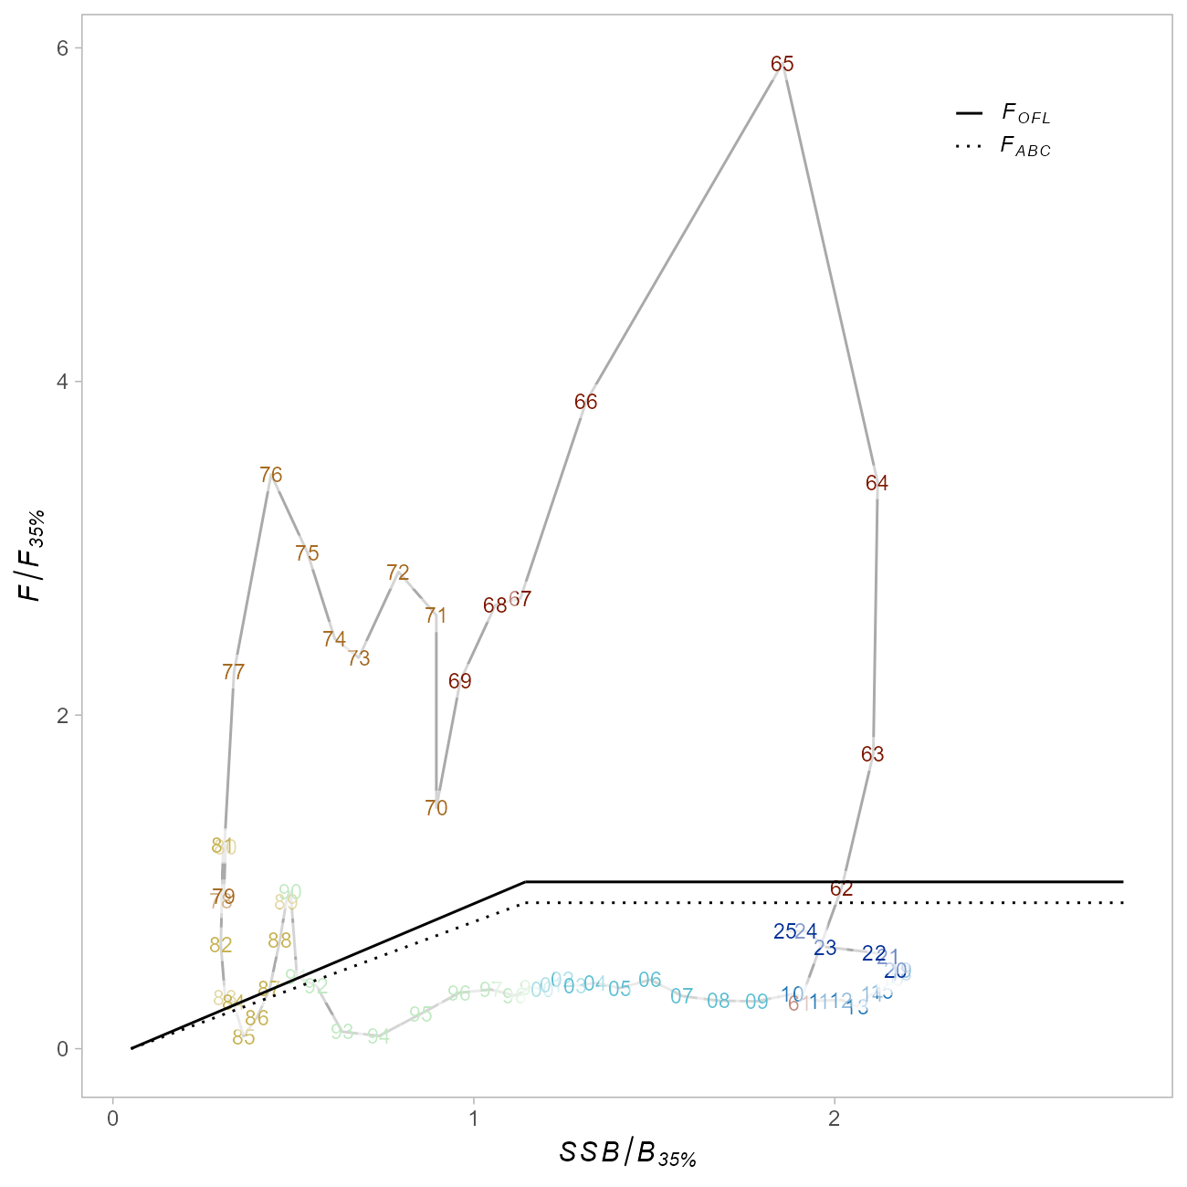

Figure 9.12. Time series of estimated fishing mortality versus estimated spawning stock biomass (phase-plane plot), including applicable OFL and maximum FABC definitions for the stock, including 2 years of projected values. Target levels correspond to B35% and F35% for author recommended model.

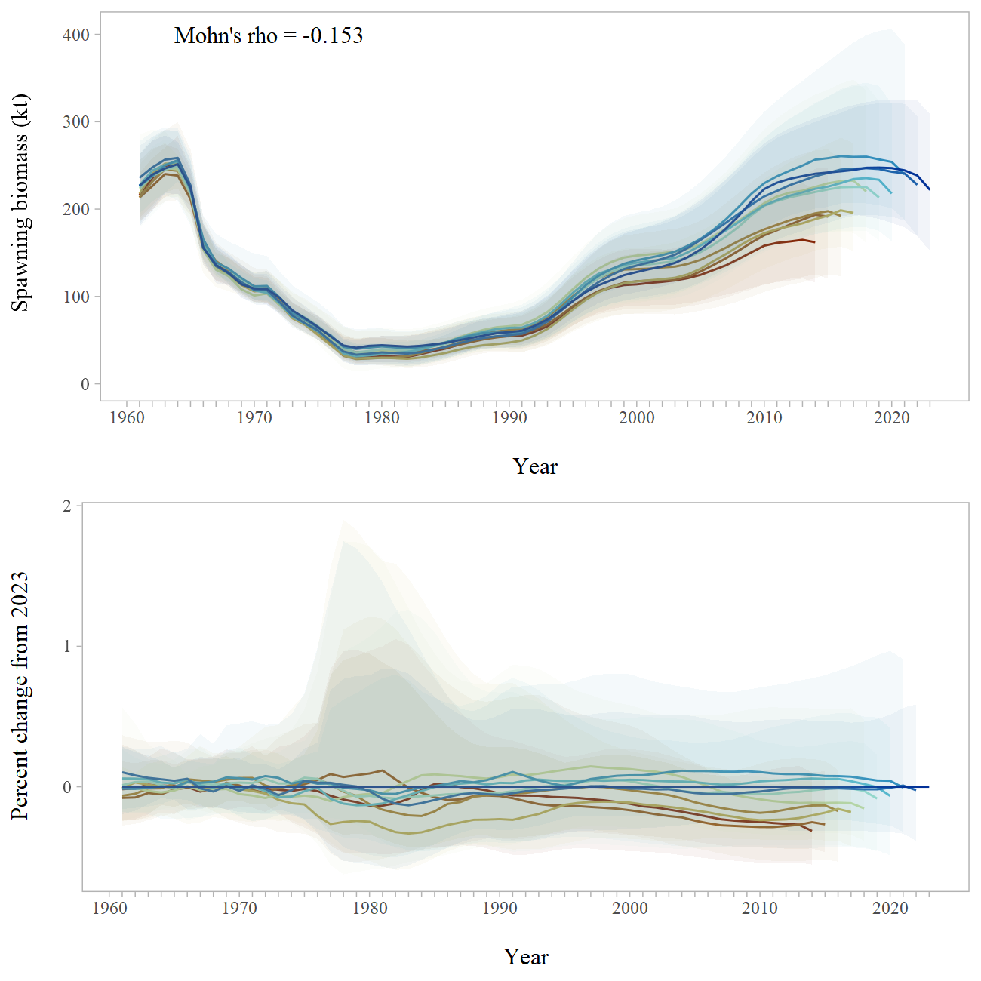

Figure 9.13. Retrospective peels of estimated female spawning biomass for the past 10 years from the recommended model with 95% credible intervals derived from MCMC (top), and the percent difference in female spawning biomass from the recommended model in the terminal year with 95% credible intervals from MCMC.

# Appendix: Summary of and Selected Responses to the 2021 CIE review of Gulf of Alaska Pacific Ocean perch

The Center for Independent Expert (CIE) review for Gulf of Alaska Pacific ocean perch was conducted virtually from March 30 to April 1, 2021. The panel of experts consisted of Drs Noel Cadigan, Saang-Yoon Hyun, and Geoff Tingley. Overall, the review was productive, resulting in a number of recommendations for future development and research into the assessment for GOA POP. By the conclusion of the review the experts found the assessment to be of high quality, and the reviews contained statements like, “The overall outcome of this assessment, as reviewed, is that it meets the description of best available science and exceeds the acceptability quality threshold to be used to inform management.” (Tingley).

Each of the reviewers provided research recommendations that should serve to improve the assessment model for GOA POP. A number of the recommendations focused on a variety of sensitivity analyses, while others involved more in-depth model development. Distilling these comments, the more in-depth recommendations included:

* Investigate data weighting of compositional data
* Develop a state-space model to be run in parallel to the current assessment
* Continue to investigate use of VAST estimates of survey biomass, in particular investigate reasons behind the divergence between design-based and model-based estimates of abundance

As it pertains to the use of VAST estimates of survey biomass, the consensus among the reviewers was that it is still premature to use this index in the assessment until it can be more thoroughly investigated. This was also the consensus with the use of acoustic survey biomass estimates as an additional index to the model. Due to the recommendations that further work be conducted before implementation into the assessment in conjunction with the work that the AFSC internal review team performed through 2020 and 2021 (which additionally identified different methods to estimate fishery selectivity as a topic to be considered in the assessment model development), and given that the assessment has changed senior authors, the GOA POP assessment will not incorporate any substantial model changes for the 2023 assessment cycle, but will investigate and continue to develop these various recommendations to be potentially implemented in the next full assessment that will be conducted in 2025.

Tables 13 through 10.17 compile the main recommendations suggested by the reviewers and are organized by the terms of reference (TOR) of the review. A subset of these recommendations were addressed for this Update, and responses to those requests or comments follow the tables.

Table 9.13. TOR 1: Evaluate the data used in the assessments, specifically trawl survey estimates of biomass, and recommend how data should be treated within the assessment model.

| Reviewer | Recommendation | Response |
| --- | --- | --- |
| Tingley | Sensitivities to plausible alternative catch histories, particularly for the early years of the fishery, should be run, but only when there are substantive changes to the assessment model structure or major assumptions. | This sensitivity was investigated for the present cycle (see below). |
| Tingley | Continue to explore different approaches to the appropriate weighting of the composition data, by using different statistical approaches but possibly also by careful quality control of these data, excluding data of known poorer quality. | This has been continually evaluated since 2017, and the results are very sensitive to the biomass index used. We will present updated results in September 2022. |
| Tingley | At a future assessment, it is recommended to try and incorporate all of the high-quality length composition data from both the survey and the commercial fishery, at least in a sensitivity. | We plan to investigate this sensitivity in the summer of 2023 |
| Tingley | Prior to or as part of the next assessment, explore whether the plus group should continue to start at age 25 or whether an older plus group starting age is more appropriate. | We have explored this in previous assessments, but will update this analysis in the summer of 2022. |
|  |  | This sensitivity was investigated for the present cycle (see below). |
| Cadigan | Investigate if stock weights-at-age from the survey are significantly (i.e., in the statistical sense) different than fishery weights-at-age. Also, investigate if there is significant temporal variation in both stock and fishery weights-at-age. Provide figures of how mean weight-at-age changes over time, with different panels for groups of ages (i.e., 1-5, 6-10, 10+). Consider using more efficient and less bias methods for analyzing size-at-age from length-stratified age samples (e.g., Perreault et al., 2019). Investigate spatiotemporal variation in weight as a function of length. | We have previously evaluated time-dependent and have compared between the survey and fishery. We will update this analysis in the spring of 2023, in particular with the different groups of ages, as well as new methods of length-stratified sampling. |
|  |  | This sensitivity was investigated for the present cycle (see below). |
| Cadigan | Consider new sampling programs to collect information on POP maturity. | TBD, dependent on funding |
| Cadigan | Investigate a bootstrap re-sampling procedure (e.g., Jourdain et al., 2020) to estimate uncertainty (i.e., covariance) in survey age compositions. This could also be considered for fishery compositions, although I recognize that it may be less straight-forward if there is data-borrowing for unsampled fishery ?strata? (i.e., gears, areas, seasons, etc.). | Currently being investigated by Siskey et al. results for POP will be presented in September 2022 |
| Hyun | If the survey for the POP stock assessment continues to rely on a bottom trawl survey, they should consider increasing the current trawlable area. | The current method for selecting trawl sites will continue to expand our understanding of trawlable and untrawlable grid cells |
| Hyun | They should revise the calculation of the CV of annual bottom trawl survey indices (annual relative population sizes) because they failed to consider the covariances of survey indices from neighboring strata when calculating the variance of the annual survey index. | We will discuss the potential for this calculation with GAP in the spring of 2022. |

Table 9.14. TOR2: Evaluate the stock assessment model for GOA Pacific ocean perch in general and comment on appropriateness of parameter estimates to assess stock status determinations.

| Reviewer | Recommendation | Response |
| --- | --- | --- |
| Tingley | Exploration of additional information to better define the realistic range of M for Pacific ocean perch is recommended. This should consider data available for Pacific ocean perch and for other long-lived rockfish species. | In the 2020 assessment we used Hamel (2015) as the prior for M. We will be performing sensitivities to M in the summer of 2022, as per the SSC request. |
|  |  | This sensitivity was investigated for the present cycle (see below). |
| Cadigan | Investigate a sensitivity model run with an initial age-structure derived using the assumed M and a few years of F like that estimated for 1961. For example, initial cumulative Z = a*M + min(a,3)*Finit will be appropriate if the stock experienced Finit fishing mortality for three years prior to the start of the assessment model. | Within the internal review team we investigated alternative methods to estimate initial age-structure. We will revisit this with this recommendation in the spring of 2023. |
| Cadigan | Consider including a stock-recruit model with autocorrelated errors to improve the fit of the POP assessment model. Investigate possible drivers of patterns in recruitment deviations. | We have been investigating time-dependent mean recruitment, and will revisit this analysis with this suggestion in the summer of 2022. |
| Cadigan | Consider removing priors for F Regularity and sigma-R. | This sensitivity was investigated for the present cycle (see below). |
| Cadigan, Hyun | A research (i.e., exploratory) state-space stock assessment model, run in tandem with the current stock assessment model, should be developed. | We will begin to develop a state-space model after some of the higher priority suggestions have been addressed. |
| Cadigan | Consider including fishery length composition information in off-years when ages are not measured. However, this may not provide much additional information about recent recruitment trends because of the low selectivity of the fishery for ages less than seven. | We will perform this request as a sensitivity run in the summer of 2023. |
| Cadigan | Evaluate the quality of fishery and survey age compositions for tracking cohorts. | This is a common evaluation in our standard assessments. We feel that given the amount of funding and realistic level of sampling, that our age composition data is adequate to track cohorts. |
| Cadigan | Provide a retrospective analysis of current status evaluations. This will provide additional information on the reliability of the status evaluations. | We will perform this sensitivity analysis in the summer of 2023. |
| Cadigan | Provide convergence diagnostics, including the maximum absolute gradient and the results of a jitter test. | This is potentially a broader topic, but we can fairly easily provide these diagnostics in the 2023 SAFE document. |

Table 9.15. TOR 3: Evaluate the strengths and weaknesses in the stock assessment model for GOA Pacific ocean perch, and recommend any improvements to the assessment model.

| Reviewer | Recommendation | response |
| --- | --- | --- |
| Tingley | In the absence of better information about the likely magnitude of M, sensitivities using values of fixed M that bracket the estimated value M should be run in future stock assessments to inform on the level of risk inherent in the current assumptions about M. | We will perform this sensitivity analysis in the summer of 2022 and present the results of this in September 2022 Plan Team meeting. |
| Hyun | They should incorporate the annual fishery cpue?s into the assessment model framework. | Historically, the fishery CPUE data for POP has been highly variable and questionable, which has caused doubt as to its usefulness in the model. |
| Hyun | They should improve the model fit to the survey indices. One of the efficient ways to improve the goodness-of-fit might be to consider process errors in state variables (random effects). | We intend to develop a state-spaced model once more higher priority model developments are completed. |
| Hyun | The penalized likelihood form as the prior of M, q, and | We will investigate this in the summer of 2023 |
|  | must be revised (beyond the typo). The revised form, which I suggest above, might improve the model performance. |  |
| Hyun | They should do formal model validation, setting true values of free parameters, generating pseudo data, feeding those simulated data into the assessment model, estimating parameters, and comparing estimates of free parameters with the corresponding true values. Such model validation would help us to judge the reliability of parameter estimates and the resultant derived quantities made by the model. | Similar to the model convergence and jitter test diagnostics recommended in the previous TOR, this may be a broader diagnostic to consider in AFSC assessments, however, this model validation will be investigated in the summer of 2023. |
| Hyun | For the retrospective error analysis, they should also examine estimates of annual fishing mortality. | We will perform this sensitivity analysis in the summer of 2023. |

Table 9.16. Evaluate and recommend how survey data are used for biomass indices within the assessment. Specifically, advise on trawl survey indices arising from design-based methods versus model-based approaches.

| Reviewer | Recommendation | Response |
| --- | --- | --- |
| Tingley | Continue to exclude the 1984 and 1987 survey biomass estimates and survey composition data from all future assessments as these are clearly not part of the longer survey timeseries due to the use of differences in vessels, trawl gear, tow duration and survey timing. | We will no longer be including these surveys in the POP assessment. |
| Tingley, Cadigan | Exclude the 1990 and 1993 Gulf of Alaska Bottom Trawl Survey biomass estimates and the survey composition data from all future Pacific ocean perch (and other species) assessments (or include them only in sensitivities, possibly including them as a separate timeseries). These two years do not appear to be part of the longer survey timeseries due to different timing, tow duration and survey structure. | We will investigate the model sensitivity to these surveys in the summer of 2022. |
| Tingley | It is recommended that the current approach of estimating the missing eastern data from the 2001 Gulf of Alaska Bottom Trawl Survey is discontinued for all future assessments of Pacific ocean perch and that one of the proposed approaches, or an alternative approach, is used so as to reduce uncertainty in the next assessment. | We will investigate one of the alternatives in the summer of 2022. |
| Tingley | Continue to support the development and application of spatio-temporal models (such as VAST) for use in stock assessments. In order to make this effective, there need to be a rapid development of a suite of informative diagnostics for spatio-temporal models in a fisheries stock assessment context. Until such time as suitable diagnostics are available, it is recommended that these spatio-temporal models are only used in sensitivity model runs and not in the base case from which management advice is developed. | We will be working with GAP to evaluate the VAST model for POP in the spring of 2022. |
| Cadigan | It was premature to use VAST biomass indices in the POP stock assessment. There are several diagnostic analyses that need to be explored. | We will be working with GAP to evaluate the VAST model for POP in the spring of 2022. |
| Cadigan | Provide the stratum size-weighted averages of the VAST ordinary raw residuals. | We will be working with GAP to evaluate the VAST model for POP in the spring of 2022. |
| Cadigan | Provide trawlable biomass values aggregated over survey strata. This should include time-series of maps indicating strata, where each stratum is colored to indicate the area-expanded VAST biomass. Also useful are time-series plots of VAST biomass aggregated over sets of strata for standard depth ranges shown in Table 2. It will also be informative if this could be further divided into trawlable and untrawlable grounds. | We will be working with GAP to evaluate the VAST model for POP in the spring of 2022. |
| Cadigan | Account for potential vessel and tow time effects in a VAST model. Examine the statistical significance of vessel and tow duration effects. Consider including vessel as a random effect. | We will be working with GAP to evaluate the VAST model for POP in the spring of 2022. |
| Cadigan | Consider including the 1984 and 1987 survey catches in the VAST model, to extend the survey biomass indices back to those years. This VAST model should include those effects that were different or less standardized in the 1984 and 1987 surveys. Consider the potential confounding of year effects with other effects. | We will be working with GAP to evaluate the VAST model for POP in the spring of 2022. |
| Cadigan | Investigate methods to produce length and size compositions that are weighted by VAST spatial density estimates. | We will be working with GAP to evaluate the VAST model for POP in the spring of 2022. |

Table 9.17. Evaluate abundance estimates from summer acoustic-trawl data, and recommend how it may be used within the assessment.

| Reviewer | Recommendation | response |
| --- | --- | --- |
| Tingley | It is recommended that attempts to develop an acoustic abundance index for Pacific ocean perch from the MACE Acoustic Survey data for use in assessments should be discontinued until the evidence base supports a substantially increased likelihood that the processed acoustic backscatter represents a reliable abundance index for Pacific ocean perch. | We will be continuing to work with MACE in 2022 and 2023 to investigate the utility of this survey in the POP assessment. |
| Tingley | It is, however, also recommended that the existing MACE acoustic and trawl data are further explored in detail to ascertain whether the backscatter data can be reliably and robustly be decomposed into Pacific ocean perch and other species or not. | We will be continuing to work with MACE in 2022 and 2023 to investigate the utility of this survey in the POP assessment. |
| Cadigan | More years of acoustic survey data are needed before deciding how it could be included in the POP assessment. However, having an additional fishery-independent abundance index, and in particular an acoustic survey of the off-bottom (i.e., 0.5m) water column, can be quite valuable for detecting changes in availability of POP to the bottom-trawl survey. | We will be continuing to work with MACE in 2022 and 2023 to investigate the utility of this survey in the POP assessment. |
| Cadigan | Continue and improve research on the sources of uncertainty and possibly bias listed above. This should include quantification and incorporation of these sources of uncertainty into acoustic biomass and age/size compositions. | We will be continuing to work with MACE in 2022 and 2023 to investigate the utility of this survey in the POP assessment. |

## Responses to Selected CIE Comments from Spring 2021

## Alternative Catch Histories

Tingley: *“Sensitivities to plausible alternative catch histories, particularly for the early years of the fishery, should be run, but only when there are substantive changes to the assessment model structure or major assumptions.”*

**Response:** Revisiting the historical catch reconstruction would be onerous given that no new historical data sources have emerged since this review, and there is little complementary data (aside from the length compositions) for the early period of the model to corroborate any alternative trajectories.

To address this comment, we leveraged the fact that the base model already separates the data weights assigned to the early (pre-1977) and late (1977-2021) catch time series. In the base model, these series are weighted identically. We explored alternative weights for the early time series of 20%, 50%, and 150% of the value used in the base model, effectively investigating the impacts of reducing or increasing the certainty of this data source. The terminal spawning and total biomass estimates from these models ranged by less than 10%. As expected, the early series and uncertainty thereof affects the model’s estimate of initial and unfished biomass, with less certain (down-weighted) trajectories resulting in slightly higher estimates of these values (Figure 14).

There were two additional sensitivities run (results not shown) that provide further insight into this topic. Firstly, a sensitivity where the model begins during the “late” period (1975) – ignoring all data (catches & lengths) from the early catch period – resulted in a population trajectory nearly five times as high as the base model (in terms of total and summary biomass). A separate model run where the early length composition data were dropped, but the historical catches and model start year were the same as the base model, resulted in a perception of unfished biomass that was ~50% higher than the base model, though the population trajectory from ~1975 to present was nearly the same as the base model.

These findings suggest that there is indeed information contained within the early catch series regarding model scale, particularly when contextualized by the early length composition data. Reducing the weight of these data results in qualitatively similar population trajectories, with slightly higher notions of unfished biomass; ignoring these data completely result in a much higher perception of stock size. Given these findings, revisiting the historical catch reconstruction is unlikely to be an influential exercise at this time.

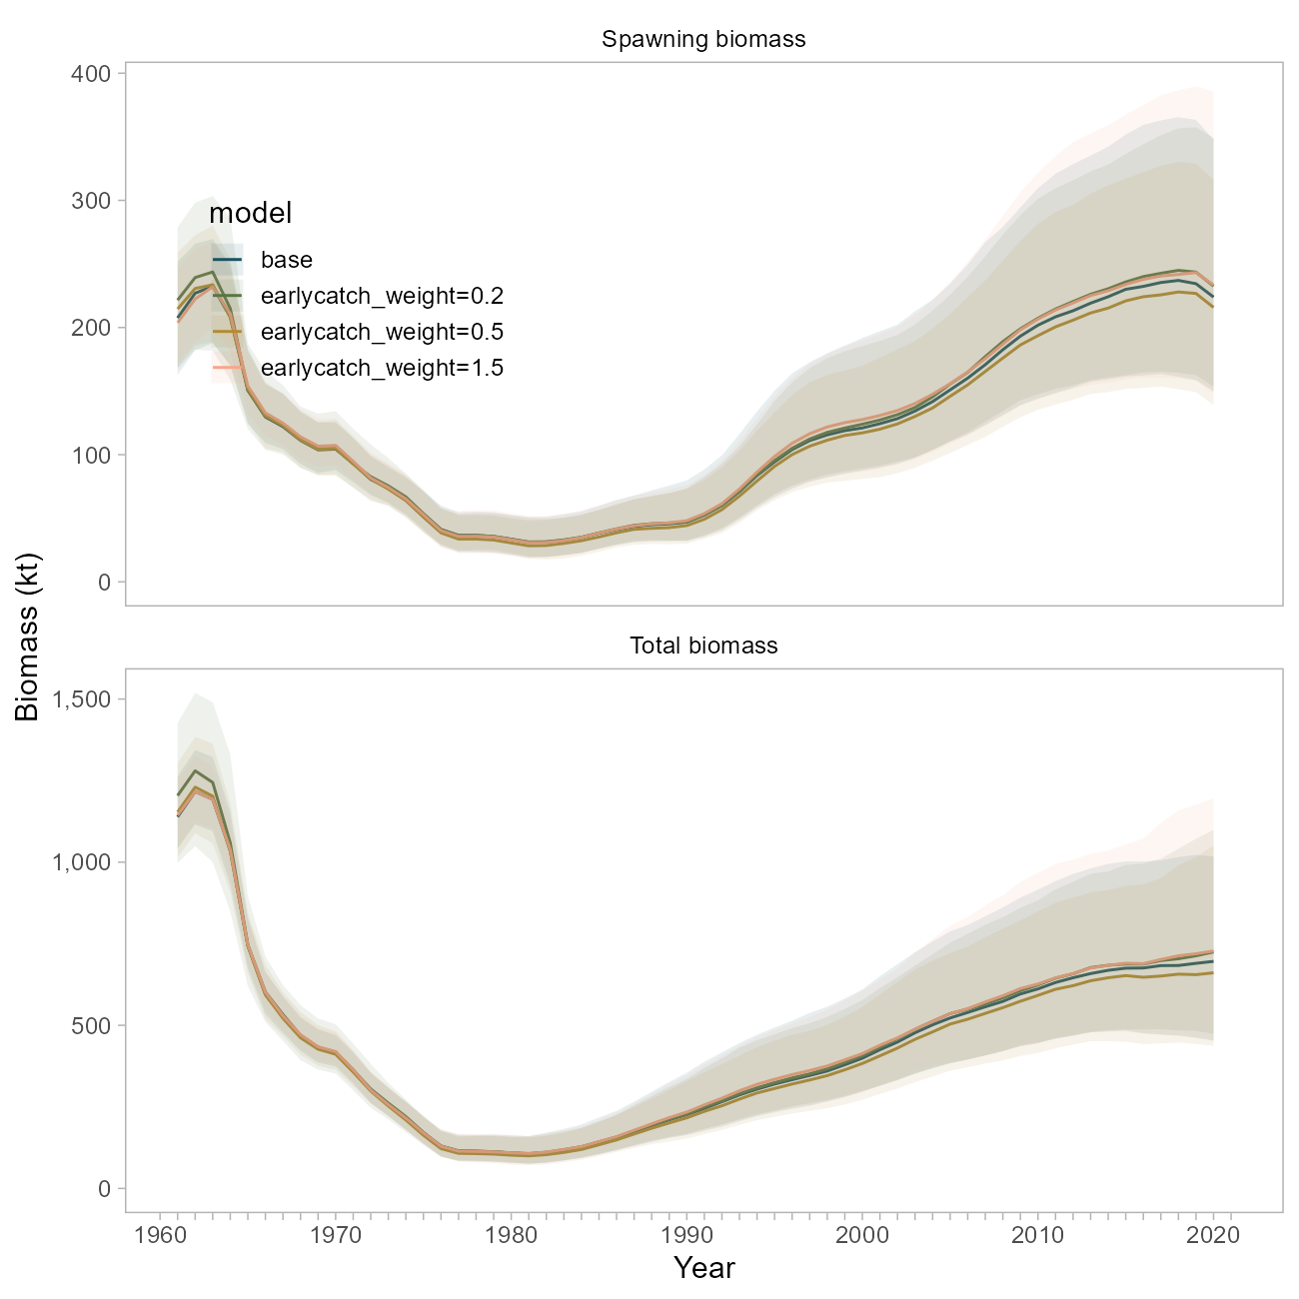

Figure 9.14. Comparison of biomass trajectories between the base model and three sensitivity runs where the early catch time series was weighted at 20, 50 or 150 percent of the weight used in the base model.

## Plus Group

Tingley: *“Prior to or as part of the next assessment, explore whether the plus group should continue to start at age 25 or whether an older plus group starting age is more appropriate.”*

This sensitivity has been explored in previous assessments, and was revisited in a run of the Stock Synthesis version of this model (described below) where the plus group was started at age 29. Model impacts were trivial.

## Stock Weights-at-Age in Survey vs Fishery

Cadigan: *“Investigate if stock weights-at-age from the survey are significantly (i.e., in the statistical sense) different than fishery weights-at-age. Also, investigate if there is significant temporal variation in both stock and fishery weights-at-age. Provide figures of how mean weight-at-age changes over time, with different panels for groups of ages (i.e., 1-5, 6-10, 10+). Consider using more efficient and less bias methods for analyzing size-at-age from length-stratified age samples (e.g., Perreault et al., 2019). Investigate spatiotemporal variation in weight as a function of length.”*

The base model currently uses two size-at-age matrices that represent the probability of a fish of size $l$ being age $a$ for either an early (pre 1980’s) or late (1980-present) period; both matrices were derived using survey data. Similarly, a single weight-at-age vector developed using survey data is applied to the entire population.

We have previously evaluated time-dependence in size-at-age, and have also previously compared sizes-at-age between the survey and fishery. This analysis is limited by the fact that fishery-dependent age records are more sparsely sampled both through time and in terms of overall numbers than the survey (Figure 15), which impacts the amount of data available to inform the construction of a separate size-at-age key for the fishery.

To address this comment, we undertook two investigations. First, we ran a model using the original survey-based weight at age vector, but included a new size-at-age matrix for the fishery data only from 1980 onwards. This matrix was defined using the fishery data only, and is more certain as it includes more data from the entire age spectrum (Figure 16). This means that fish of all ages, but particularly adults, are more likely to be assigned a length of below 42 cm than the survey-derived matrix would suggest.

The weight-at-age relationship developed using fishery data alone suggests adult fish (ages 20+) to be at a smaller weight in the fishery than in the survey (averaging 742 grams in the fishery vs 891 grams in the survey, Figure 17). This would be consistent with discrepancies in selectivity, targeted harvesting, or un-modeled aspects of fisher behavior, *or* could be an artifact of sampling differences between fleets.

Use of this matrix results in slightly lower biomass trajectories (blue line, Figure 18), consistent with the notion that the fishery-derived size-at-age matrix assumes a lower probability of larger lengths-at-age.

Separately, we investigated the application of the fishery-derived *weight*-at-age vector (shown in pink in Figure 17)). For this sensitivity, the weight-at-age vector was simply replaced with the new values. The biomass trajectory, particularly for spawning biomass, was nearly identical to the base case, much moreso than the sensitivity using the separate size-at-age matrices (green line, Figure 18).

This suggests that derived quantities in this model are less sensitive to the weight-at-age parameters than they are to relationship between length and age, and the uncertainty thereof. We believe the survey to be a well-sampled representation of the population, and the associated size-at-age matrix to better represent uncertainty in the growth process for this stock. In this model, this relationship is governed by the size-at-age matrices discussed above, but would be reasonably addressed in a new framework that allows for estimation of von Bertalanffy growth parameters within the model (and the associated variation across ages, or through time).

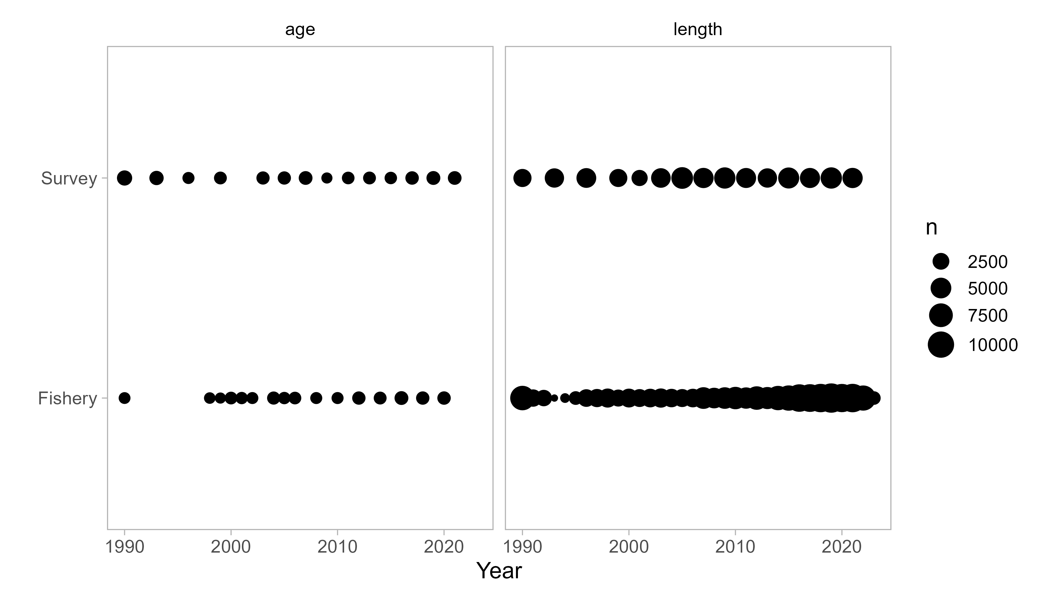

Figure 9.15. Number of raw observations of length and age for the survey and fishery. Note this figure does not represent total data included in the base model, rather the data available for the construction of size-at-age matrices.

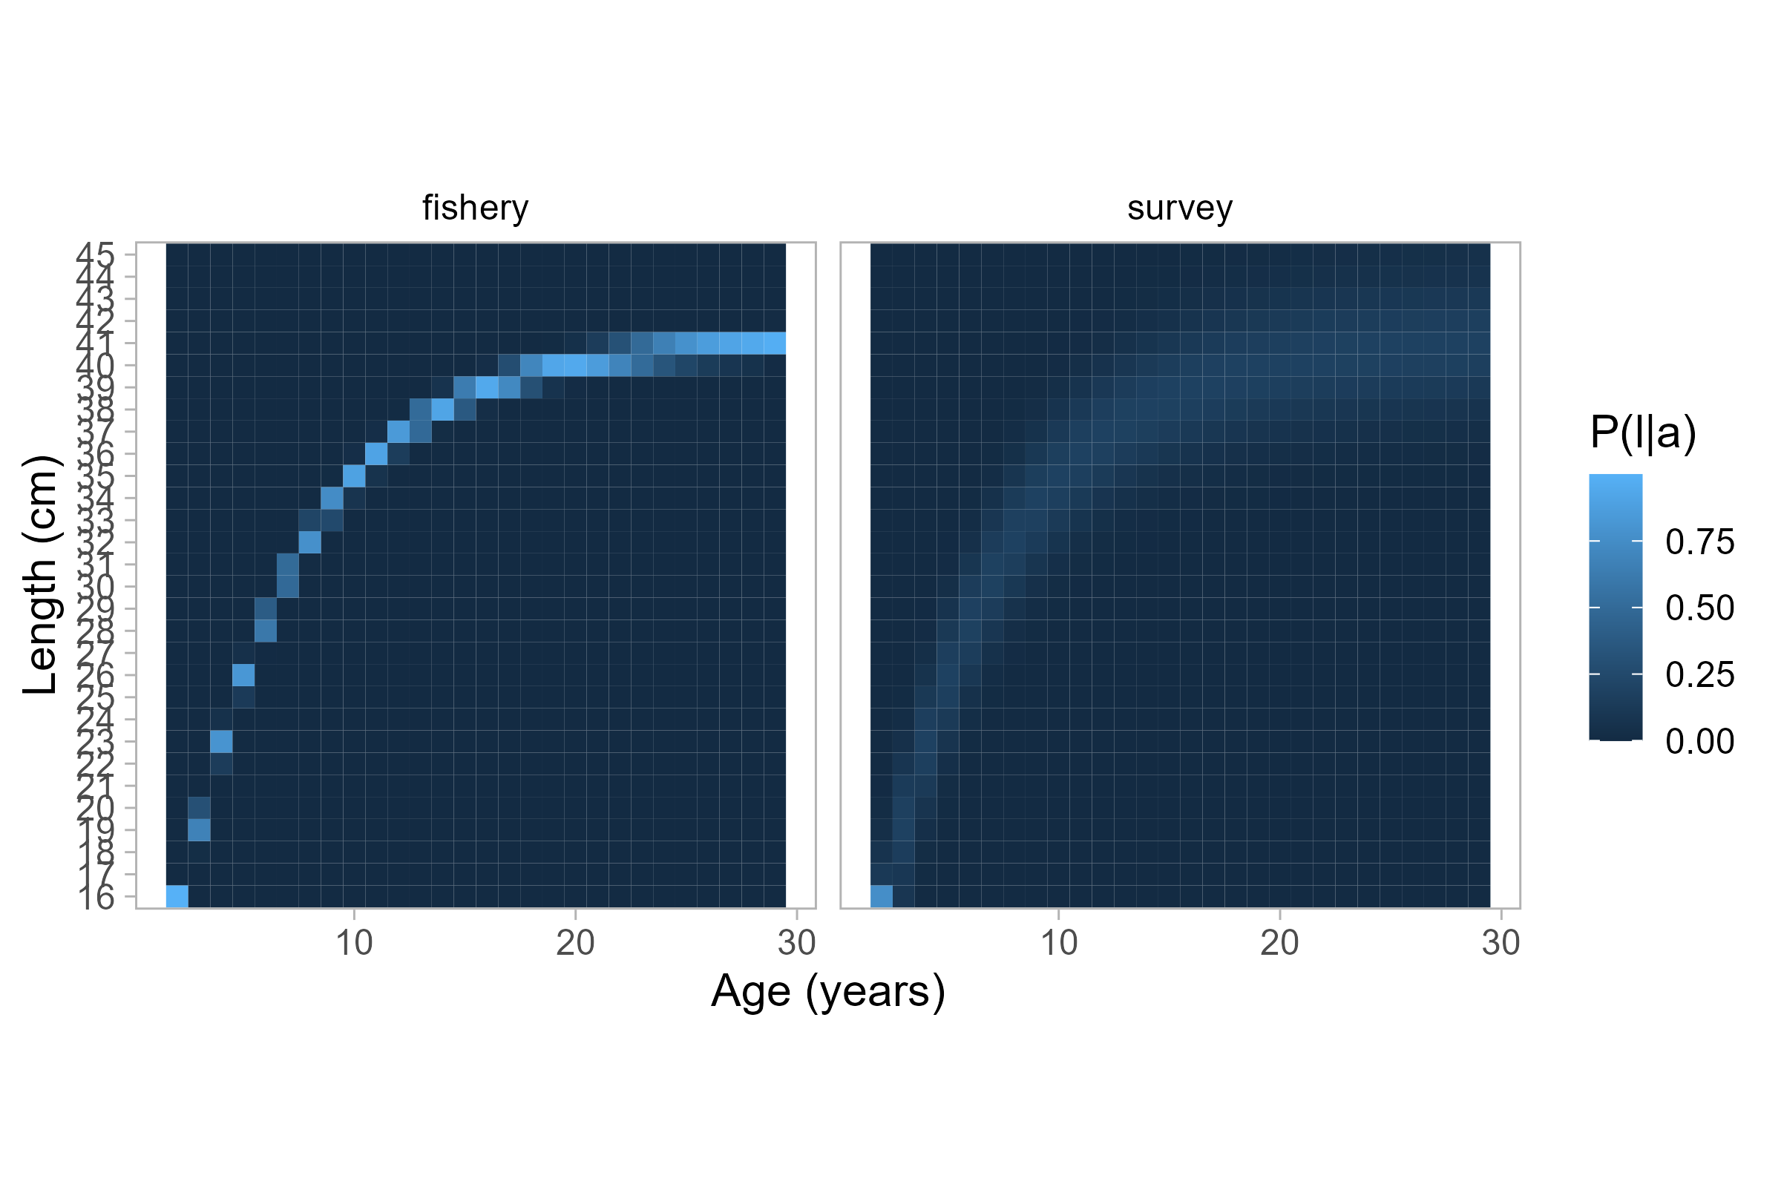

Figure 9.16. Size-at-age probability matrices for each fleet. The matrix on the right is used for all data in the base model.

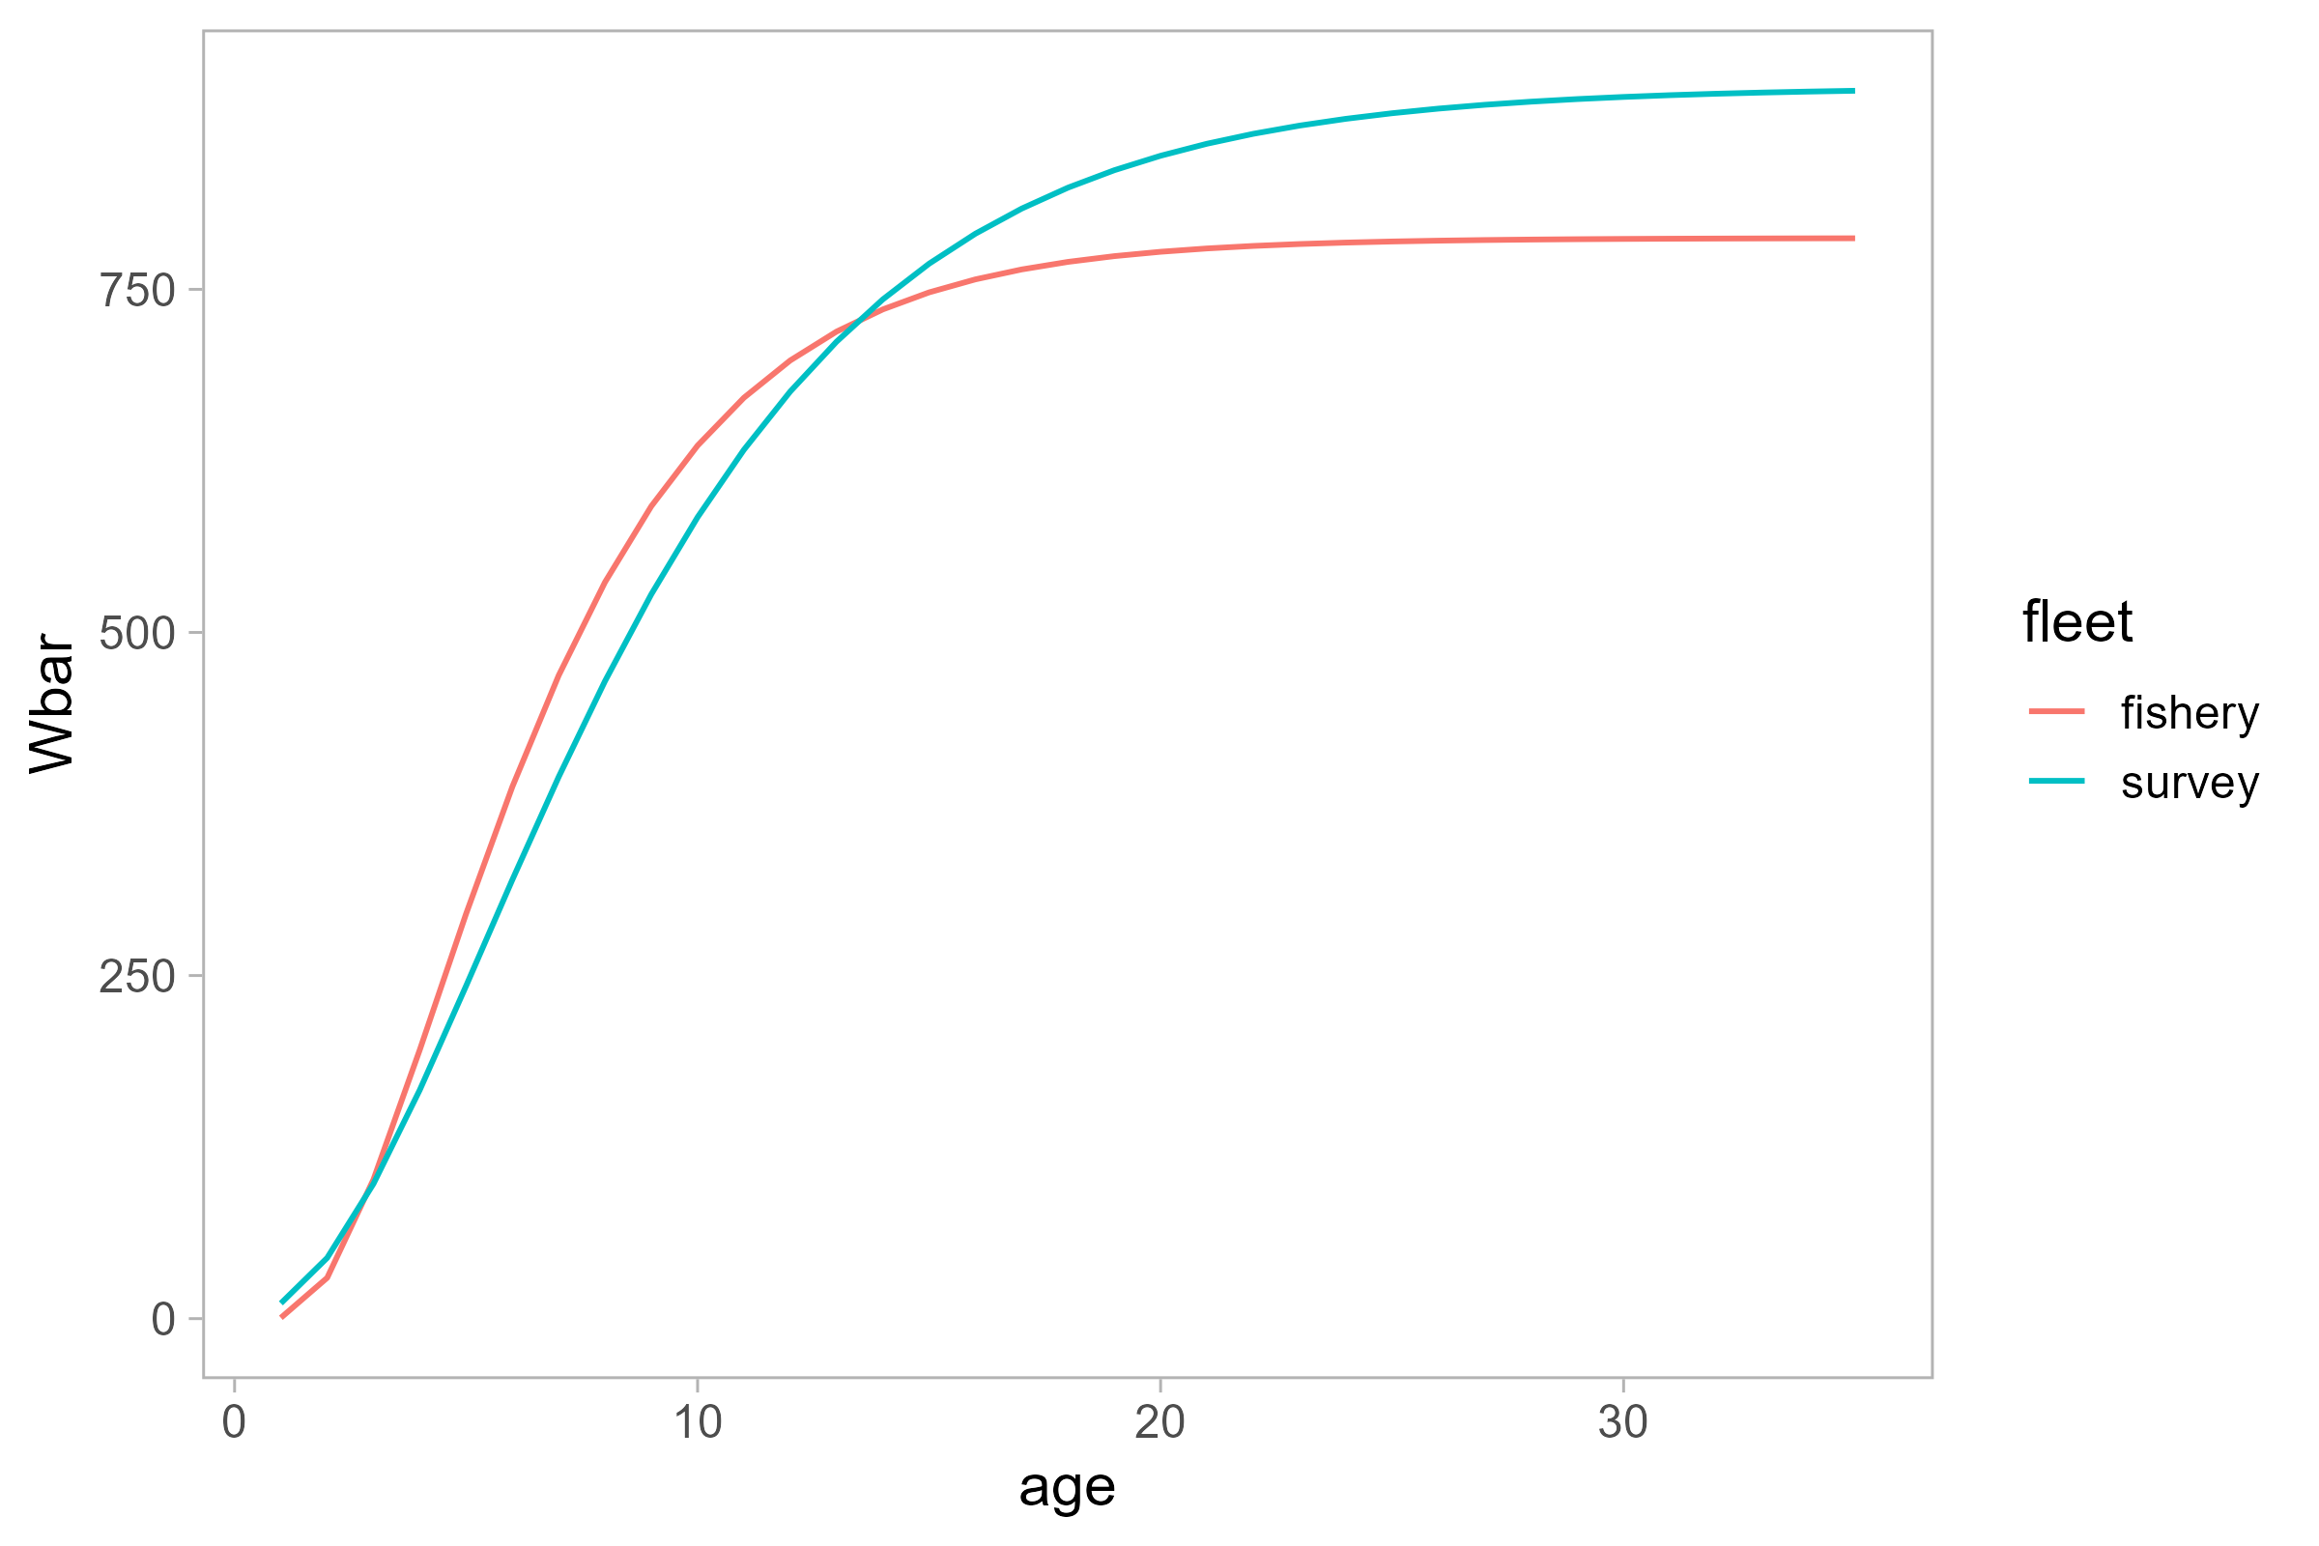

Figure 9.17. Estimated weight-age relationship for two fleets.

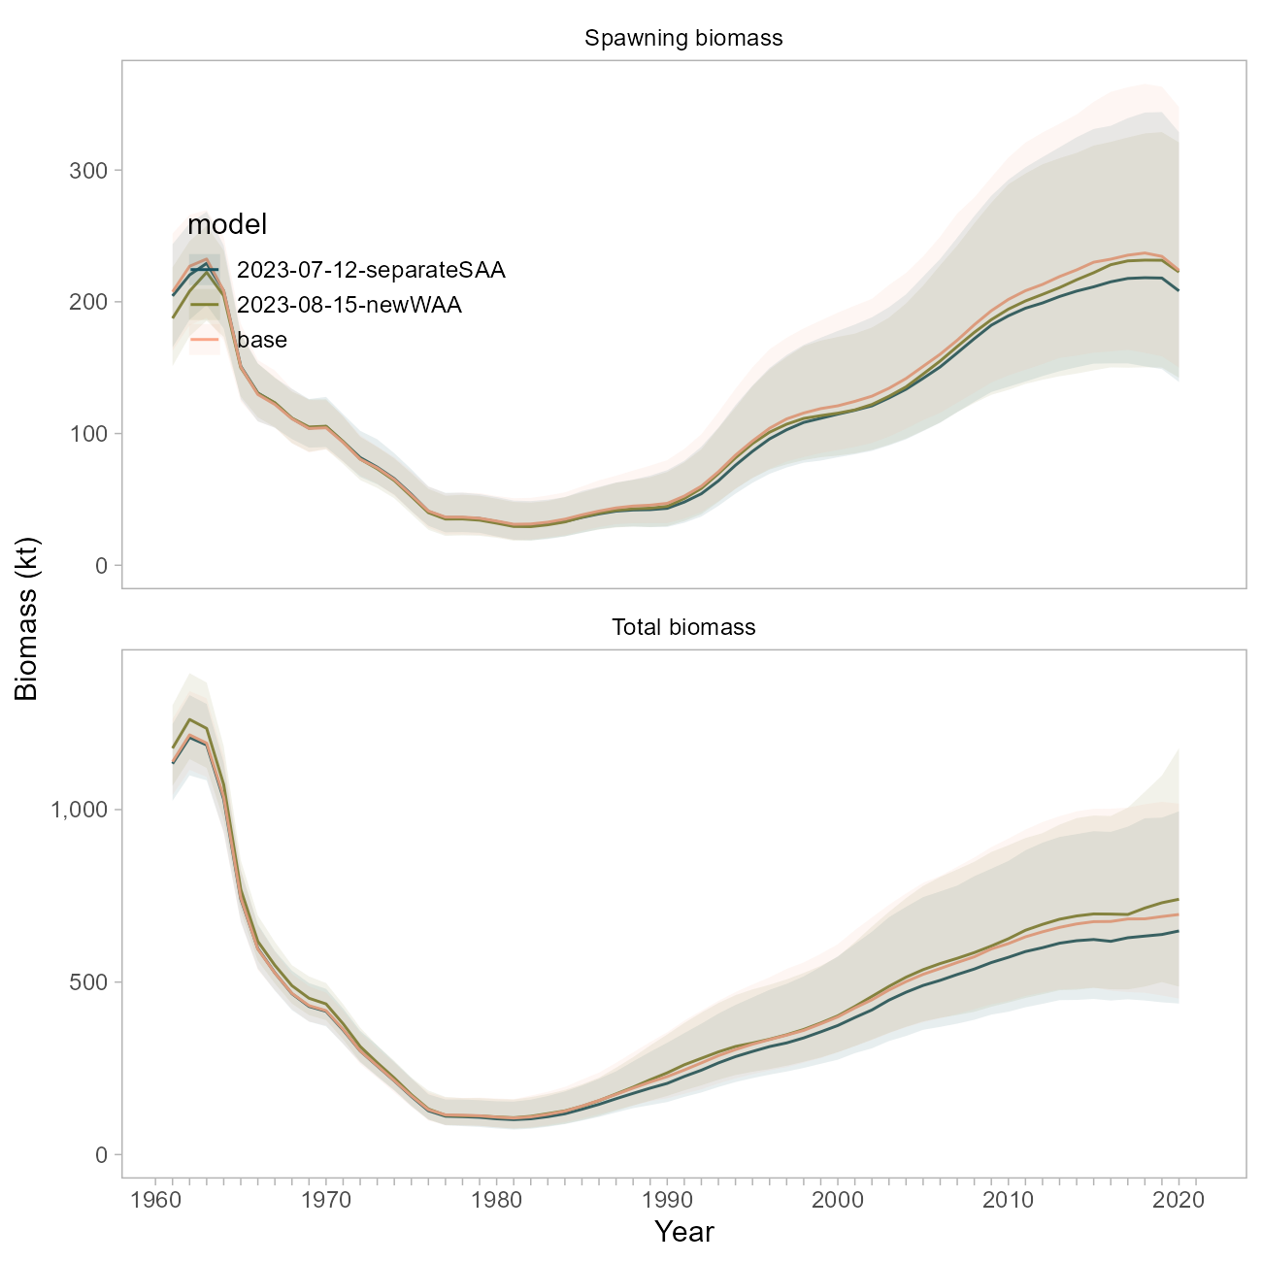

Figure 9.18. Biomass trajectory comparison between the base model, a model using a separate size-at-age matrix for the fishery data from 1980 onwards (‘separateSAA’), and a model using the fishery-derived weight-at-age vector for all population dynamics (‘newWAA’).

## Natural Mortality

Tingley TOR 1: *“Exploration of additional information to better define the realistic range of M for Pacific ocean perch is recommended. This should consider data available for Pacific ocean perch and for other long-lived rockfish species.”*

Tingley TOR 3: *“In the absence of better information about the likely magnitude of M, sensitivities using values of fixed M that bracket the estimated value M should be run in future stock assessments to inform on the level of risk inherent in the current assumptions about M.”*

There has been a fair amount of investigation on this topic; the following response is meant to succinctly describe our findings and is organized into the principal lenses through which $M$ was explored in the POP model: through the priors, through likelihood profiles, and through the application of a new modeling framework.

### Priors on M

The current POP base model uses a restrictive maximum-age based Hamel (2015) prior for $M∼N\left(μ=0.0614,σ^{2}=0.00614\right)$ (a 10% coefficient of variation).

The FishLife R package (Thorson et al., 2023) was recently updated to incorporate morphometric, spawning, behavioral, reproductive and trophic traits from a global database of fish life-history (“FishBase”). This tool enables us to develop an $M$ prior for POP that is informed by similar species and therefore better accounts for uncertainty. The prior suggested by the FishLife R package (version 3.0.0) for POP specifically is broader and centered at a higher value (0.0939) base model prior (Figure 19). The FishLife $M$ prior for the genus *Sebastes* encompasses values from 0 to 0.20. The MLE from the base model (~0.075) is at the ~6th percentile of the POP-specific prior distribution, and the 22nd percentile of the prior distribution for *Sebastes*.

A sensitivity run for the base model using the POP-specific FishLife prior resulted in an even higher estimate of $M$ at 0.112 (Figure 19). Biomass trajectories from this model (using the broader prior) are higher than the base model (Figure 20). The overall NLL from this sensitivity is ~8 units lower than the base model (252.818 vs 260.057 units). The fits to the survey are not visually improved, though the time series of expected survey values is smoother (Figure 21).

### Likelihood Profiles on M

We profiled over values of $M$ from 0.01 to 0.30 in increments of 0.02 using the base model. This method involves fixing $M$ and removing the prior on $M$ from the total NLL calculation.

In the absence of the prior, the total likelihood (“objective function”, black line in Figure 22) indicates that the MLE for $M$ would be much higher than it is in the base model, around 0.15. The data likelihood component (red line in Figure 22) is otherwise the most well-defined and suggests an MLE for $M$ closer to 0.06, in agreement with the Hamel (2015) prior mean, and consistent with where the base model estimates $M$ given the narrow prior and preponderance of information in the data. There was no statistical difference in the data likelihood component for models with $M$ values between 0.04 to 0.08.

The fishery size composition data appears to be in conflict with the fishery age composition and survey age and abundance data, whereby the former suggests $M$ values much higher than the latter, though both appear to minimize at values outside the tested realm (Figure 22).

These observations indicate that the MLE indicated by the data likelihood and the curvature of that profile is probably a compromise between the data sources (survey abundance and ages, fishery ages, and maturity data) that suggest lower, more realistic values for $M$ (e.g., less than 0.10) and the one data source (fishery lengths) that suggests a high value for $M$. Data weights are identical for these components, meaning that the higher input sample sizes for the age data are pulling the estimate lower than what the fishery lengths would suggest. The influence of the fishery length data is also reduced in the base model due to the inclusion of multiple other data sources and the specification of the narrow prior.

### Looking at M in a New Modeling Framework

The POP model was transitioned to the Stock Synthesis modeling framework Methot and Wetzel (2013) (v3.30.17). This was *not* undertaken as a full bridging exercise, rather as a learning tool to investigate whether certain issues in the POP model could be resolved or reproduced by changing or simplifying assumptions inherent to the bespoke model framework. This SS3 model was designed to 1) incorporate all the data that is currently used in the POP base model, 2) better account for uncertainty in key population dynamics processes, with the goal of 3) roughly matching the scale and trend in derived quantities as the base model. *At present, we do not propose the SS3 model for management use and are not showing extensive model results here*.

Key differences between the 2021 base and SS3 model include:

* survey catchability $q$ is analytical; and
* no size-at-age matrix is used (von Bertalanffy parameters are instead estimated, with attendant uncertainty); and
* *Data Weighting*: we explored a version of the SS3 model where there are no data weights applied (all data sources’ contributions to the overall objective function are equally weighted, whereas the base model weights all data sources to “1” and the catch data to “50”), as well as a version with three iterations of Francis compositional weights applied. Regardless of whether selectivity was dome-shaped or logistic (see below), the suggested Francis data weights down-weighted all compositional data components. The survey ages were down-weighted the most (between 6% and 9%); the fishery lengths were down-weighted the least (to 16% with logistic selectivity, or 42% with dome-shaped); and the fishery ages were down-weighted in between the two other compositional data sources (to 6% with logistic selectivity and 20% without). The results presented in this appendix use model runs *without* data weights applied. Note that the hessian matrix was invertible for all models, but only upon application of data weights was convergence (maximum gradient < 1e-5) achieved.
* *Fishery Selectivity* is specified differently in the SS3 model. The functional form is double normal, so that fishery selectivity can be dome shaped , logistic, or somewhere in between (as it is in the base model), given the same four time-blocks as in the base model. We explored either forcing fishery selectivity to be logistic, or allowing the descending limb to form a dome. Dome shaped selectivity resulted in a large increase in model scale (Figure 24).

We investigated the influence of $M$ in the SS3 model, using either the original, narrow $M$ prior, the broader POP-specific FishLife prior described above, or fixing $M$ to the 2021 MLE (0.075, Figure 19). These three alternatives were tested against the two selectivity specifications mentioned above.

Several useful findings emerged from this effort:

* The $M$ prior seems less influential on model dynamics than does the specification of fishery selectivity, and whether or not data weights are applied. For example, a model using the FishLife prior, logistic fishery selectivity and no data weighting estimated $M$ to be 0.032 (Figure 23a); when data weighting was enabled for this same model, the $M$ estimate agreed more with the prior with an MLE of 0.091 (Figure 23b). In an SS3 model where selectivity was allowed to be dome-shaped, $M$ was closer to the 2021 base value at 0.086 (Figure 23c)) though the model scale is greatly increased (Figure 24).Using the original, restrictive Hamel (2015) prior in a model with logistic fishery selectivity and no data weights resulted in an $M$ estimate nearly equivalent to the prior mean (0.061, Figure 23d).
* Biomass trajectories across our six experimental runs illustrate that *variation in model scale is most readily described by differences in selectivity* versus the prior or estimate of $M$. Specifically, all models with dome-shaped selectivity exhibited higher biomass trajectories, better fits to the compositional data, and worse fits to the survey data (grey lines, Figures 24 and 10.25)), while those with logistic selectivity were closer in scale to the 2021 model, did not fit the compositional data as well, but fit the survey best overall (blue lines, Figures 24 and 10.25)). The tradeoffs in model fit are consistent with observations from the base model that there are conflicts between these data types.
* Recall that using the FishLife prior in the base model resulted in an estimate of $M$ to be high at 0.11 (Figure 19), which was illustrated further using likelihood profiles on the base model (Figure 22). The fact that this dynamic ( $M$ pushing ever-higher) did not persist in the SS3 model is likely *due to the increased flexibility of the double-normal curve*; the base model is controlled by the gamma function to be traditionally dome-shaped. This would explain the need to constrain $M$ in the base model when the transition to gamma-shaped selectivity was made; the SS3 model assumes that older fish are indeed selected by the fishery, and there is information in the fishery and survey ages to suggest that $M$ is low.
* We ran likelihood profiles on $M$ on the experimental SS3 model(s) (Figure 26). The *conflict between survey and age versus length (fishery) data persists*; the recruitment trend would suggest a higher value of $M$, and this was true for models with logistic or dome-shaped selectivity. This indicates that the conflict between these data sources is not an artifact of the bespoke model. The main distinction between the two profiles is that the model with logistic selectivity effectively ignores the $M$ prior and estimates a very low value, likely to compensate for the high exploitation of older fish. The reader is advised that *there was a large range of $M$ values that were statistically indistinguishable* for both models (between 0.02 and 0.12).

### Conclusions regarding M

Overall, given the framework of the base model, it is apparent that the current prior on $M$ is reinforcing the perception that $M$ is between 0.04 and 0.07, and that in the absence of this prior (or in the presence of the broader FishLife prior) the base model’s estimate for $M$ would be higher. This estimate represents a compromise between the survey index, survey age, and fishery age data, which all suggest low values for $M$, and the fishery length data, which suggests a high value for $M$. Using a higher and broader prior in the base model resulted in improved likelihood scores, but presented changes in the scale of the population.

Investigations using an alternative modeling framework revealed that the specification of fishery selectivity seems more influential than $M$ in model scale and overall fits. We confirmed via likelihood profile that 1) there is conflict between the compositional data sources and 2) there is a broad range of $M$ values (from 0.02 to 0.12) that are statistically indistinguishable. The observation regarding a range of $M$ values was also found in assessments of POP for the US West Coast (Wetzel *et al.* (2017)).

The data conflict is much more pronounced in the current POP model versus the SS3 model, both in terms of the range of $M$ values that are statistically indistinguishable, the discrepancy between MLEs for $M$ for each likelihood component, and the influence of the prior on the overall MLE. A visual inspection of the data reveals that the fishery length compositions appear nearly stable through time, while the age compositions from both sources appear to track cohorts to a greater degree. Secondary to the recommendations below, we will explore data weighting approaches in the new modeling framework. We re-iterate that the magnitude of disagreement between data sources appears less pronounced in the SS3 model.

*We do not recommend transitioning to the FishLife prior within the current model framework*. We suggest that the change in the prior for $M$ should not be made without concurrently revisiting the treatment of *selectivity, and potential re-weighting of compositional data*. Given our findings above, *we recommend this be undertaken within the context of a new modeling framework*, where it has been revealed that the prior is less influential than other factors.

The previous assessment author indicates that the strict prior on $M$ in the base model was a necessary compromise when the fishery selectivity was transitioned to the current gamma (dome-shaped) distribution, so it is likely that both selectivity specification and differences in how population dynamics are represented (e.g., recruitment) between the current and SS3 models are facilitating estimation of $M$. We conclude that it is worthwhile to continue developing the SS3 model with particular attention on these processes. *The use of the FishLife prior (or a hybrid of the Hamel and FishLife approaches) is likely appropriate, and not unduly influential, within the SS3 framework*.

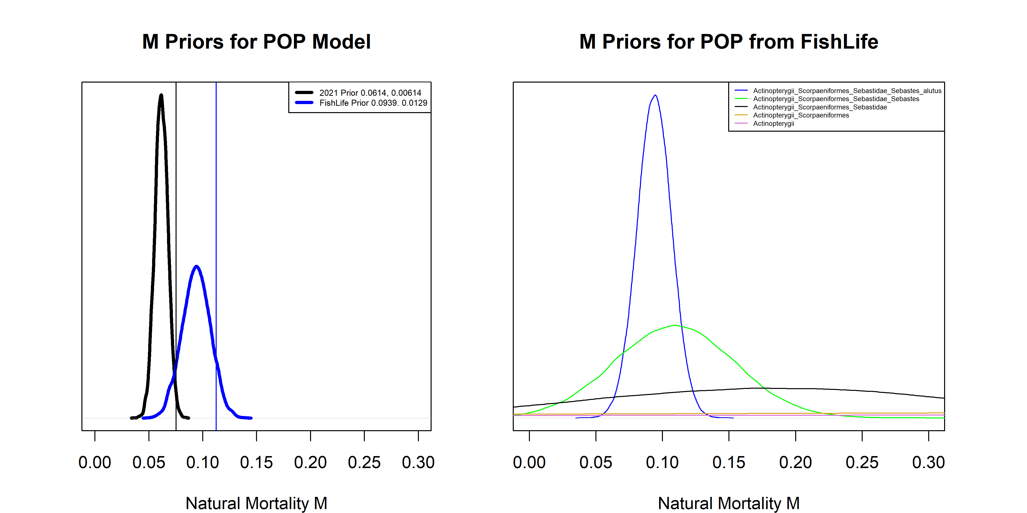

Figure 9.19. Left: Comparison of M priors (thick lines) and maximum likelihood estimates (thin vertical lines) between the base model (black), and the base model using a prior from the FishLife package (blue). Right: M priors from the FishLife package for POP and related taxa.

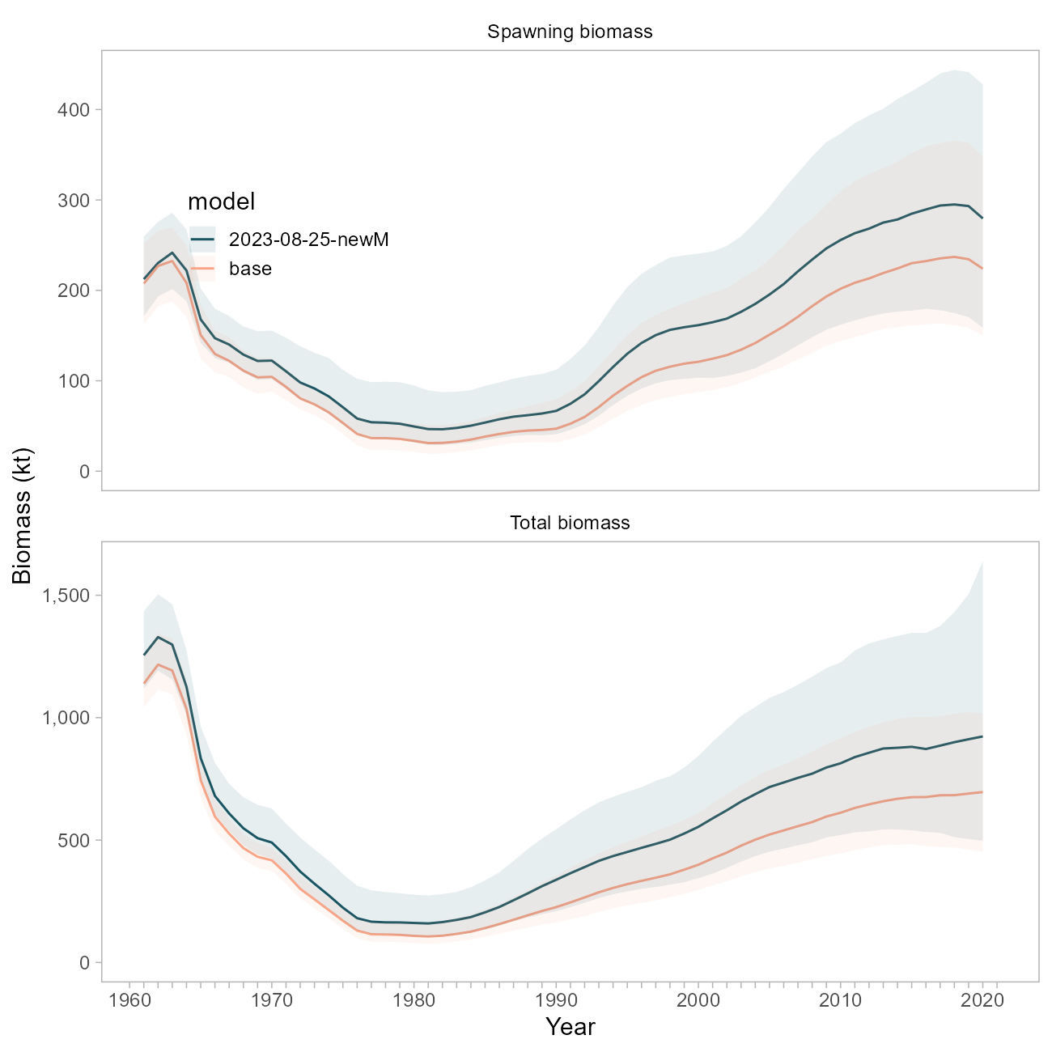

Figure 9.20. Comparison of biomass trajectories between the base model and a model using the FishLife prior for natural mortality.

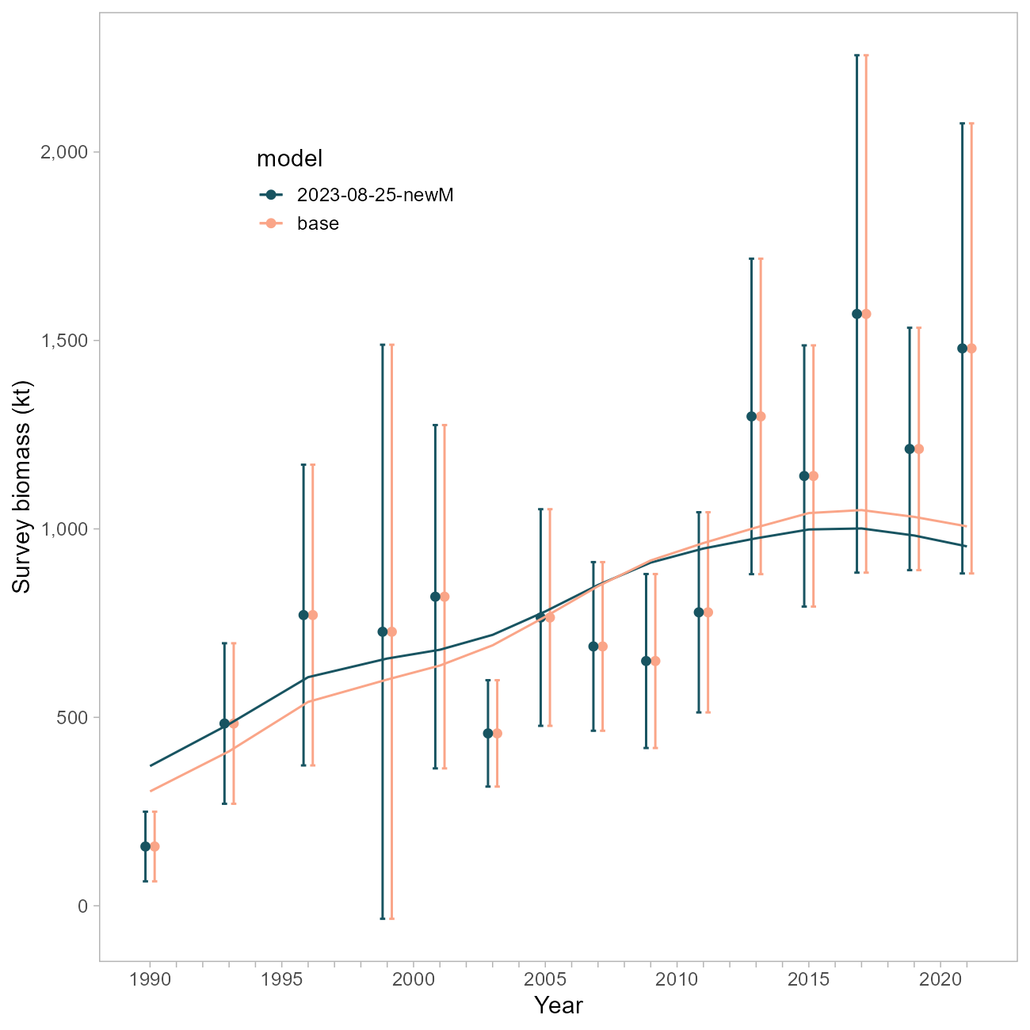

Figure 9.21. Comparison of survey fits between the base model and a model using the FishLife prior for natural mortality.

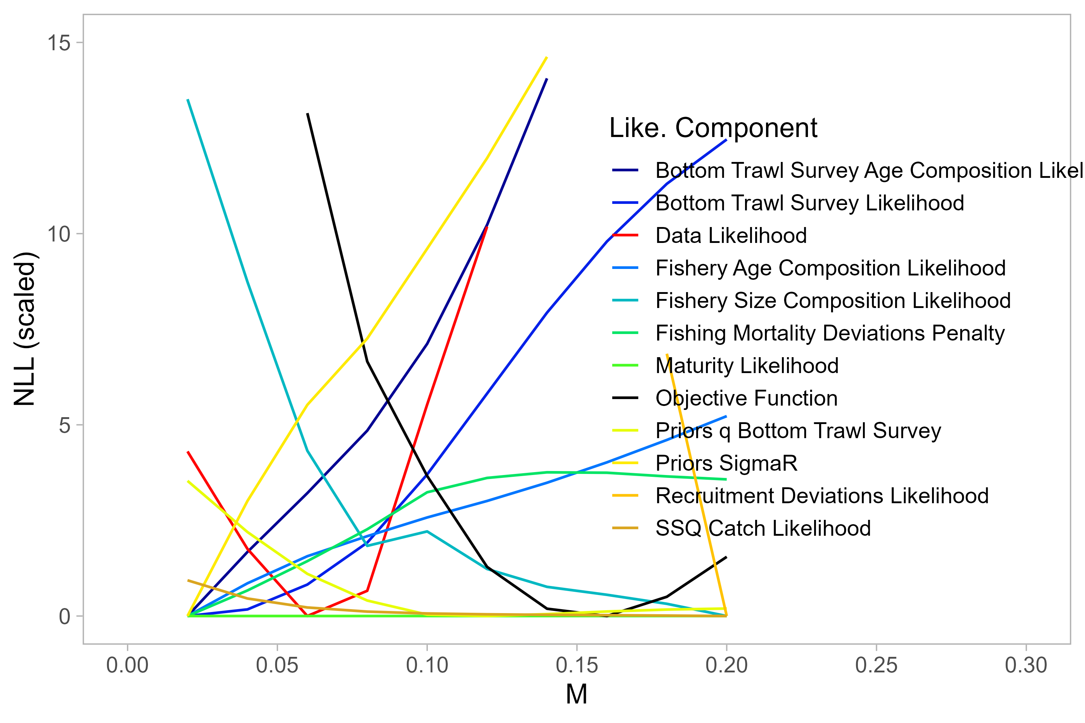

Figure 9.22. Likelihood profile on M using the base model.

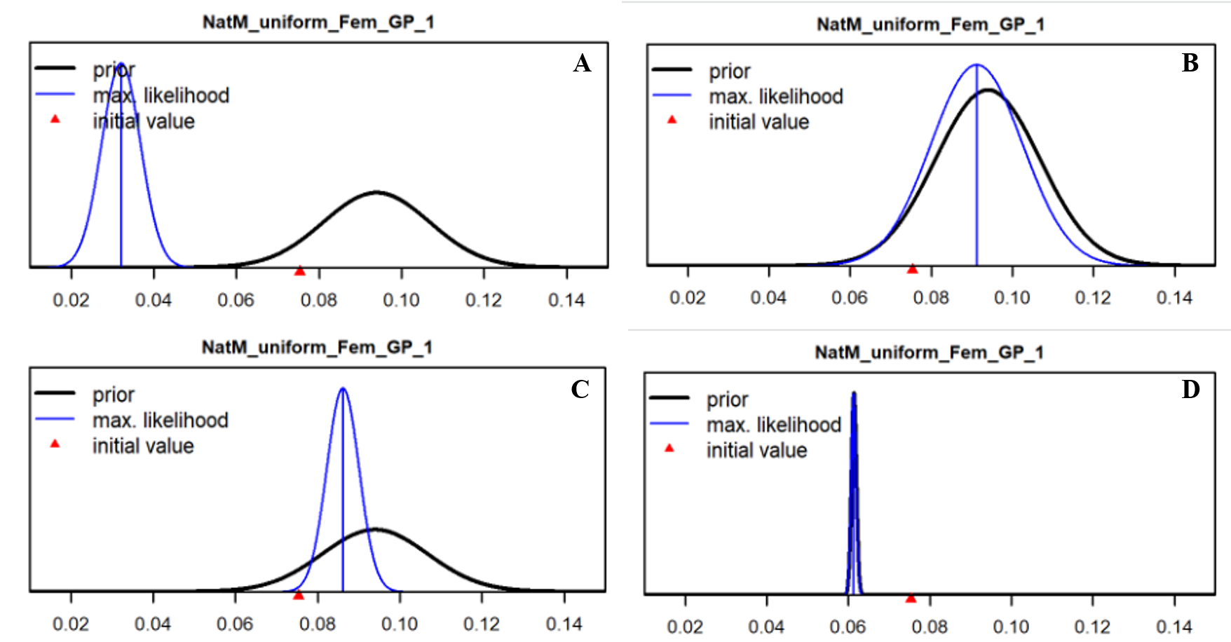

Figure 9.23. Prior (black line) and posterior (blue line) estimates of M using (A-C) the new FishLife prior or D) the original Hamel (2015) prior. Fishery selectivity is forced to be logistic in A, B and D. Tuned compositional data weights using the Francis method have been applied in B.

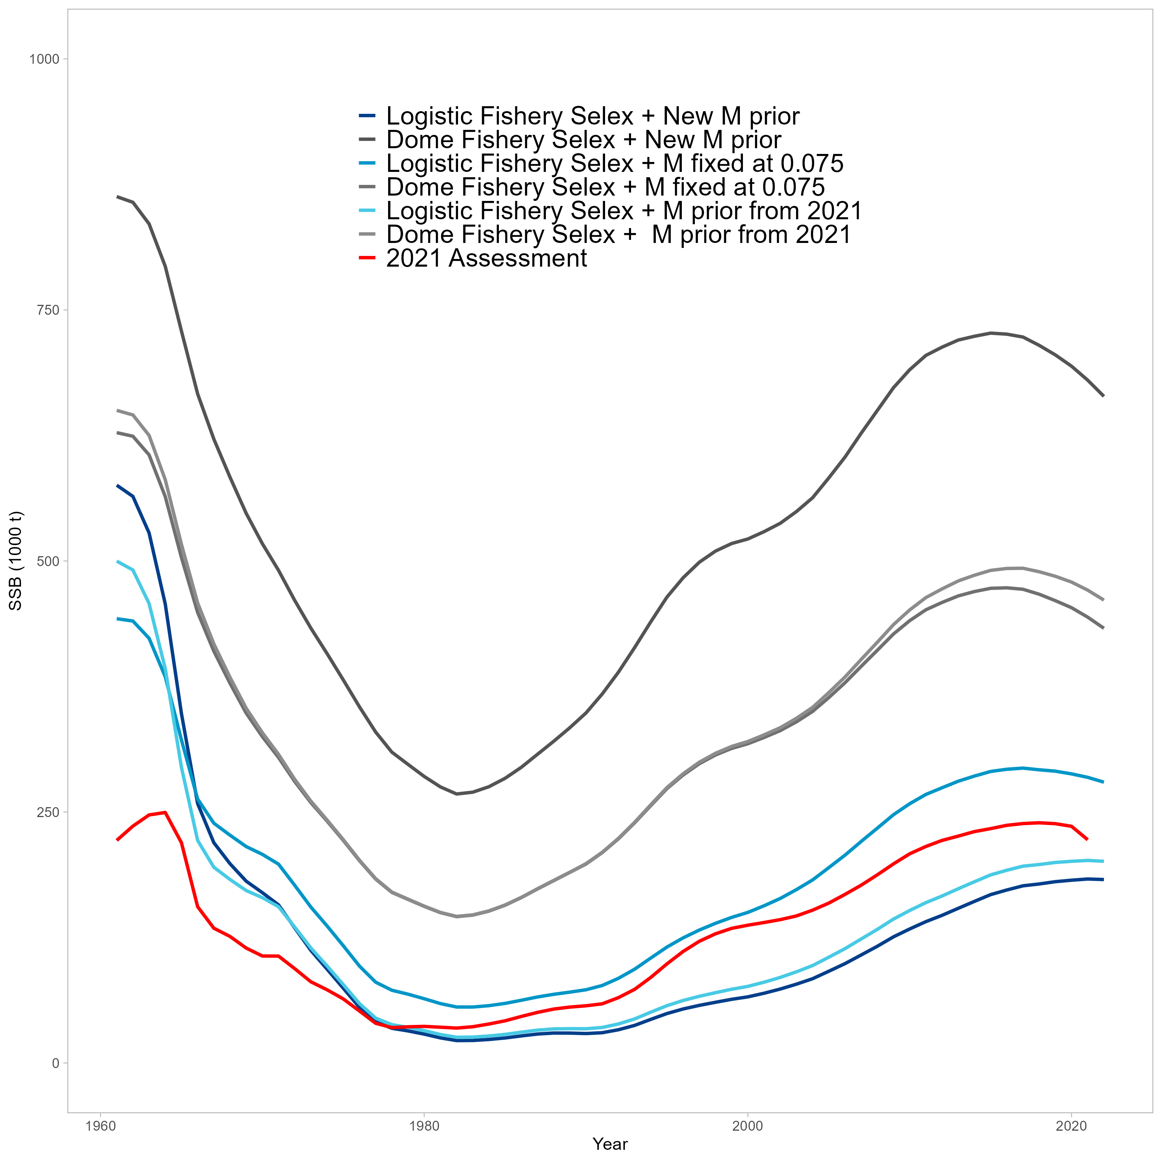

Figure 9.24. Comparison of SSB trajectories for alternative SS3 configurations implemented for natural mortality explorations. The red line is the 2021 POP Assessment.

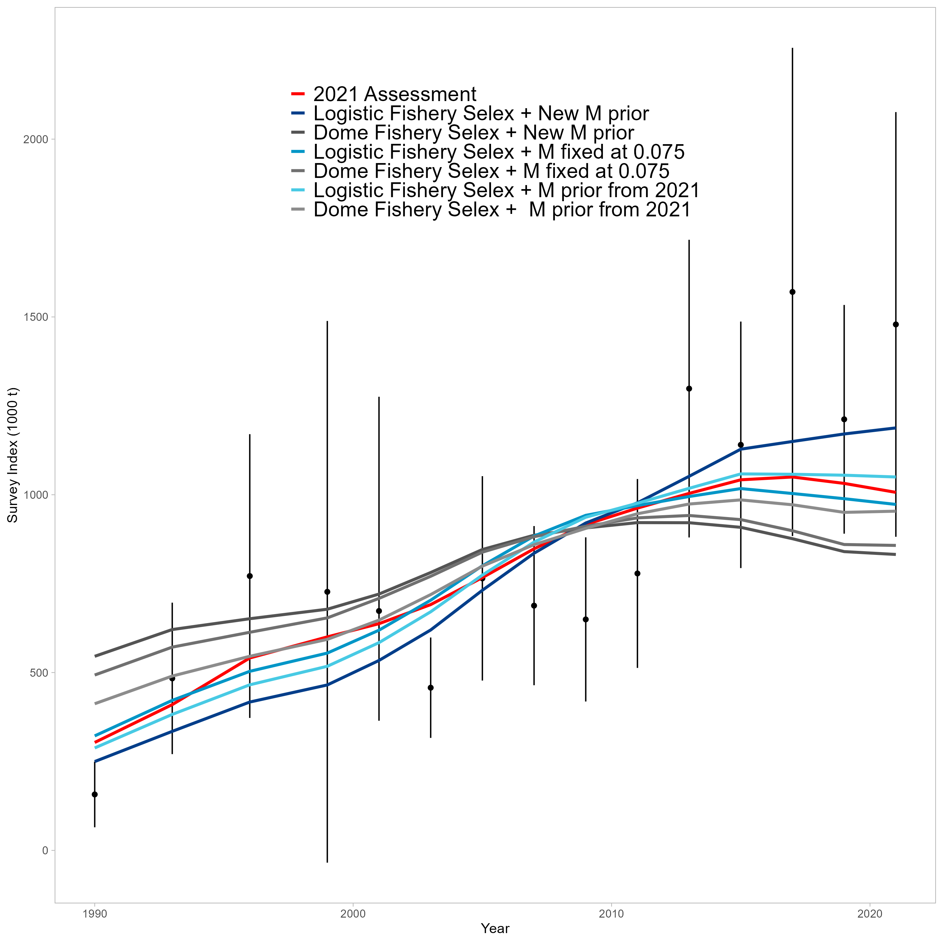

Figure 9.25. Comparison of survey fits for alternative SS3 configurations implemented for natural mortality explorations. The red line is the 2021 POP Assessment.

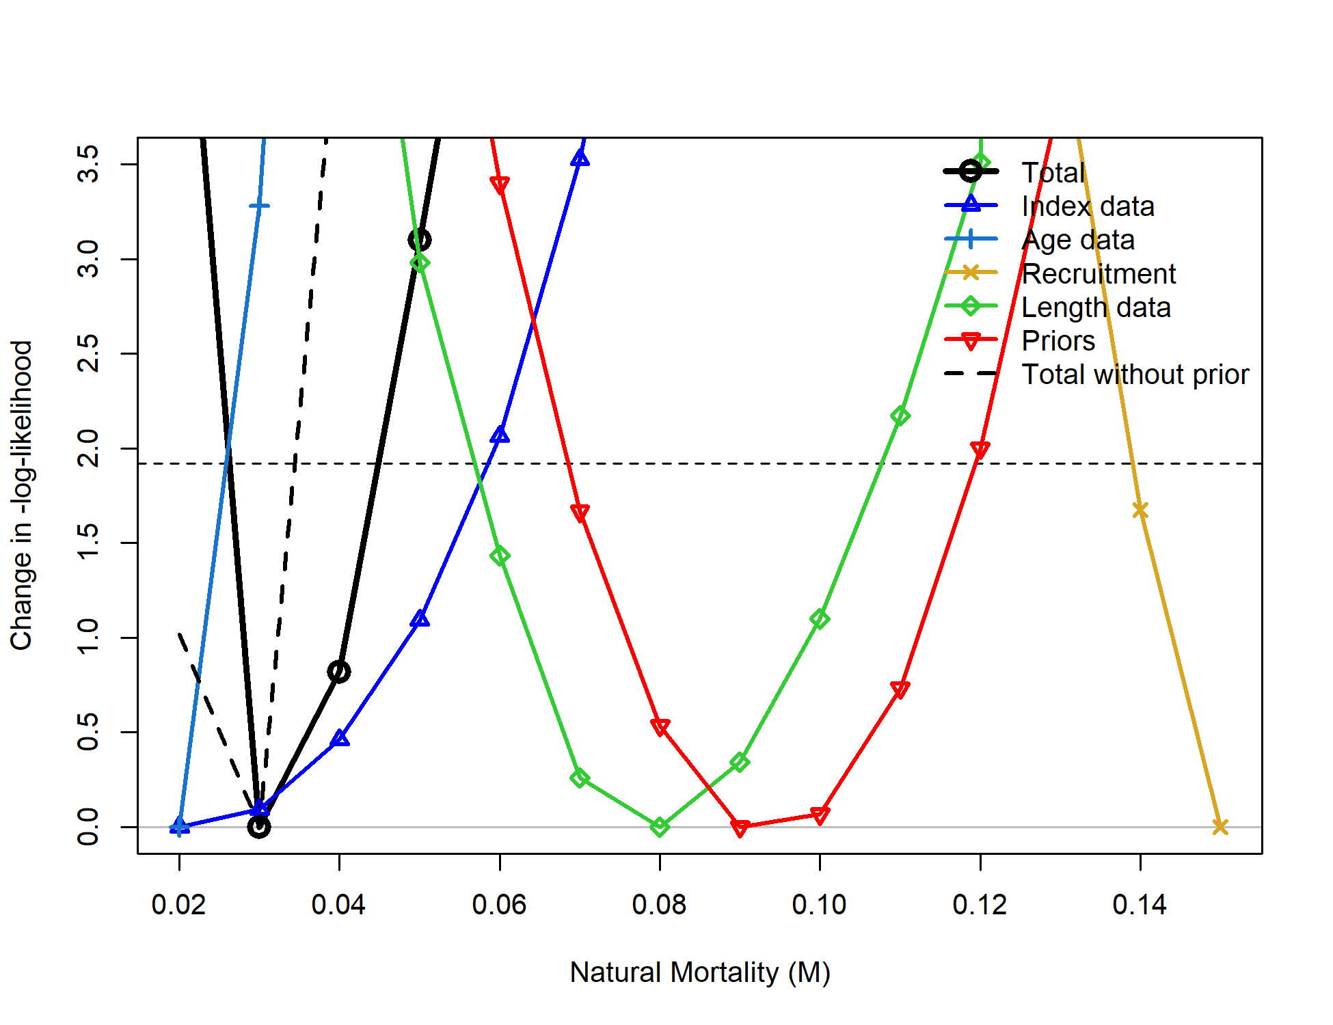

Figure 9.26. Likelihood profile on M using the SS3 Model. Values below the horizontal dashed line are statistically indistinguishable.

## Priors & Penalties on *F*, $σ_{R}$

Cadigan: *“Consider removing priors for $F$ Regularity and $σ_{R}$.”*

For clarity, the “prior for $F$ Regularity” is a term that penalizes the vector of $F$ deviations using the sum-of-squares (in practice, assuming a mean of 0 and a variance of 1), which is essentially the data weight that is multiplied against the sum-of-squares of $F$ deviations. $σ_{R}$ is indeed estimated using a lognormally-distributed prior( $σ_{R}∼lN\left(1.7,0.2\right)$). We addressed this comment by separately disabling each of these functions; additionally, the SS3 model mentioned above does not involve a prior on $σ_{R}$ nor a penalty for $F$, so comparisons can be made among model frameworks for further information.

Disabling the penalty on $σ_{R}$ did not result in changes to biomass trajectories (Figure 27).

Removing the penalty on $F$ did result in changes to the biomass trajectories, such that the sensitivity run estimated $F$ to be lower and the overall biomass to be higher in the absence of a penalty (Figure 28). The SS3 model, by comparison, estimates $F$ to be higher than both ADMB models yet the trajectory is similar (Figure 29).

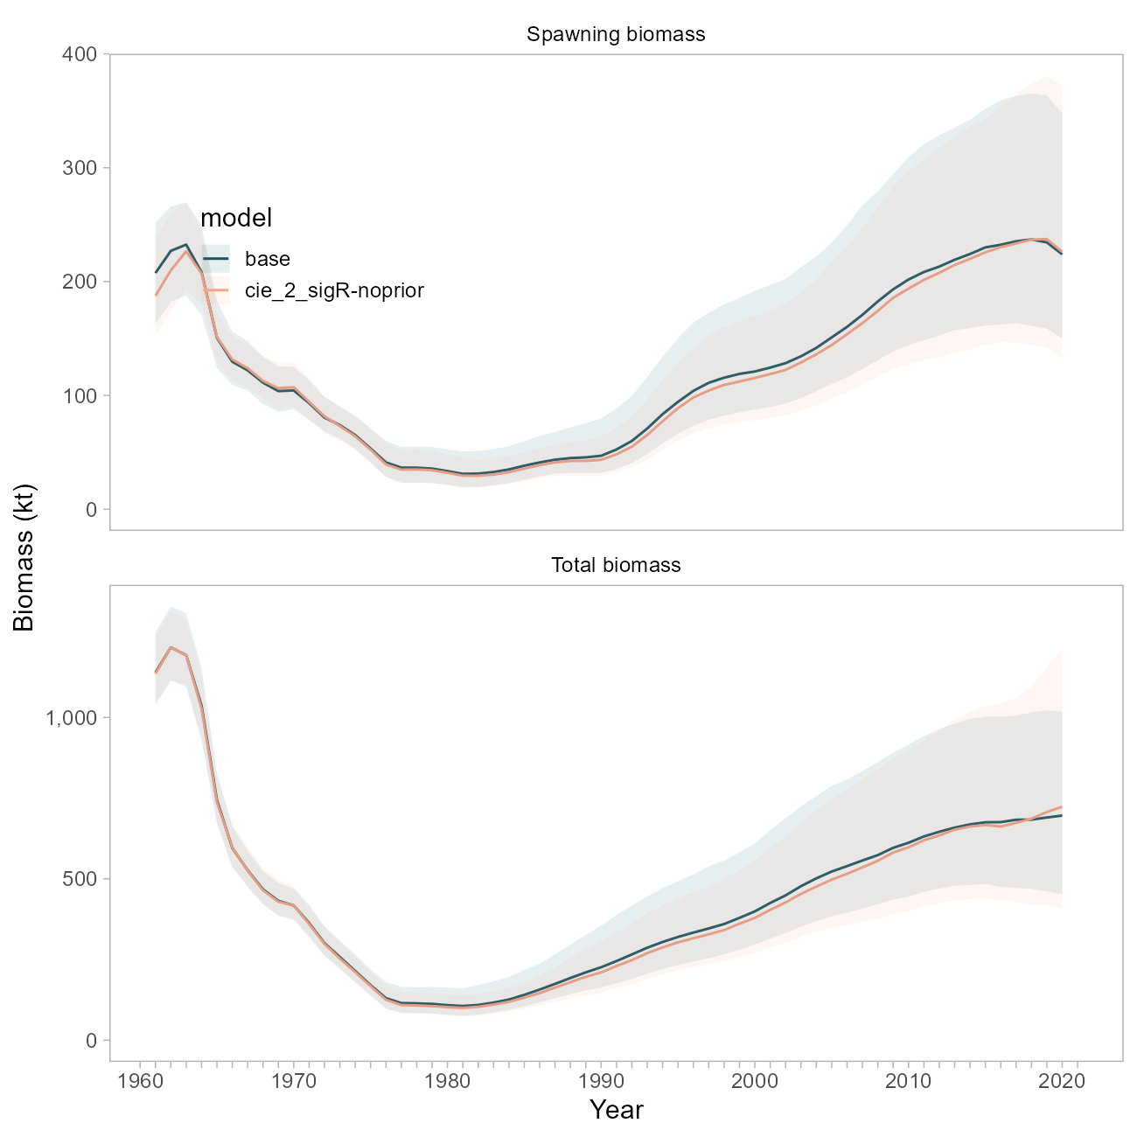

Figure 9.27. Comparison of biomass trajectories between the base model and a model with the prior on sigma-R disabled.

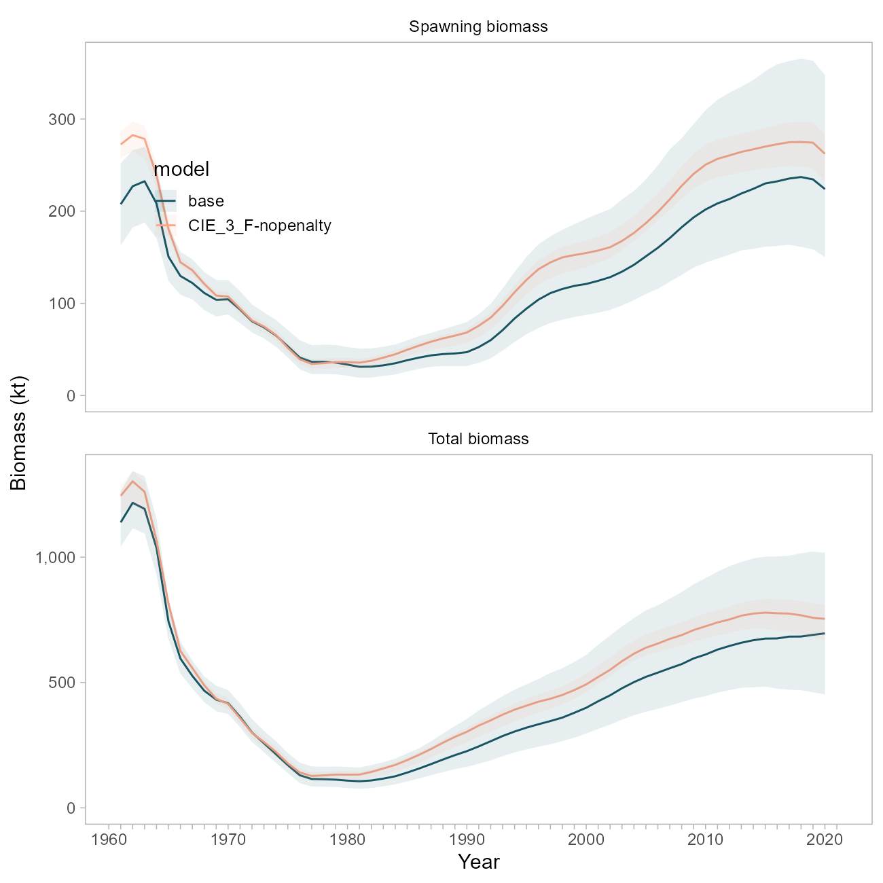

Figure 9.28. Comparison of biomass trajectories between the base model and a model with the regularization penalty on F disabled.

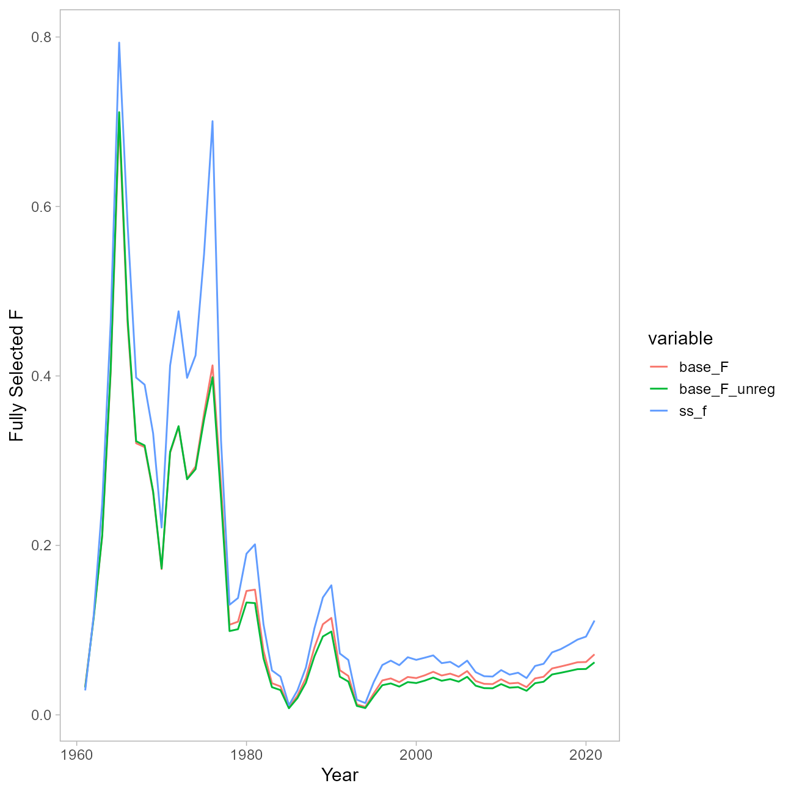

Figure 9.29. Comparison of F trajectories between the base model and a model with the regularization penalty on F disabled, and the SS3 model.

## References

Methot, R.D., Wetzel, C.R., 2013. Stock synthesis: A biological and statistical framework for fish stock assessment and fishery management. Fisheries Research 142, 86–99. <https://doi.org/10.1016/j.fishres.2012.10.012>

Thorson, J.T., Maureaud, A.A., Frelat, R., Mérigot, B., Bigman, J.S., Friedman, S.T., Palomares, M.L.D., Pinsky, M.L., Price, S.A., Wainwright, P., 2023. Identifying direct and indirect associations among traits by merging phylogenetic comparative methods and structural equation models. Methods Ecol. Evol. n/a. <https://doi.org/10.1111/2041-210X.14076>

# Appendix: Model Equations

## Population Dynamics

| Equation | Description | Notation |
| --- | --- | --- |
| $$N_{2,y}=e^{μ_{r}+ϵ_{y}^{r}}$$ | Annual numbers at age of recruitment (age-2) | $y$ year, $a$ age $μ_{r}$ average recruitment, $ϵ_{y}^{r}$ annual recruitment deviation |
| $$N_{ay}=N_{a-1,y-1}e^{-\left(M+F_{a-1,y-1}\right)}=N_{a-1,y-1}e^{-Z_{a-1,y-1}}$$ | Annual numbers at age between recruitment age and plus age group | $M$ natural mortality, $F_{ay}$ annual fishing mortality at age, $Z_{ay}$ annual total mortality at age |
| $$N_{a^{+},y}=N_{a^{+}-1,y-1}e^{-Z_{a^{+}-1,y-1}}+N_{a^{+},y-1}e^{-Z_{a^{+},y-1}}$$ | Annual numbers at age in plus group | $a^{+}$ plus group age (29) |
| $$SB_{Y}=\sum_{a=2}^{a+}{w_{a}}{\hat{m}}_{a}N_{ay}$$ | Annual spawning biomass | ${\hat{m}}_{a}$ maturity at age |
| $${\hat{m}}_{a}=\frac{1}{1+e^{-δ^{m}\left(a-a_{50\%}^{m}\right)}}$$ | Maturity at age | $δ^{m}$ logistic slope parameter $a_{50\%}^{m}$ logistic age at 50% maturity |

## Observation Model

| Equation | Description | Notation |
| --- | --- | --- |
| $${\hat{C}}_{y}=\sum_{a=2}^{a^{+}}{w_{a}}\frac{N_{ay}F_{ay}\left(1-e^{-Z_{ay}}\right)}{Z_{ay}}$$ | Catch in year $y$ | $w_{a}$ weight at age, $s_{ay}^{f}$ fishery selectivity by age and year |
| $$F_{ay}=s_{ay}^{f}F_{y}=s_{ay}^{f}e^{μ_{f}+ϵ_{y}^{f}}$$ | Annual fishing mortality | $F_{y}$ annual fishing mortality, $μ_{f}$ average fishing mortality, $ϵ_{y}^{f}$ annual fishing mortality deviation |
| $$S_{a,1961:1976}=\frac{1}{1+e^{-δ\left(a-a_{50\%}\right)}}$$ | Logistic fishery selectivity for 1961-1976 time period | $δ$ logistic slope parameter $a_{50\%}$ logistic age at 50$ selectivity |
| $${\hat{I}}_{y}=q\sum_{a=2}^{a+}{N_{ay}}s_{a}w_{a}$$ | Predicted bottom trawl survey biomass index | $q$ bottom trawl survey catchability, $s_{a}$ bottom trawl survey selectivity |
| $$S_{a}=\frac{1}{1+e^{-δ\left(a-a_{50\%}\right)}}$$ | Bottom trawl survey selectivity | $δ^{m}$ logistic slope parameter $a_{50\%}^{m}$ logistic age at 50$ maturity |
| $${\hat{p}}_{ay}=T_{a→a'}\frac{N_{ay}s_{a}}{\sum_{a=2}^{a^{+}}{N_{ay}}s_{a}}$$ | Predicted bottom trawl survey age composition | $T_{a→a'}$ ageing error matrix |
| $${\hat{p}}_{ay}=T_{a→a'}\frac{C_{ay}}{\sum_{a=2}^{a^{+}}{C_{ay}}}$$ | Predicted fishery age composition |  |
| $${\hat{p}}_{Ly}=T_{a→l,y}\frac{C_{ly}}{\sum_{l=0}^{l^{+}}{C_{ly}}}$$ | Predicted fishery length composition | $T_{a→l,y}$ size-age transition matrix |

## Likelihood Components

The $λ$ notation indicates the weight assigned to each likelihood component. The value of lambda used is shown in the rightmost column.

| Equation | Component | Notation | Component weight |
| --- | --- | --- | --- |
| | Catches |  | 50 |
| | Bottom trawl survey biomass | $σ_{I_{y}}$ annual survey sampling error | 1 |
| | Fishery and bottom trawl survey age composition | $n_{ay}$ square root of sample size | 1 |
| | Fishery length composition | $n_{ay}$ number of hauls standardized to maximum of 100 | 1 |
| | Maturity | $n_{ay}$ number of observations at age by dataset | 1000 (penalty on maturity at age 0) |
| $$\frac{1}{2σ_{θ}^{2}}ln⟨\frac{θ}{θ_{prior}}⟩^{2}$$ | Prior penalty for natural mortality $M$, survey catchability $q$ and recruitment variability | parameter estimate, $σ_{θ}^{2}$ prior uncertainty, $θ_{prior}$ prior mean | N/A | |  |  |
|  | Recruitment deviation penalty | $σ_{r}$ recruitment variability | 1 |
| | Fishing mortality deviation penalty |  | 0.1 |

1. In 2012, the Plan Team and SSC recommended combined OFLs for the Western, Central, and West Yakutat areas (W/C/WYK) because the original rationale of an overfished stock no longer applied. However, because of concerns over stock structure, the OFL for SEO remained separate to ensure this unharvested OFL was not utilized in another area. The Council adopted these recommendations.